Hospital Management System (HMS)
Project Report
Report Date: November 29, 2025
1. Summary

The Hospital Management System (HMS) represents a web-based solution designed to streamline and automate various hospital operations, particularly focusing on appointment scheduling, patient management, and treatment record keeping. This system has been developed using modern web technologies including Flask, a lightweight Python web framework, SQLite for data persistence, and Bootstrap for responsive user interface design.
- The application serves three distinct user roles: Hospital Administrators, Doctors and Patients.
- Administrators can manage the entire system including doctor profiles, departments, and view appointment data.
- Doctors can manage their appointments, record patient treatments, and maintain availability schedules.
- Patients can register themselves, search for doctors, book appointments, and access their complete medical history.

2. Technology Stack
2.1 Backend Technologies
- Flask 3.0.0 – Used to build the application’s backend, handle routing, sessions, and rendering pages.
- Werkzeug 3.0.1– Used for securely hashing user passwords and managing authentication sessions.
- SQLite3– Used to store and manage all application data in a lightweight, file-based database.
2.2 Frontend Technologies
- HTML5 – Used to structure all web pages and define the layout of the user interface.
- CSS3 – Used to style the application with colours, layouts, fonts, and visual effects.
- Bootstrap 5.3 – Used to create a fully responsive layout with ready-made UI components like forms, tables, and modals.
- Jinja2 – Used to dynamically insert backend data into HTML pages during rendering.

3. Architecture Overview
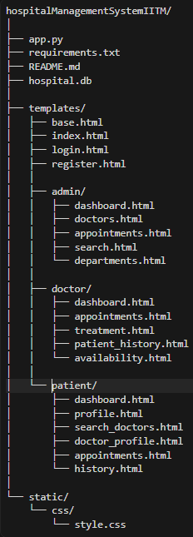
4. Database Schema
The database consists of seven interconnected tables.
- The users table stores authentication details for all users, including:
  - Username
  - Hashed password
  - Role
  - Contact information

- The departments table stores medical specialization details with:
  - Unique department name
  - Optional description
- The doctors table:
  - Extends the users table
  - Stores doctor name and specialization ID
  - Includes an is_active flag for soft deletion
- The patients table:
  - Extends the users table
  - Stores age, gender, and address
  - Includes an is_active flag for soft deletion
- The appointments table:
    - Links doctors and patients
    - Stores appointment date, time, and status
    - Status values include Booked, Completed, and Cancelled
    - Prevents double booking using a unique constraint on doctor, date, and time
- The treatments table:
    - Stores diagnosis, prescribed medicines, and doctor notes
    - Is created only after an appointment is completed
    - Maintains the patient’s permanent medical history
- The availability table:
  - Stores doctors’ available time slots for the next seven days
  - Allows flexible schedule updates by doctors

5. References
- Flask Documentation. (2024). Flask Web Framework. Retrieved from https://flask.palletsprojects.com/en/3.0.x/
- SQLite Documentation. (2024). SQLite Database Engine. Retrieved from https://docs.python.org/3/library/sqlite3.html
- Werkzeug Documentation. (2024). Werkzeug Utilities. Retrieved from https://werkzeug.palletsprojects.com/en/3.0.x/
- Bootstrap Documentation. (2024). Bootstrap CSS Framework. Retrieved from https://getbootstrap.com/docs/5.3/
- Jinja2 Documentation. (2024). Jinja2 Template Engine. Retrieved from https://jinja.palletsprojects.com/
- Python Software Foundation. (2024). Python Programming Language. Retrieved from https://www.python.org/

Appendix : Project Statistics
Metric | Value
Total Lines of Code | Approximately 785 lines in app.py
HTML Templates | 18 template files organized by user role
Database Tables | 7 interconnected tables with proper relationships
Application Routes | 25+ routes handling various functionalities
User Roles | 3 distinct roles (Admin, Doctor, Patient)
Database Functions | 3 core functions (init_db, get_db, query_db)
Authentication Decorators | 1 custom decorator (login_required)

- MAD1Recording.mp4

