Autonomous landing scene recognition based on transfer learning for drones

Now-a-day drones are using everywhere like riots area surveillance, video recording for news or functions, delivering parcels and many more but services of drones will get difficult when it comes to landing, as drones are not human being to perform save landing and it will make use of artificial intelligence which will analyse surrounding data and then instruct drone where to land but all existing artificial intelligence algorithms are not accurate enough as some landing places will be more similar to one and other so incorrect landing prediction or decision will be applied.

To overcome from above issue author of this paper employing transfer learning based pre-trained RESNEXT50 model which will separate similar places based on probability and the places which are same will have high probability and will predicted for landing. In propose paper author trained propose algorithm with SGD and ADAM optimizer but ADAM is giving high accuracy so we will be using ResNext50 with ADAM optimizer and then comparing its performance with existing ResNet50.

In this paper author study autonomous landing scene recognition with knowledge transfer for drone’s. Considering the difficulties in aerial remote sensing, especially that some scenes are extremely similar, or the same scene has different representations in different altitudes, we employ a deep convolution neural network (CNN) based on knowledge transfer and fine-tuning to solve the problem. Then, LandingScenes-7 dataset is established and divided into seven classes. Moreover, there is still a novelty detection problem in the classifier, and we address this by excluding other landing scenes using the approach of thresholding in the prediction stage. We employ the transfer learning method based on ResNeXt-50 backbone with the adaptive momentum (ADAM) optimization algorithm. We also compare ResNet-50 backbone and the momentum stochastic gradient descent (SGD) optimizer.

Extension Concept

In propose paper author has not used any hybrid or ensemble model to further enhance landing accuracy so as extension we are developing Hybrid Ensemble Random Forest model which will extract Optimize Features from trained ResNext50 and then further retrained optimized features with Ensemble Random Forest model and this hybrid model will improve accuracy.

To train above algorithms author of this paper has used self constructed LandingScenes7 dataset but this dataset not available on internet so we have created own landing dataset with 8 different scenes for landing and below are the dataset images

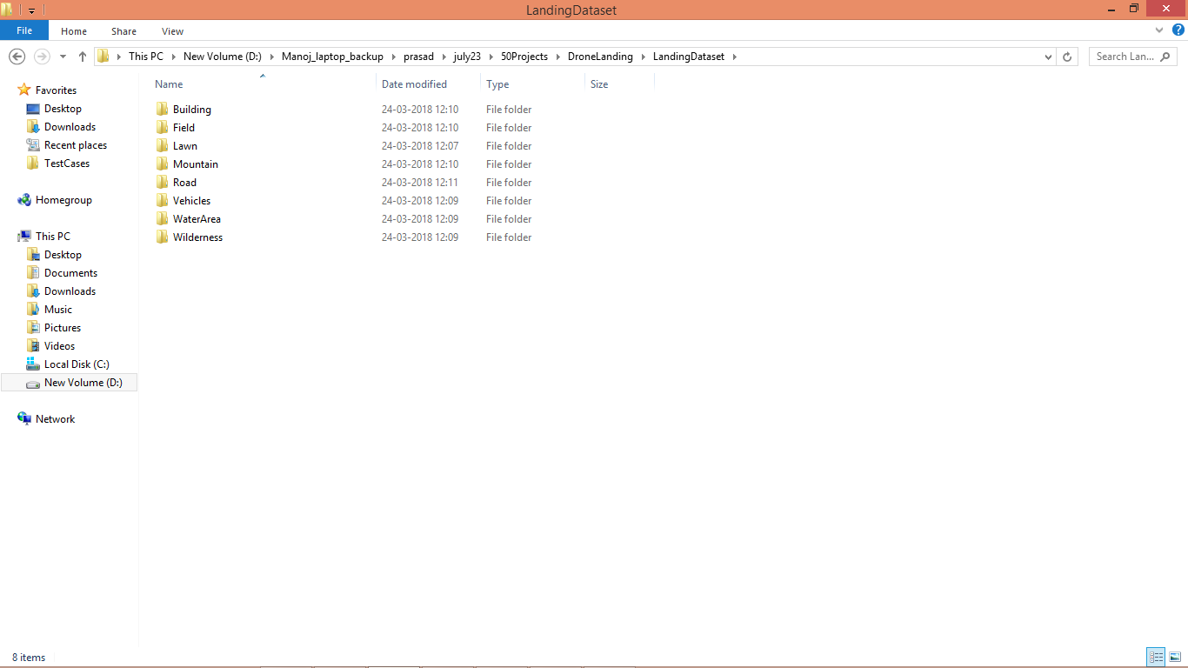

In above dataset screen we can see 8 different folders and just go inside any folder to view dataset images

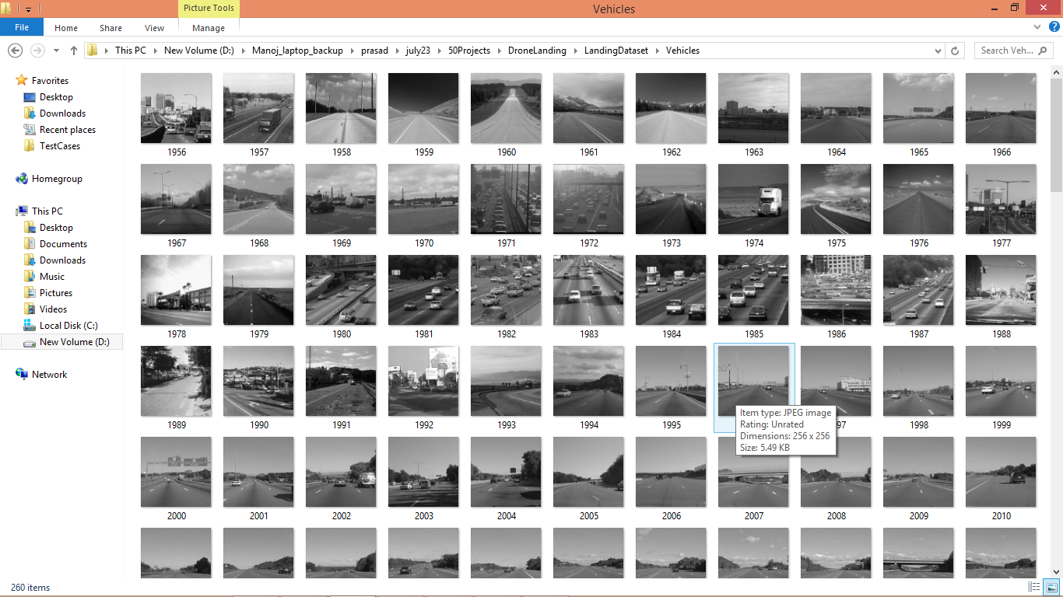

In above screen we can see some images from Road class and by using above scenes location dataset we trained models and then inform to drone about landing place name.

We have coded this project using JUPYTER notebook and below are the code and output screens with blue colour comments

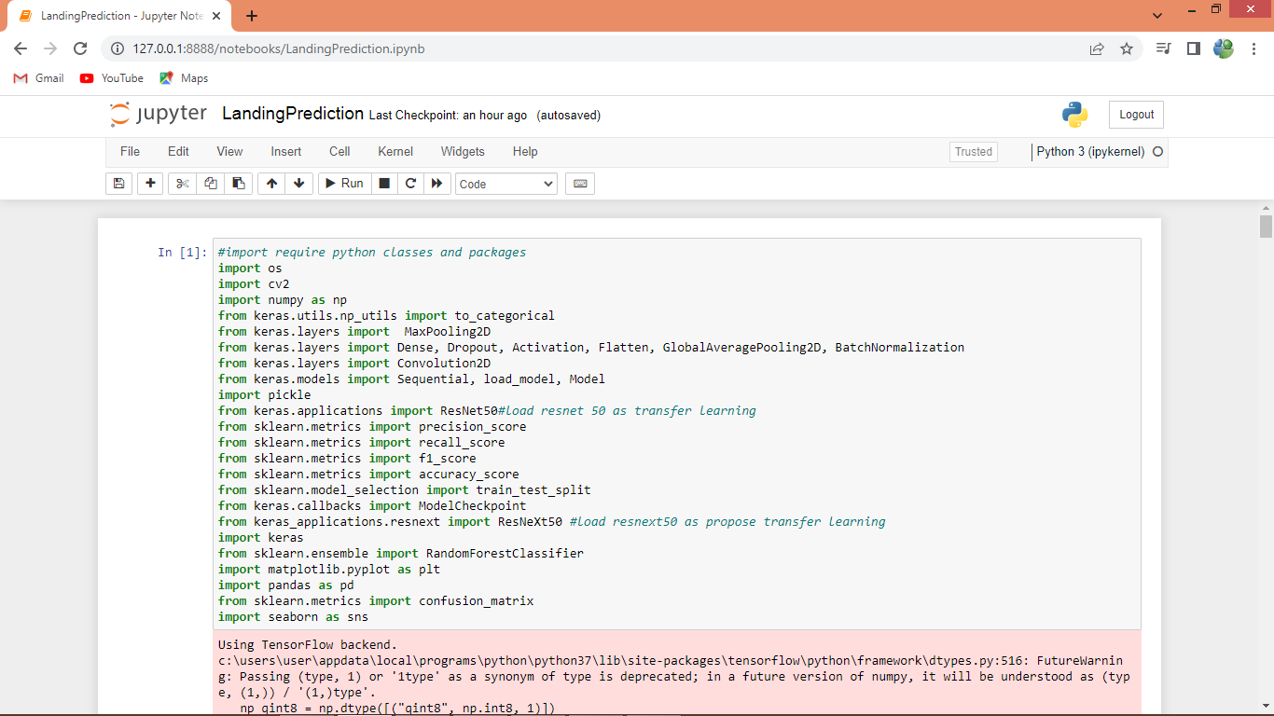

In above screen we are importing require python packages and classes

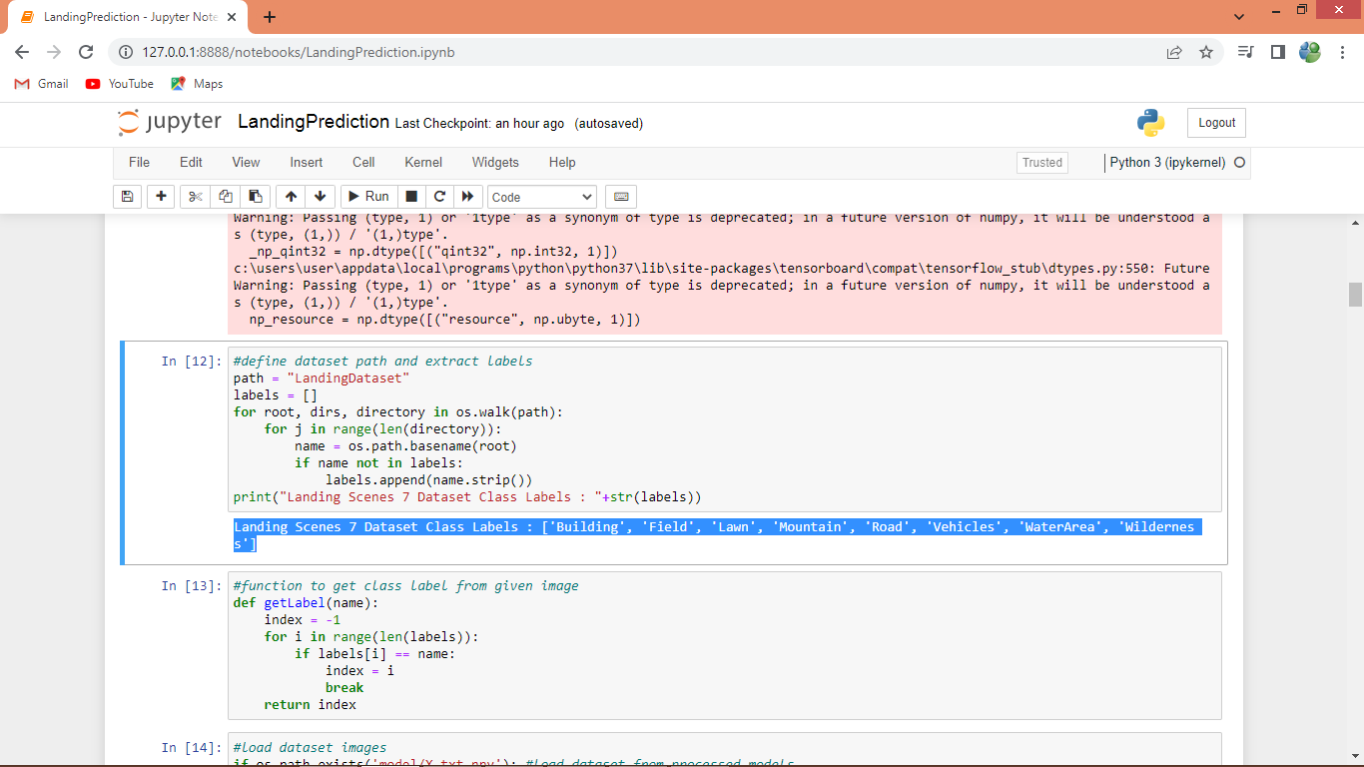

In above screen finding and displaying different landing scenes from dataset and then defining function to get class label from scenes names

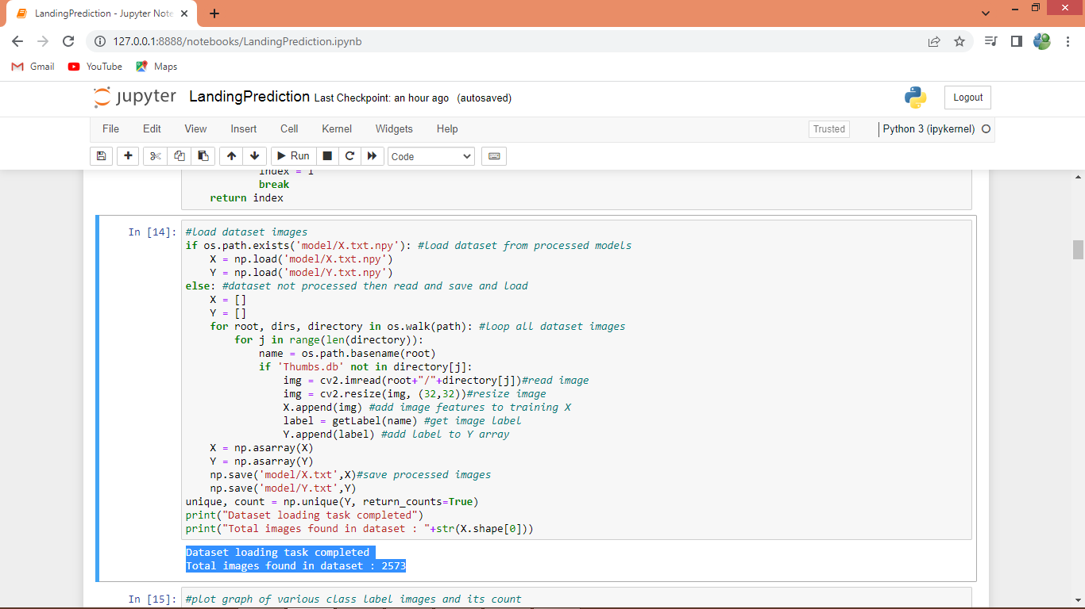

In above screen looping and loading all images from dataset folder and then in blue colour text displaying total loaded images

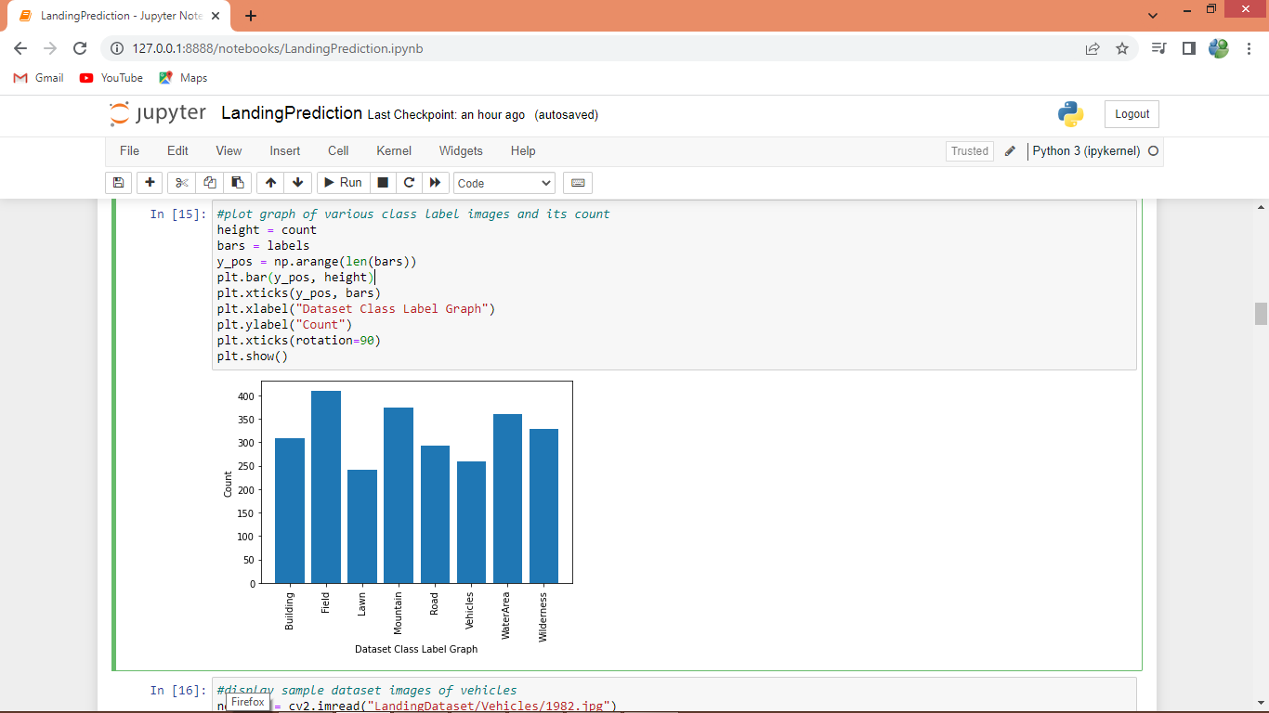

In above graph x-axis represents landing scenes names and y-axis represents count of that scene images available in dataset

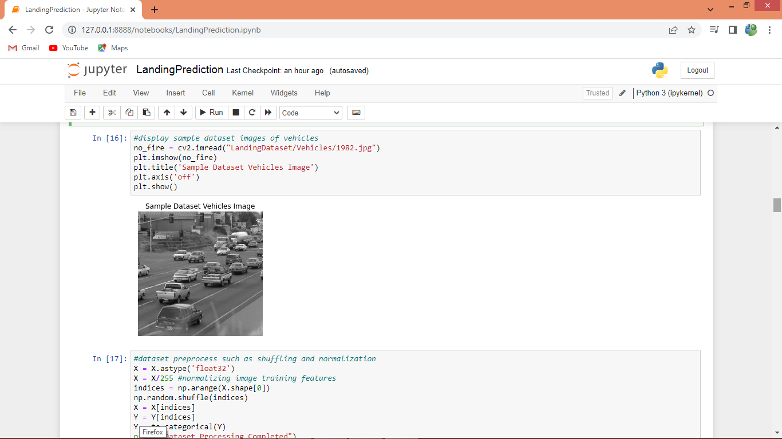

In above screen displaying sample vehicles images from dataset

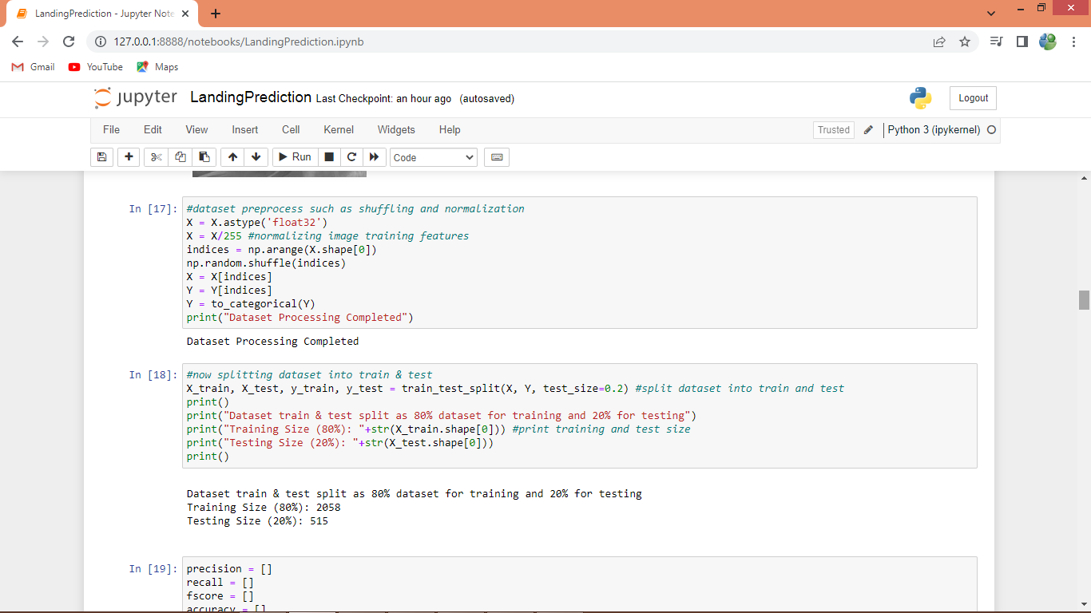

In above screen dataset pre-processing such as normalization, shuffling and splitting dataset into train and test

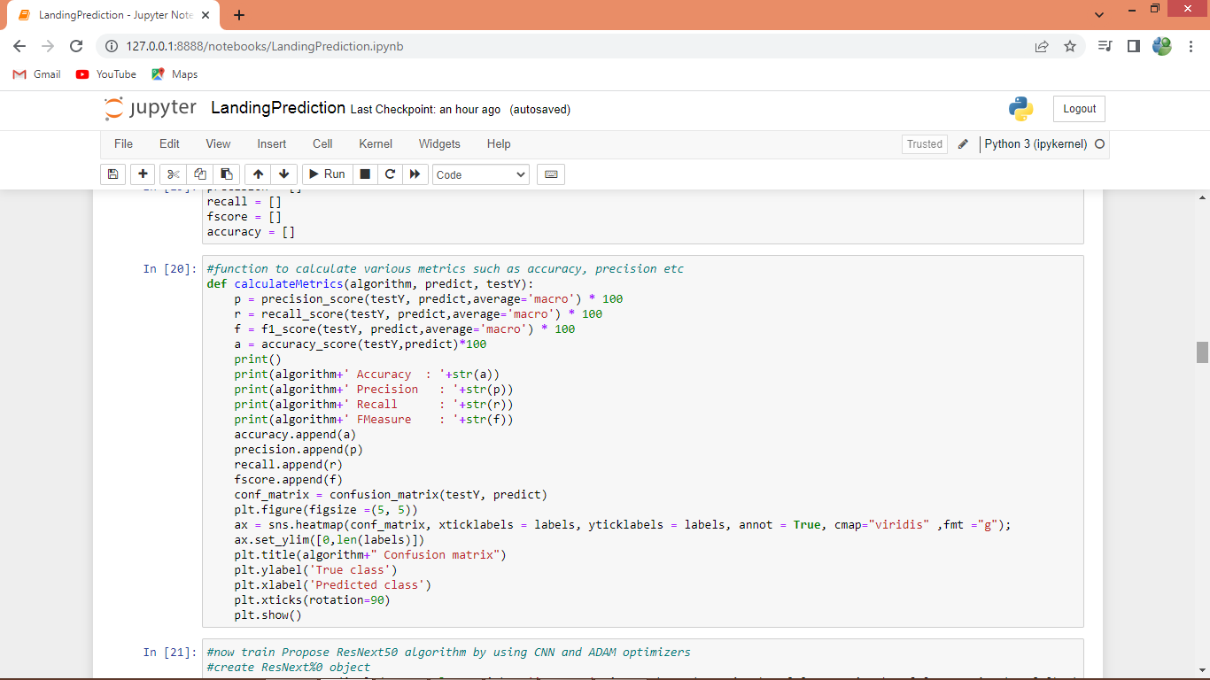

In above screen defining function to calculate accuracy and other metrics

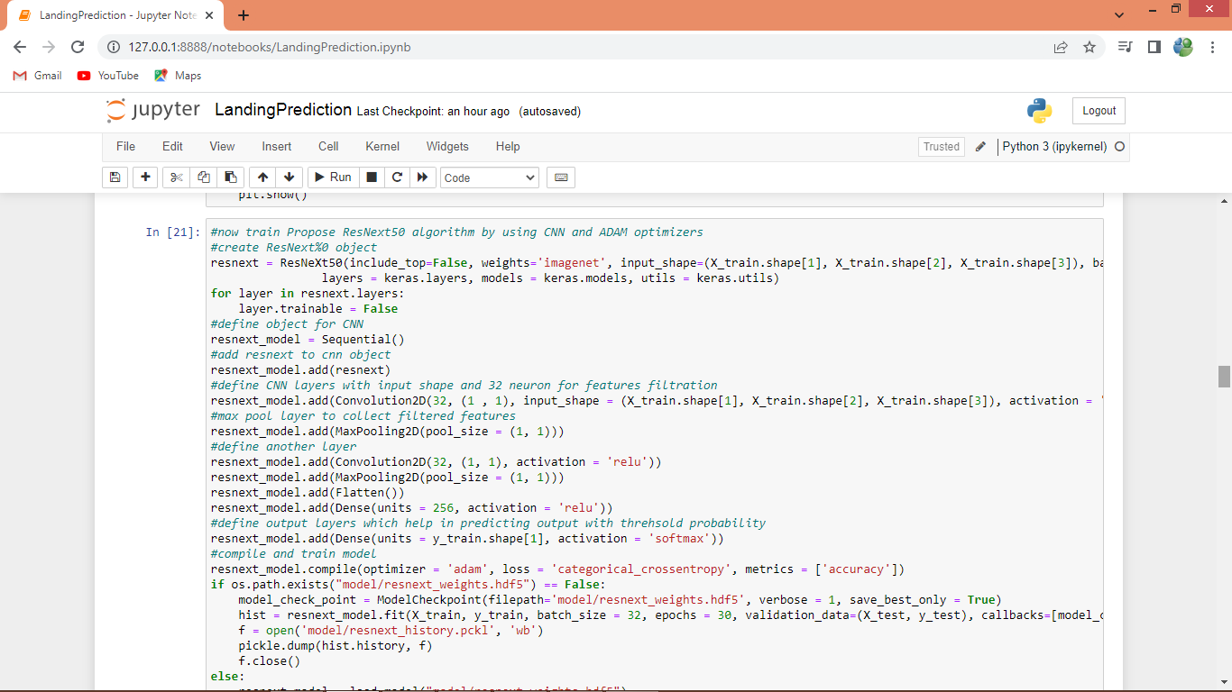

In above screen training ResNext50 algorithm with CNN layer and ADAM optimizer as transfer learning and after executing above block will get below output

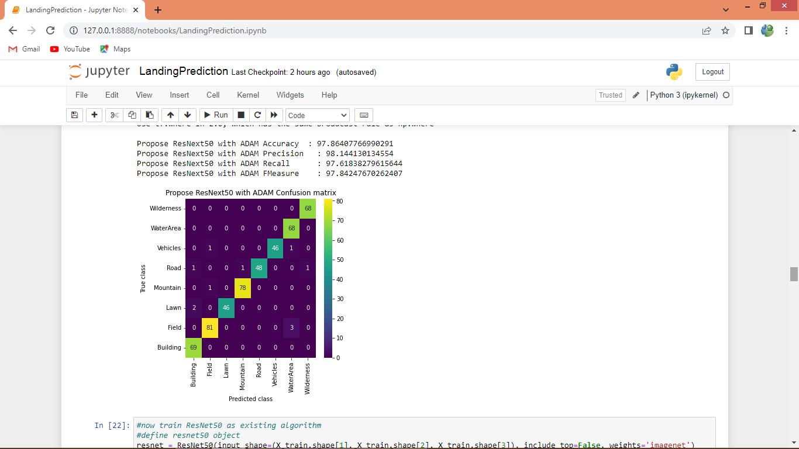

In above screen propose ResNext50 got 97% accuracy and displaying other metrics also and in confusion matrix graph x-axis represents Predicted Labels and y-axis represents True Labels and all different colour boxes in diagnol represents correct prediction count and remaining blue colour boxes represents incorrect prediction count which are very few

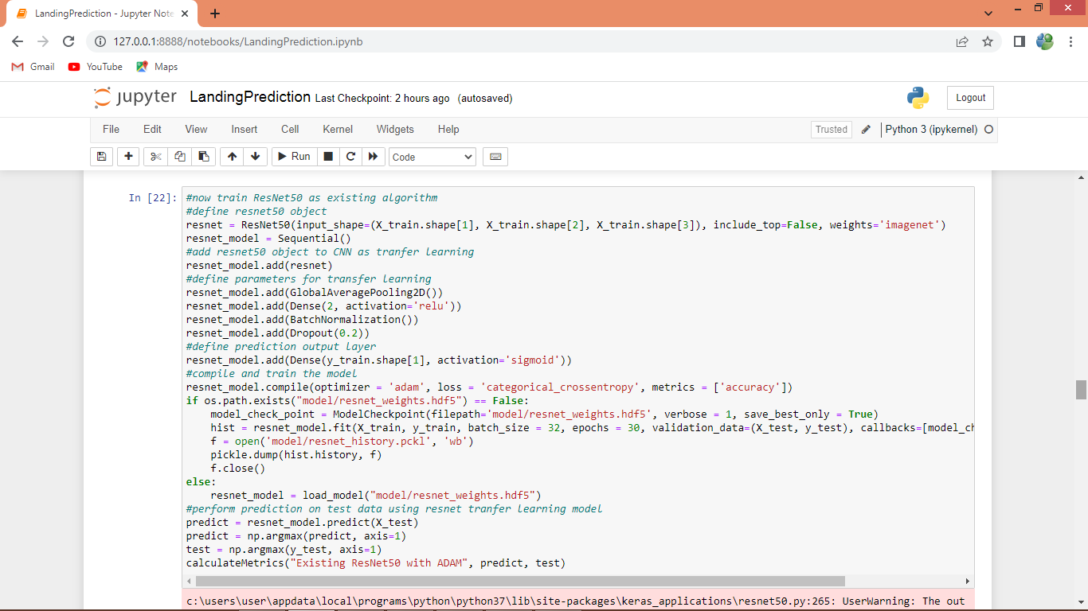

In above screen training existing ResNet50 algorithm and after executing above block will get below output

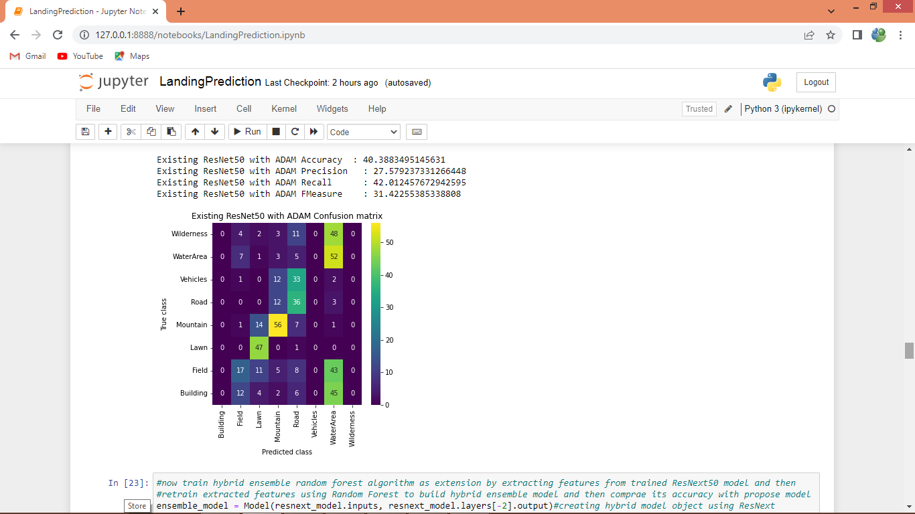

In above screen Resnet50 got 40% accuracy with ADAM optimizer and below is the extension algorithm

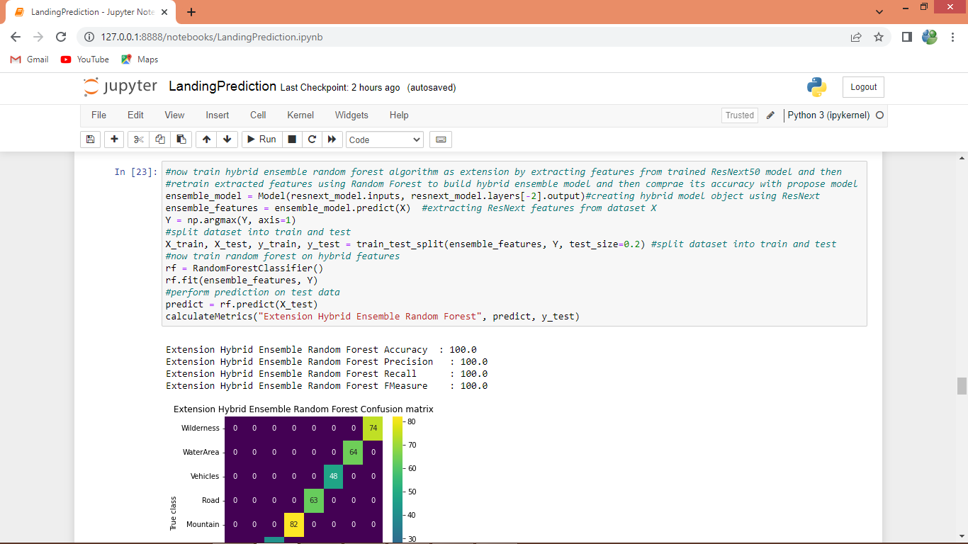

In above screen extension Hybrid Ensemble Random Forest got 100% accuracy which is higher than other algorithms

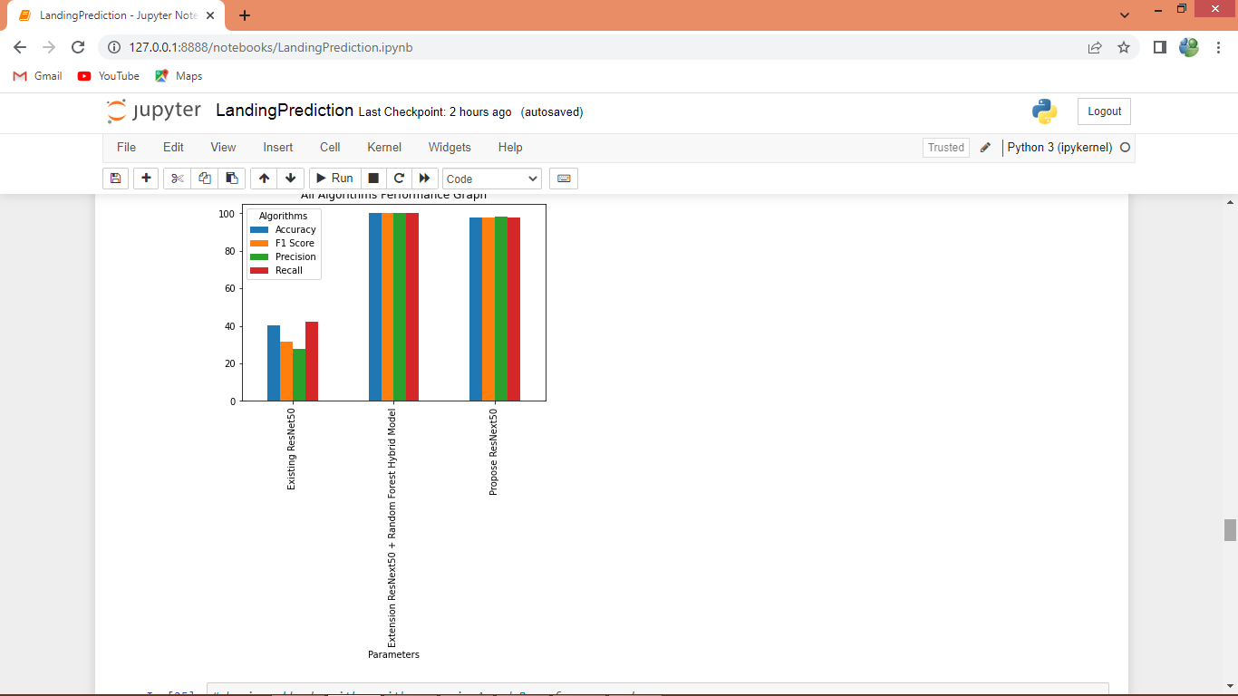

In above comparison graph x-axis represents algorithm names and y-axis represents accuracy and other metrics in different colour bars and in all algorithms extension got high accuracy

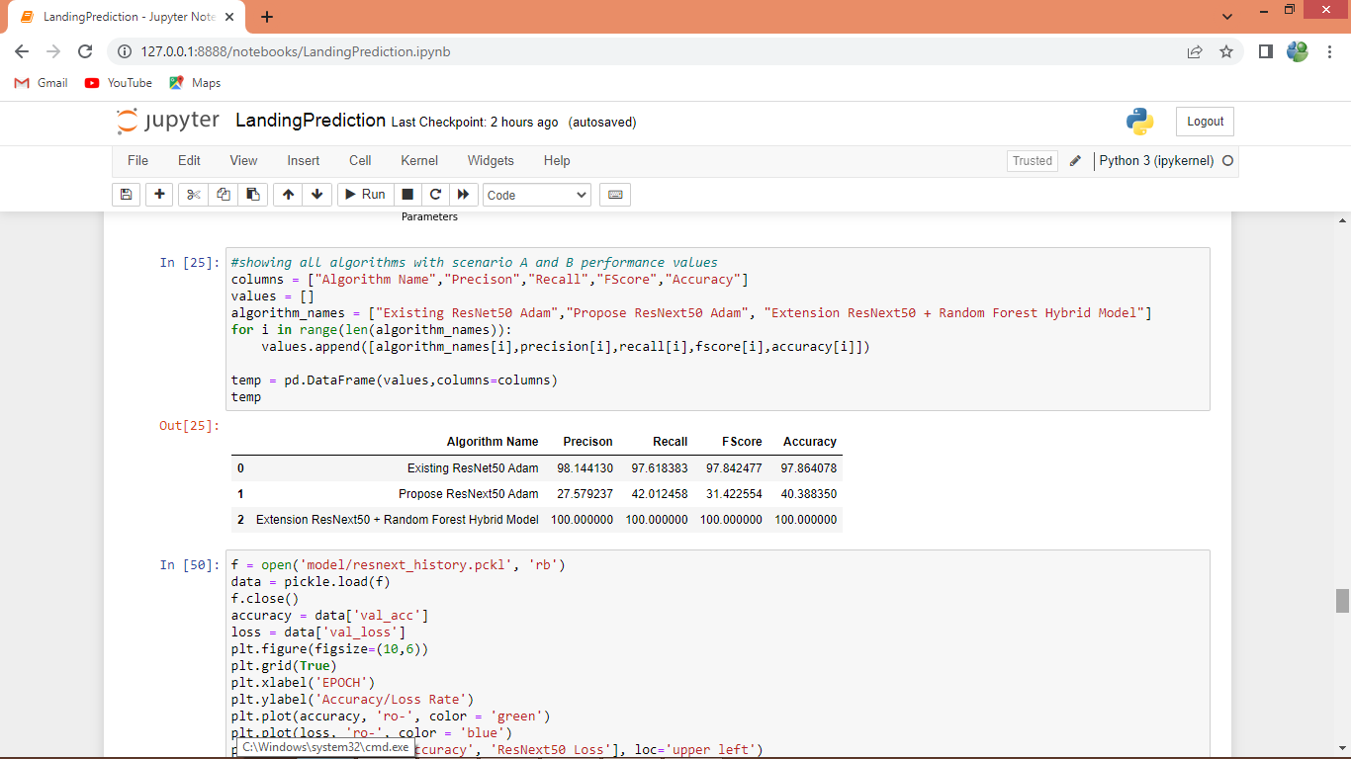

In above screen displaying all algorithm performance in tabular format

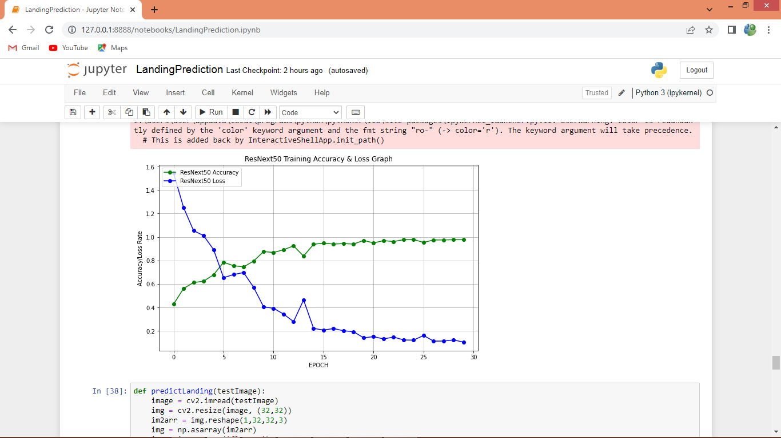

Above is ResNext50 training graph where x-axis represents training epoch and y-axis represents accuracy and loss values where green line represents accuracy and blue line represents loss and with each increasing epoch accuracy got increase and reached closer to 1 and loss got decrease

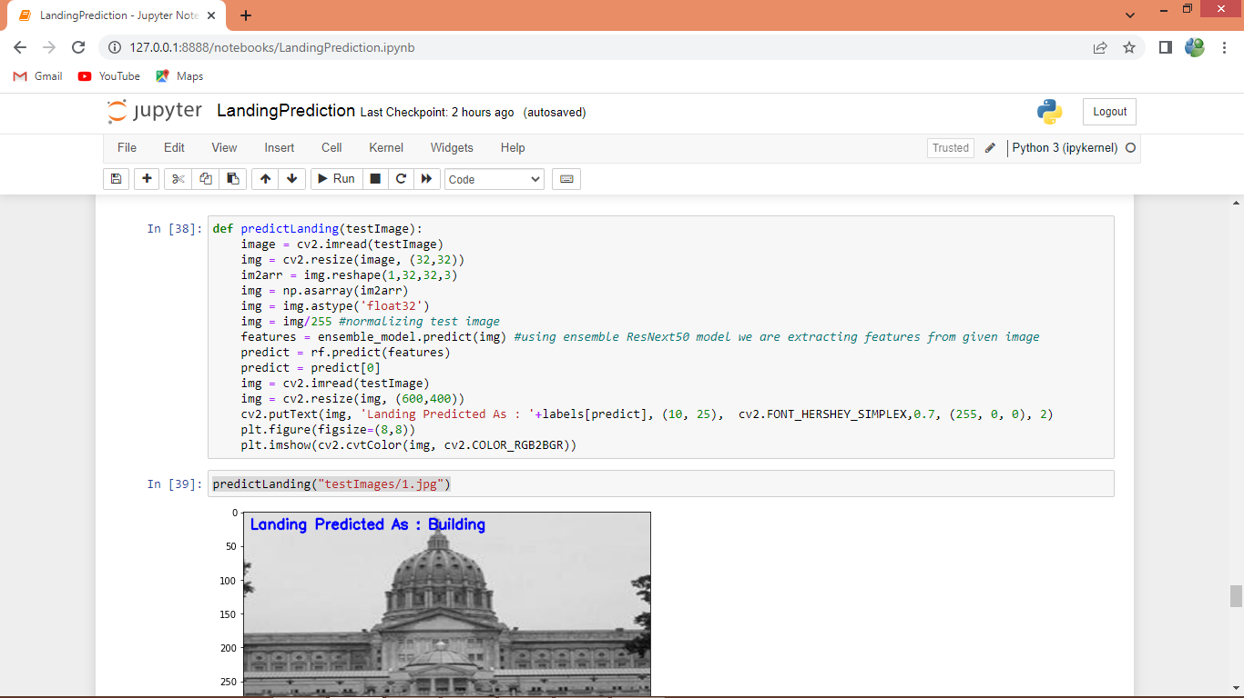

In above graph defining predict function and this function will take input image path and then using extension ensemble object it will classify given image scenes and in above image scene classify as building

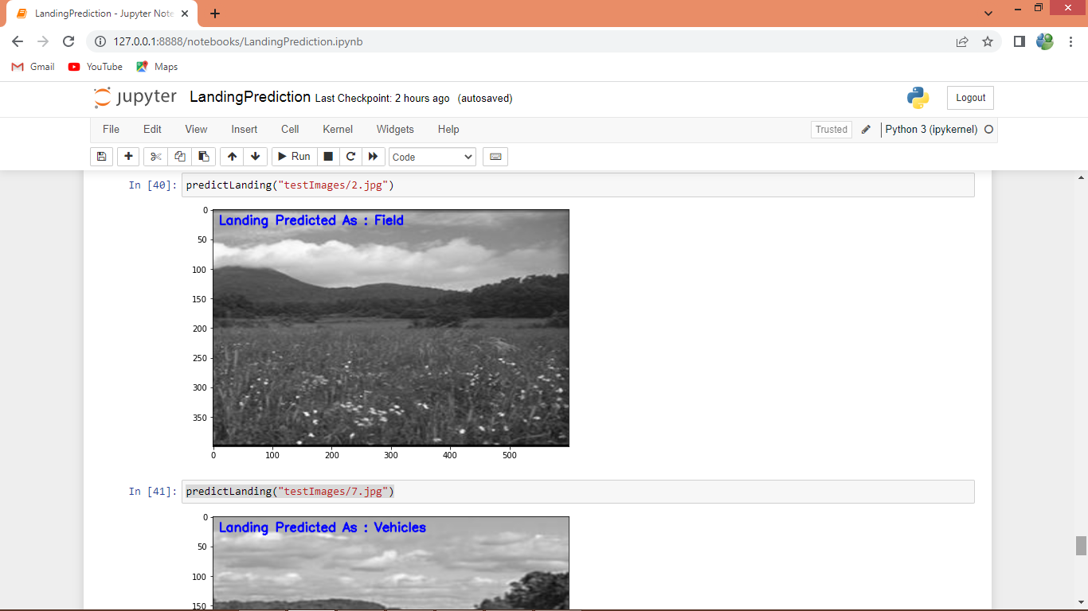

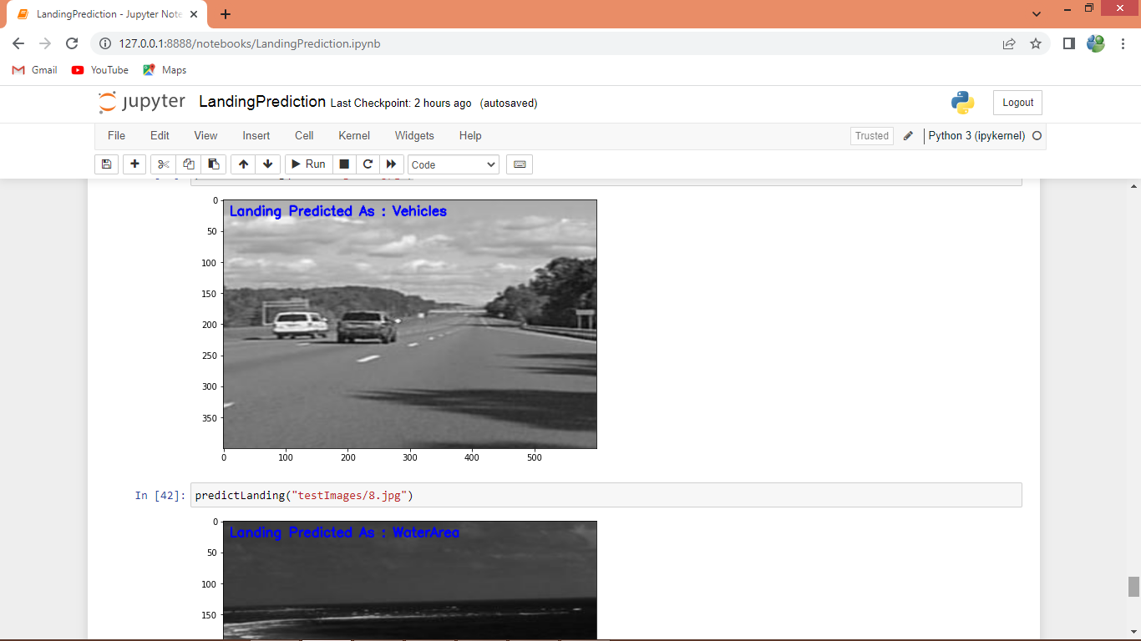

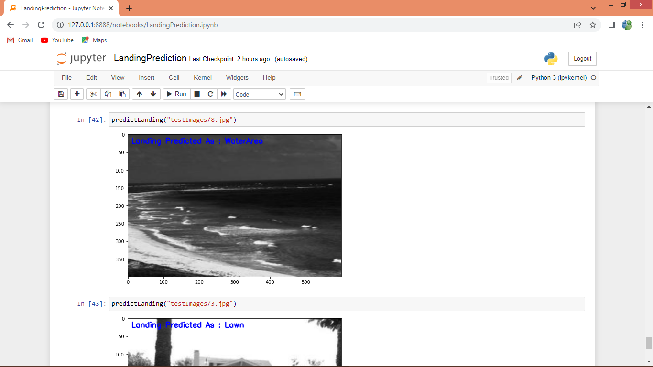

In above image for each scene we got correct classification result