## Assignment 1

**Due Date:** 5/2/2024

**Time:** 23.55

**Please note:**

This is an **individual** assignment

No late submissions are accepted.

**QUESTION #1 STATIC BACKWARD SLICING**

1. Create a static PDG for the program below

| 1. CIN >> B; 2. CIN >> X; 3. A=X+B; 4. WHILE (A<(X+B))  {  1. X=A; 2. IF (A>B)   {   1. B=10+A+B;   }   1. ELSE   {   1. X= A-1;   }   1. X--; 2. A=A-B-X;   }   1. IF B < X)   {   1. X=10;   }   1. COUT <<A; 2. COUT <<B; 3. COUT <<X; |  |
| --- | --- |

1. **Compute a static slice for the following variables.**

**Compute Slice (B,15)= { }**

**Compute Slice S(X,16) = { }**

QUESTION #2

PLEASE USE THE PROGRAM SHOWN ON THE LEFT AND COMPLETE THE PROGRAM DEPENDENCIES IN THE TABLE–

| 1. Y =10 2. IF (Y) 3. Y=Y+1; | | |  | Is **data** dependent on | | | | | --- | --- | --- | --- | --- | | **Node** |  | 1 | 2 | 3 | | 1 |  |  |  | | 2 | X |  |  | | 3 | X |  |  | | |  | Is **control** dependent on | | | | | --- | --- | --- | --- | --- | | **Node** |  | 1 | 2 | 3 | | 1 |  |  |  | | 2 |  |  |  | | 3 |  | X |  | |
| --- | --- | --- | --- | --- | --- | --- | --- | --- | --- | --- | --- | --- | --- | --- | --- | --- | --- | --- | --- | --- | --- | --- | --- | --- | --- | --- | --- | --- | --- | --- | --- | --- | --- | --- | --- | --- | --- | --- | --- | --- | --- | --- | --- | --- | --- | --- | --- |
| 1. CIN >> B; 2. CIN >> X; 3. A=X+B; 4. WHILE (A<(X+B))   {   1. X=B+X; 2. IF (A>(B~~+C~~))   {   1. B=10+A+B;   }   1. ELSE   {   1. X= 10;   }   1. X--; 2. A=A-B-X;   }   1. COUT <<A; 2. COUT <<B; 3. COUT <<X; | |  | | --- | | **Node** |  | 1 | 2 | 3 | 4 | 5 | 6 | 7 | 8 | 9 | 10 | 11 | 12 | 13 | 14 | | 1 |  |  |  |  |  |  |  |  |  |  |  |  |  |  | | 2 |  |  |  |  |  |  |  |  |  |  |  |  |  |  | | 3 |  |  |  |  |  |  |  |  |  |  |  |  |  |  | | 4 |  |  |  |  |  |  |  |  |  |  |  |  |  |  | | 5 |  |  |  |  |  |  |  |  |  |  |  |  |  |  | | 6 |  |  |  |  |  |  |  |  |  |  |  |  |  |  | | 7 |  |  |  |  |  |  |  |  |  |  |  |  |  |  | | 8 |  |  |  |  |  |  |  |  |  |  |  |  |  |  | | 9 |  |  |  |  |  |  |  |  |  |  |  |  |  |  | | 10 |  |  |  |  |  |  |  |  |  |  |  |  |  |  | | 11 |  |  |  |  |  |  |  |  |  |  |  |  |  |  | | 12 |  |  |  |  |  |  |  |  |  |  |  |  |  |  | | 13 |  |  |  |  |  |  |  |  |  |  |  |  |  |  | | 14 |  |  |  |  |  |  |  |  |  |  |  |  |  |  |   **Data Dependencies**  **Control Dependencies**   |  | | --- | |  |  | 1 | 2 | 3 | 4 | 5 | 6 | 7 | 8 | 9 | 10 | 11 | 12 | 13 | 14 | | **Node** | 1 |  |  |  |  |  |  |  |  |  |  |  |  |  |  | | 2 |  |  |  |  |  |  |  |  |  |  |  |  |  |  | | 3 |  |  |  |  |  |  |  |  |  |  |  |  |  |  | | 4 |  |  |  |  |  |  |  |  |  |  |  |  |  |  | | 5 |  |  |  |  |  |  |  |  |  |  |  |  |  |  | | 6 |  |  |  |  |  |  |  |  |  |  |  |  |  |  | | 7 |  |  |  |  |  |  |  |  |  |  |  |  |  |  | | 8 |  |  |  |  |  |  |  |  |  |  |  |  |  |  | | 9 |  |  |  |  |  |  |  |  |  |  |  |  |  |  | | 10 |  |  |  |  |  |  |  |  |  |  |  |  |  |  | | 11 |  |  |  |  |  |  |  |  |  |  |  |  |  |  | | 12 |  |  |  |  |  |  |  |  |  |  |  |  |  |  | | 13 |  |  |  |  |  |  |  |  |  |  |  |  |  |  | | 14 |  |  |  |  |  |  |  |  |  |  |  |  |  |  | | | | |

**Question #3**

Given is the following program and PDG – identify all the problems in this PDG (wrong/missing dependencies)

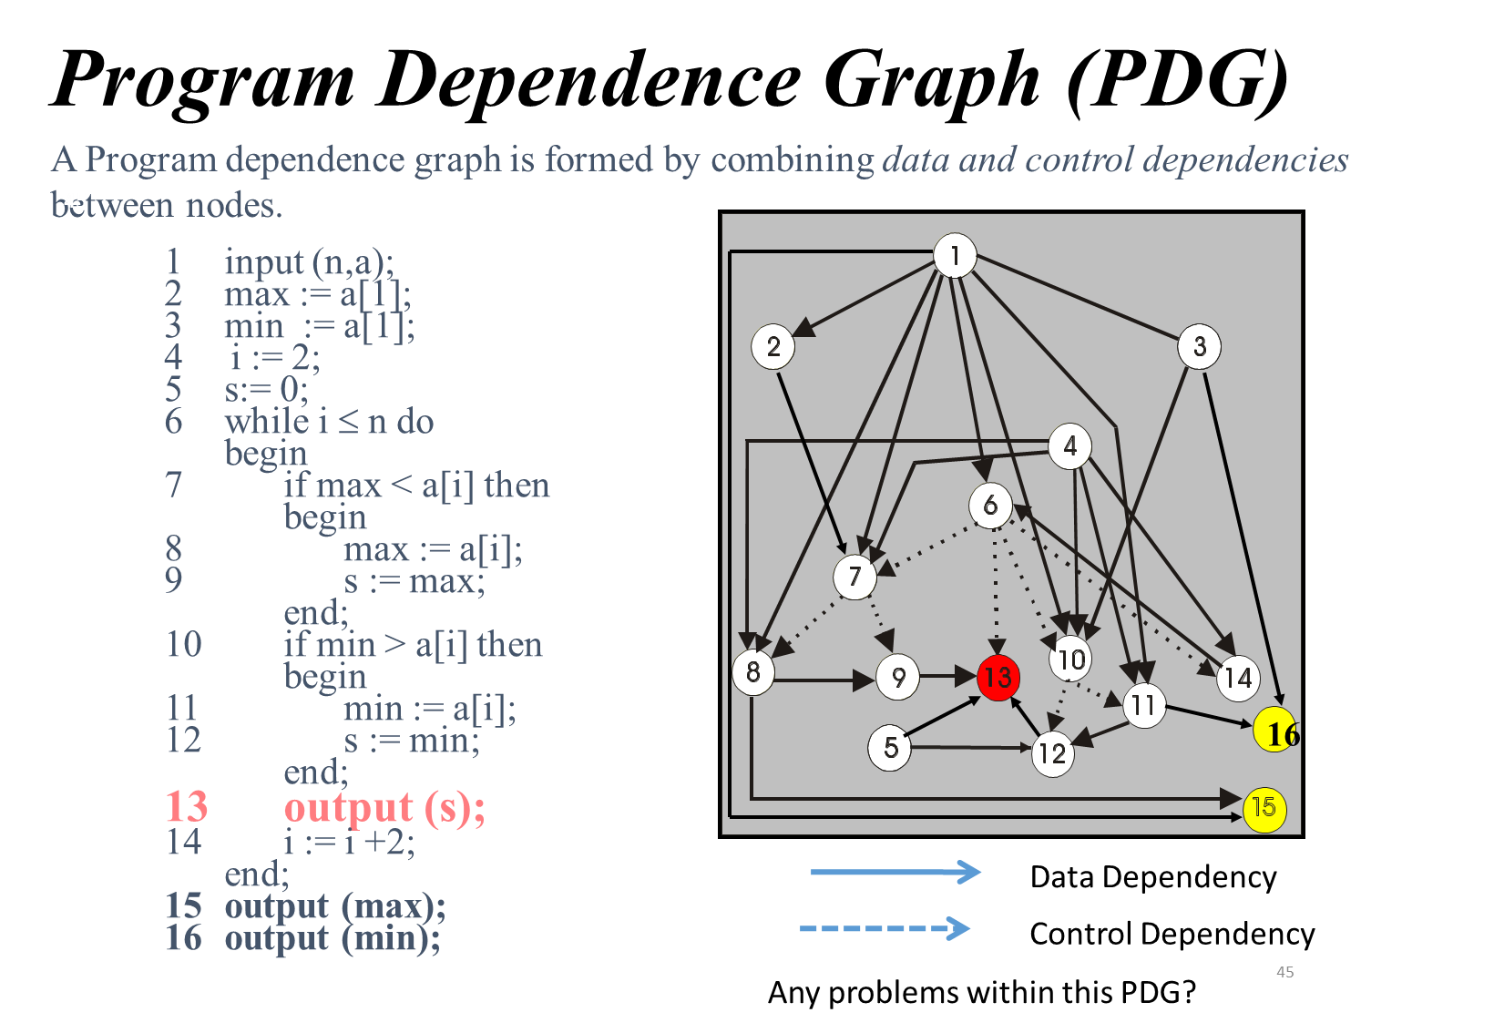

| **Data dependencies:** | **Missing:**  **Should be removed:** |
| --- | --- |
| **Control dependencies:** | **Missing:**  **Should be removed:** |

**Question #4**

In a recent department meeting your new boss made the following statement. I just read a research paper which discussed software aging and I am not sure if the claims in the paper are correct. In their paper the authors state that the cause for software aging is: (1.) ignorant surgery – that is modifications being performed to a software product by people who are not necessarily skilled/trained enough to perform such software changes; as well as by (2.) too much movement, that is, software is changed to remove technical debt.

Your boss is asking if you agree/disagree with the two claims made in the paper. Clearly state if you agree/disagree with each claim (1.) and (2.) and briefly justify your decisions (max. 50 words)

**Question #5**

You were reading in an article the following statement: The major objective of perfective maintenance is to reduce technical debt in a software system.

Is the above statement, correct? Clearly indicate if you agree/disagree. Briefly justify your answer (1-2 sentences)

**Question #6**

You were recently hired by a large organization and at the first department meeting your new boss mentions that he believes: “1.) that full software traceability only requires to maintain uni-directional links and that 2.) establishing software traceability in an organization will require additional resources and overhead since links between artifacts must be created and maintained. 3.) He further believes that MSR can be used to fully replace traditional software traceability.

Do you AGREE / DISAGREE (Circle your answer) with each statement - Briefly justify your answer (Max. 2 sentences)

1. AGREE / DISAGREE

2. AGREE / DISAGREE

3. AGREE / DISAGREE