**Assignment #2**

**Due date: 12/2/2023 at 23.55**

**Question #1**

Given is the following statement, while version control systems have advanced in the last couple of years, fully automated merging remains a challenge and is typically not recommended.

Is the above statement correct – briefly justify your answer (max 50 words)

**Question #2**

You are attending a workshop and one of the presenters makes the following statements. 1.) Dependency management systems such as Maven will help managing build dependencies and the automation of the build process. 2.) Such build management system will also remove technical debt, by eliminating all built errors.

Clearly indicate, if you agree / disagree with the above statement. Briefly justify your answer (1-2 sentences).

**Question #3**

Given is the following program and PDG

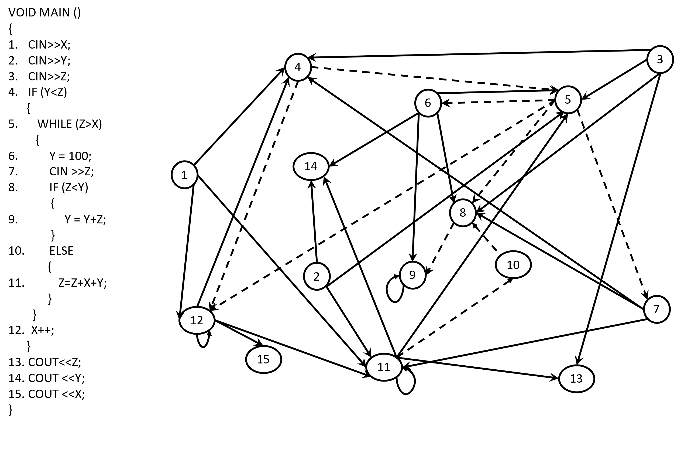

Verify the above static PDG for correctness use the tables on the next page to mark the incorrect/missing dependencies.

1. Step – verify that the PDG correct – you can either correct the PDG or draw a new one.
2. Verify that the table (on the next page) matches the corrected PDG

PLEASE COMPLETE THE PDG TABLES BELOW (IT MATCHES THE PDG FROM THE PREVIOUS PAGE)

PLEASE COORECT THE PDG BY ADDING MISSING DEPENDENCIES, REMOVING WRONG DEPENDENCIES IN THE TABLE BELOW

WRONG DEPENDENCIES – FILL THE BOX ; ADDING A MISSING DEPENDENCIES USE A CIRCLE SEE EXAMPLE BELOW

ORIGINAL CORRECTED

| 1. Y =10 2. IF (Y) 3. Y=Y+1; | |  | Is **data** dependent on | | | | | --- | --- | --- | --- | --- | | **Node** |  | 1 | 2 | 3 | | 1 |  |  |  | | 2 | X |  |  | | 3 |  |  | X | | |  | Is **data** dependent on | | | | | --- | --- | --- | --- | --- | | **Node** |  | 1 | 2 | 3 | | 1 |  |  |  | | 2 | X |  |  | | 3 |  |  |  | |
| --- | --- | --- | --- | --- | --- | --- | --- | --- | --- | --- | --- | --- | --- | --- | --- | --- | --- | --- | --- | --- | --- | --- | --- | --- | --- | --- | --- | --- | --- | --- | --- | --- | --- | --- | --- | --- | --- | --- | --- | --- | --- | --- | --- | --- | --- | --- |
|  | |  |  | | --- | --- | | **Node** |  | 1 | 2 | 3 | 4 | 5 | 6 | 7 | 8 | 9 | 10 | 11 | 12 | 13 | 14 | 15 | | 1 |  |  |  |  |  |  |  |  |  |  |  |  |  |  |  | | 2 |  |  |  |  |  |  |  |  |  |  |  |  |  |  |  | | 3 |  |  |  |  |  |  |  |  |  |  |  |  |  |  |  | | 4 | x |  | x |  |  |  | x |  |  |  |  | x |  |  |  | | 5 |  | x | x |  |  | x |  |  |  |  | x |  |  |  |  | | 6 |  |  |  |  |  |  |  |  |  |  |  |  |  |  |  | | 7 |  |  |  |  |  |  |  |  |  |  |  |  |  |  |  | | 8 |  |  | x |  |  | x | x |  |  |  |  |  |  |  |  | | 9 |  |  |  |  |  | x |  |  | x |  |  |  |  |  |  | | 10 |  |  |  |  |  |  |  |  |  |  |  |  |  |  |  | | 11 | x | x |  |  |  |  | x |  |  |  | x | x |  |  |  | | 12 | x |  |  |  |  |  |  |  |  |  |  | x |  |  |  | | 13 |  |  | x |  |  |  |  |  |  |  | x |  |  |  |  | | 14 |  | x |  |  |  | x |  |  |  |  | x |  |  |  |  | | 15 |  |  |  |  |  |  |  |  |  |  |  | x |  |  |  |   **Data Dependencies**  **Control Dependencies**   |  |  | | --- | --- | |  |  | 1 | 2 | 3 | 4 | 5 | 6 | 7 | 8 | 9 | 10 | 11 | 12 | 13 | 14 | 15 | | **Node** | 1 |  |  |  |  |  |  |  |  |  |  |  |  |  |  |  | | 2 |  |  |  |  |  |  |  |  |  |  |  |  |  |  |  | | 3 |  |  |  |  |  |  |  |  |  |  |  |  |  |  |  | | 4 |  |  |  |  |  |  |  |  |  |  |  |  |  |  |  | | 5 |  |  |  | x |  |  |  |  |  |  |  |  |  |  |  | | 6 |  |  |  |  | x |  |  |  |  |  |  |  |  |  |  | | 7 |  |  |  |  | x |  |  |  |  |  |  |  |  |  |  | | 8 |  |  |  |  | x |  |  |  |  | x |  |  |  |  |  | | 9 |  |  |  |  |  |  |  | x |  |  |  |  |  |  |  | | 10 |  |  |  |  |  |  |  |  |  |  | x |  |  |  |  | | 11 |  |  |  |  |  |  |  |  |  |  |  |  |  |  |  | | 12 |  |  |  | x | x |  |  |  |  |  |  |  |  |  |  | | 13 |  |  |  |  |  |  |  |  |  |  |  |  |  |  |  | | 14 |  |  |  |  |  |  |  |  |  |  |  |  |  |  |  | | 15 |  |  |  |  |  |  |  |  |  |  |  |  |  |  |  | |

**Question #4**

Given is the following PDG

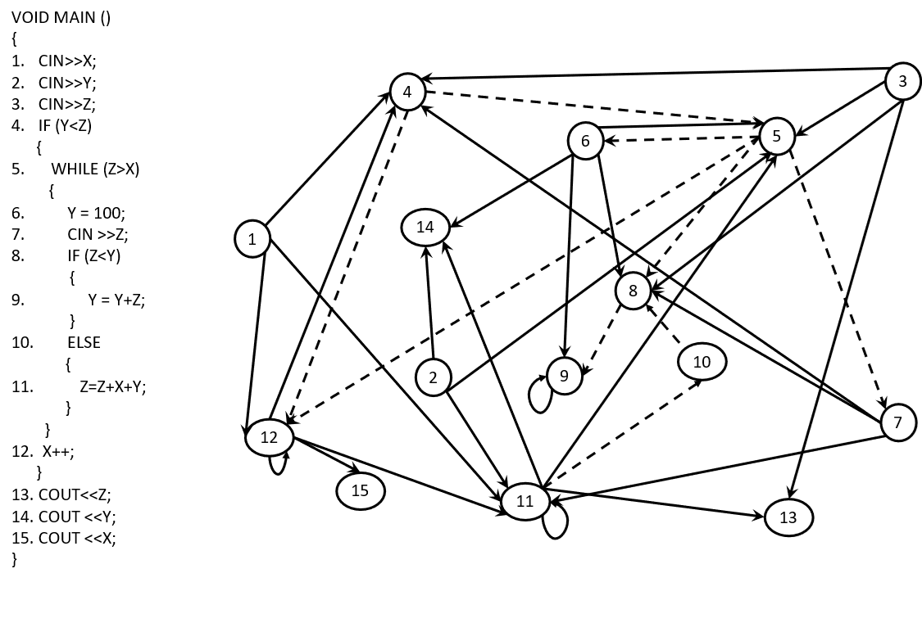

1. **Compute a static Backward slice for Node 7**

**Slice = { }**

1. **Compute a static Forward slice for Node 7**

**Slice = { }**