**CLOUD COMPUTING**

**LAB 1 - Introduction to Serverless Computing with AWS Lambda**

*Name: Sharat Subray Hegde*

*SRN : PES1UG19CS451*

*Section: G*

***a****. 1a.png: Showing two S3 buckets created - one having the original image and another ‘target’ bucket to hold the resized image. The names of the buckets should be: <Your SRN> and <Your SRN-resized> respectively.*

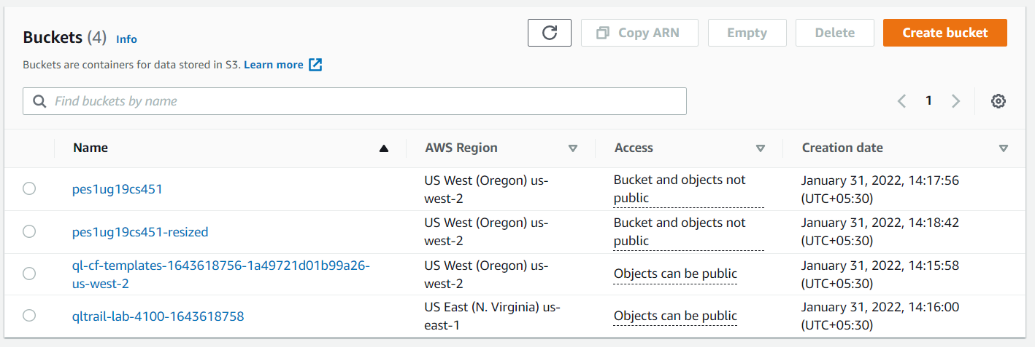

**b**. 1b.png: Showing the Test run successfully (Include Details).

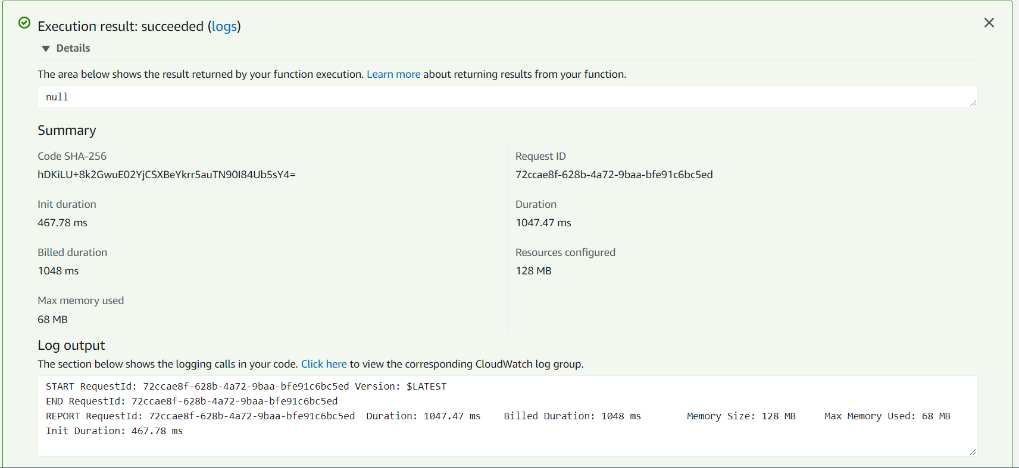

**c**. 1c.png: Showing the thumbnail created in the resized image bucket.

