**CLOUD COMPUTING**

**Assignment 1 - Introduction to REST APIs with AWS Lambda**

**and API Gateway**

*Name: Sharat Subray Hegde*

*SRN : PES1UG19CS451*

*Section: G*

1. *PES1UG19CSXXX_1a.png: Showing the lambda created with your SRN*

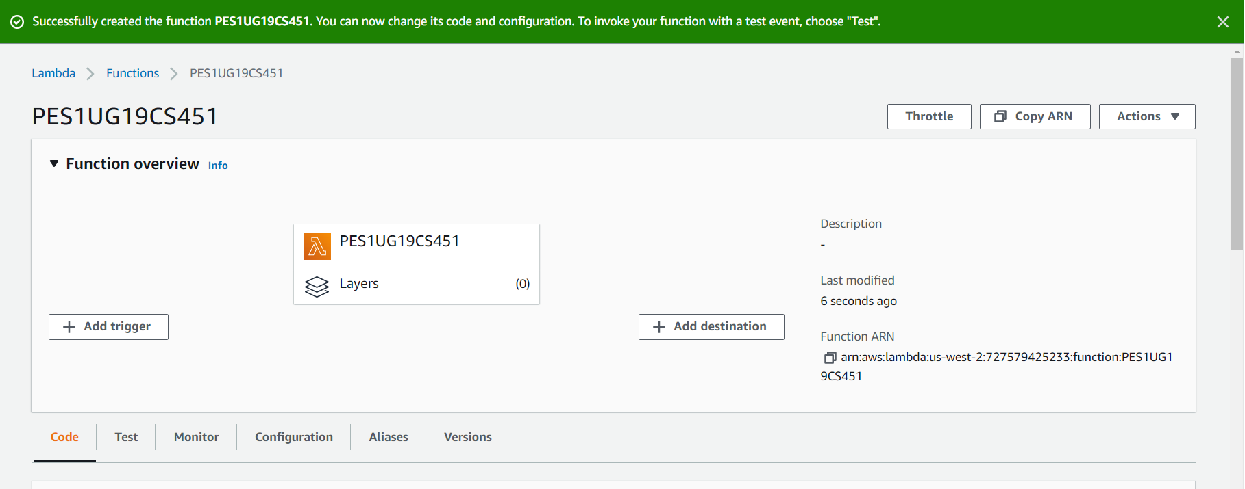

**b**. 1b.png: Showing the API Gateway created, and your unique URL in the configuration tab of the Lambda Function

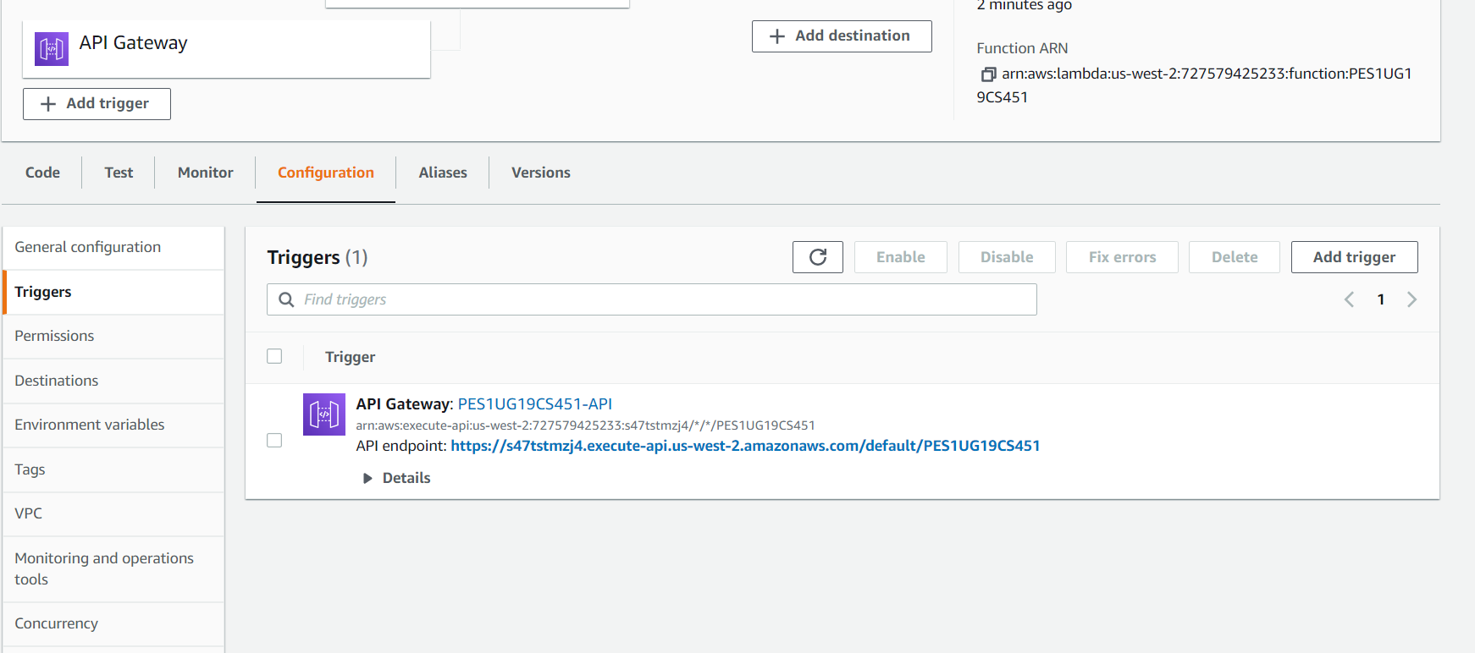

**c**. 1c.png: A screenshot of the code that lets the Lambda function perform as per the requirements listed above.

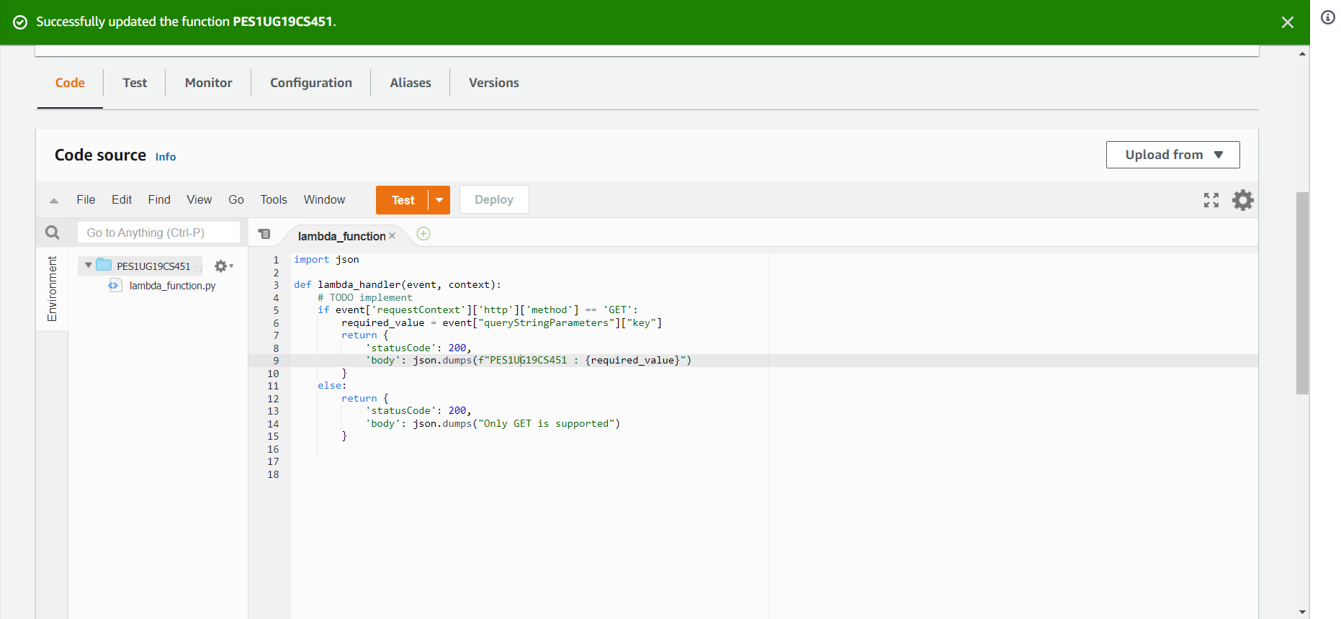

***d****. 1d.png: A screenshot of the dashboard after submission showing all test cases have passed.*

