**CLOUD COMPUTING**

**Experiment 2 - Docker on Linux/Windows/Play-with-Docker**

*Name: Sharat Subray Hegde*

*SRN : PES1UG19CS451*

*Section: G*

**1a.jpg:** Screenshot of running docker hello-world.

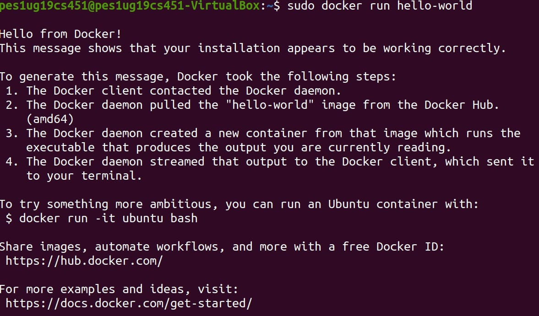

**2a.jpg:** Screenshot of C Program successfully run inside the container.



**2b.jpg:** Screenshot of the image pushed to Dockerhub.

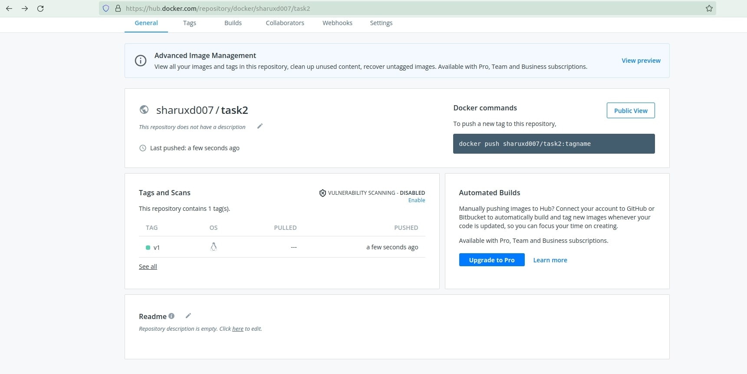

**3a.jpg:** Sample.html showing the web page on the browser.

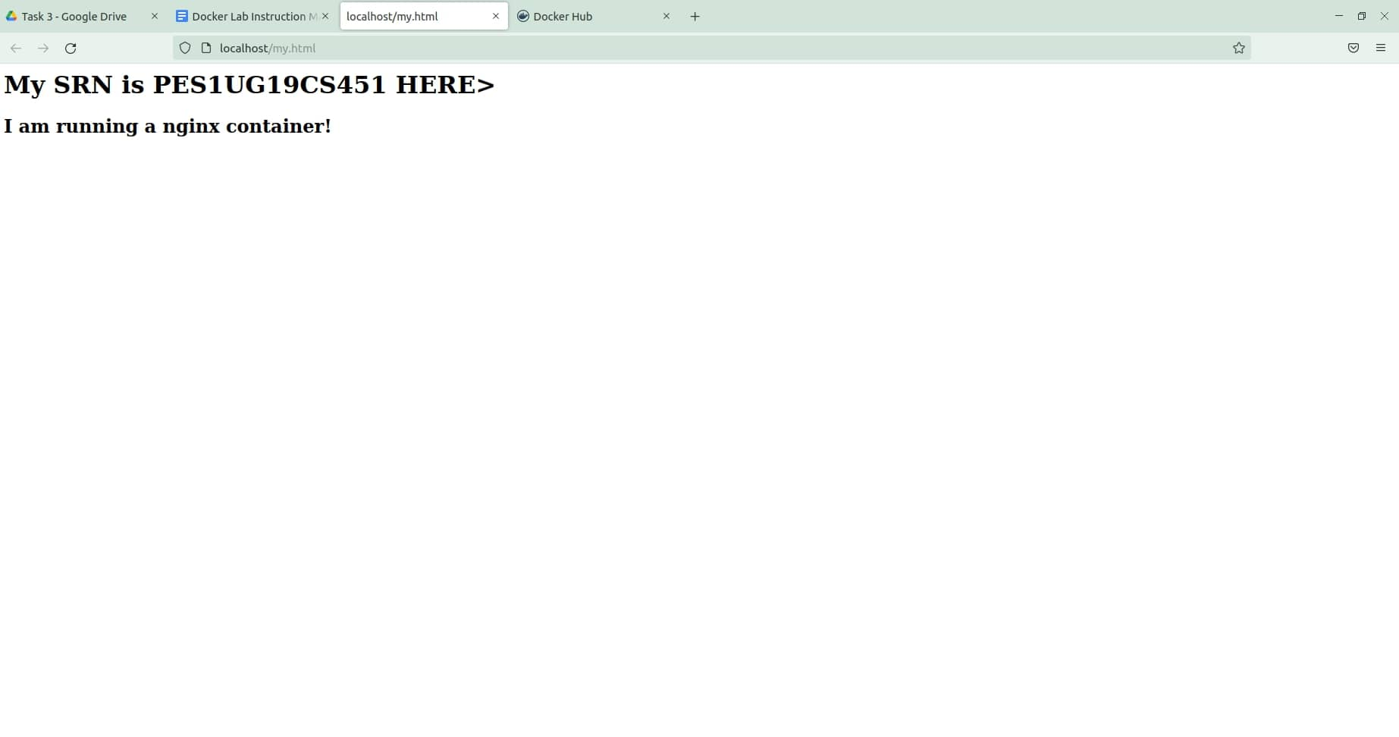

**3b.jpg:** Screenshot of docker container running nginx

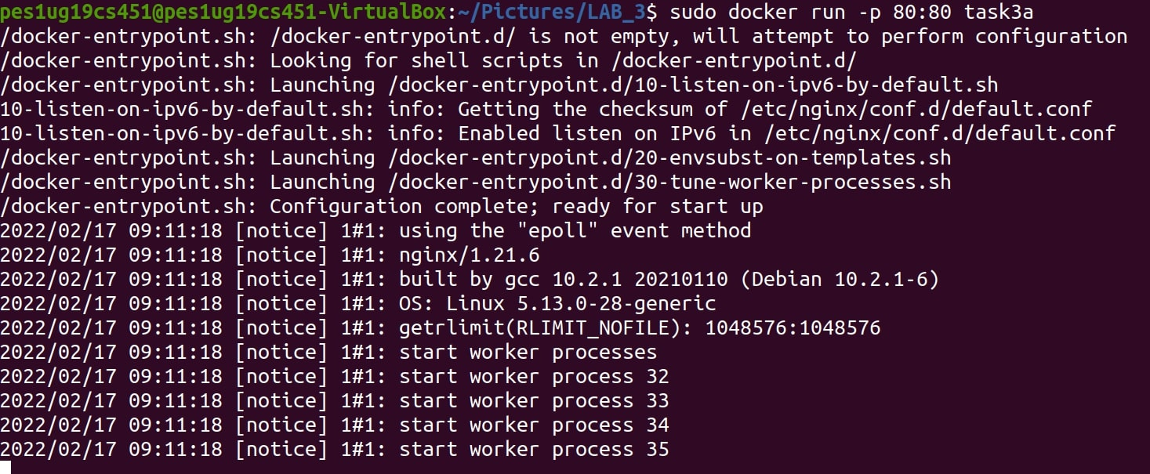

**3c.jpg:** Screenshot of python application successfully writing and reading from the MongoDB database



**3d.jpg:** Screenshot showing mongodb being run within the network(docker command has to be clearly highlighted)



**3e.jpg:** Screenshot showing python file being run within the network and successfully writing and reading from MongoDB(docker command has to be clearly highlighted)



**4a.jpg:** Screenshot of python-mongodb application running as a docker-compose application(logs of the application)

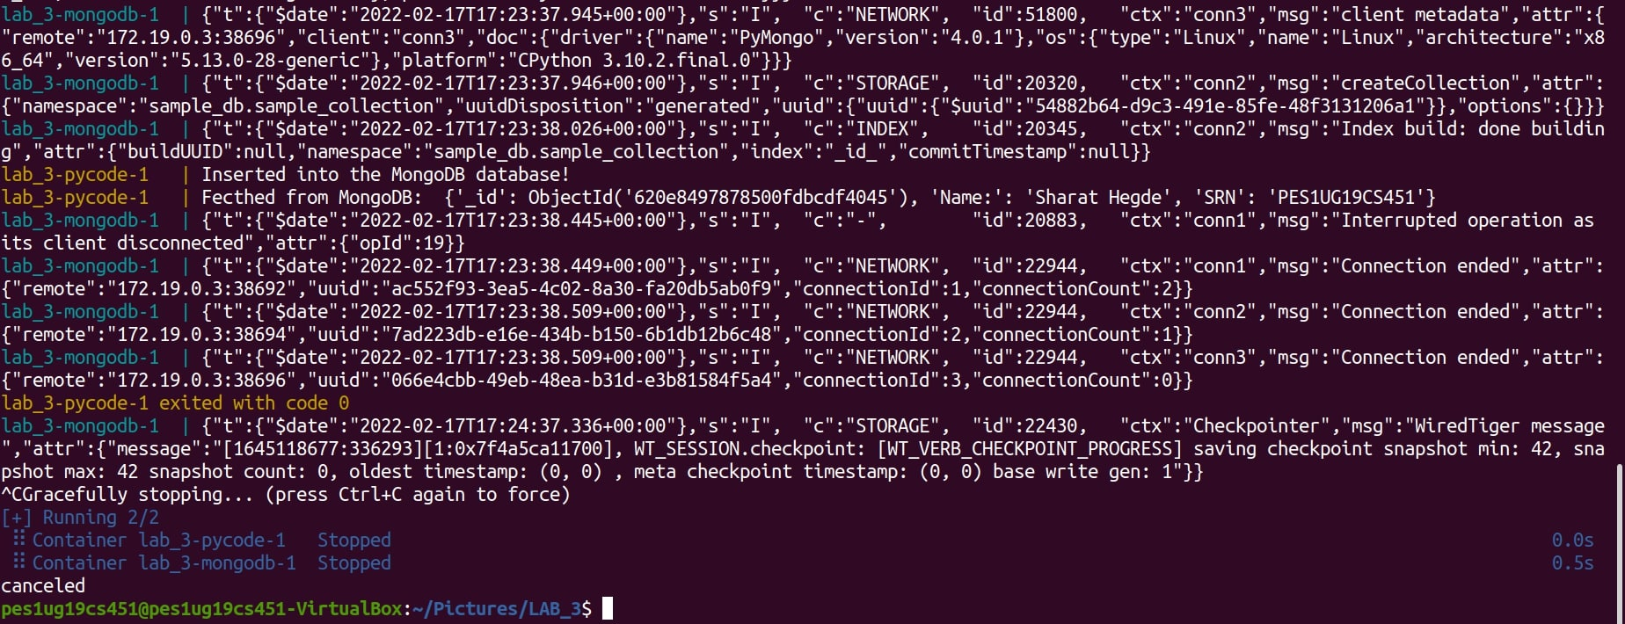

**4b.jpg:** Screenshot of 3 python application writes and reads from MongoDB after scaling the python application.

