**CLOUD COMPUTING**

**Assignment 2 - Kubernetes**

*Name: Sharat Subray Hegde*

*SRN : PES1UG19CS451*

*Section: G*

**2a**.jpg Screenshot of kubectl commands and port forwarding.

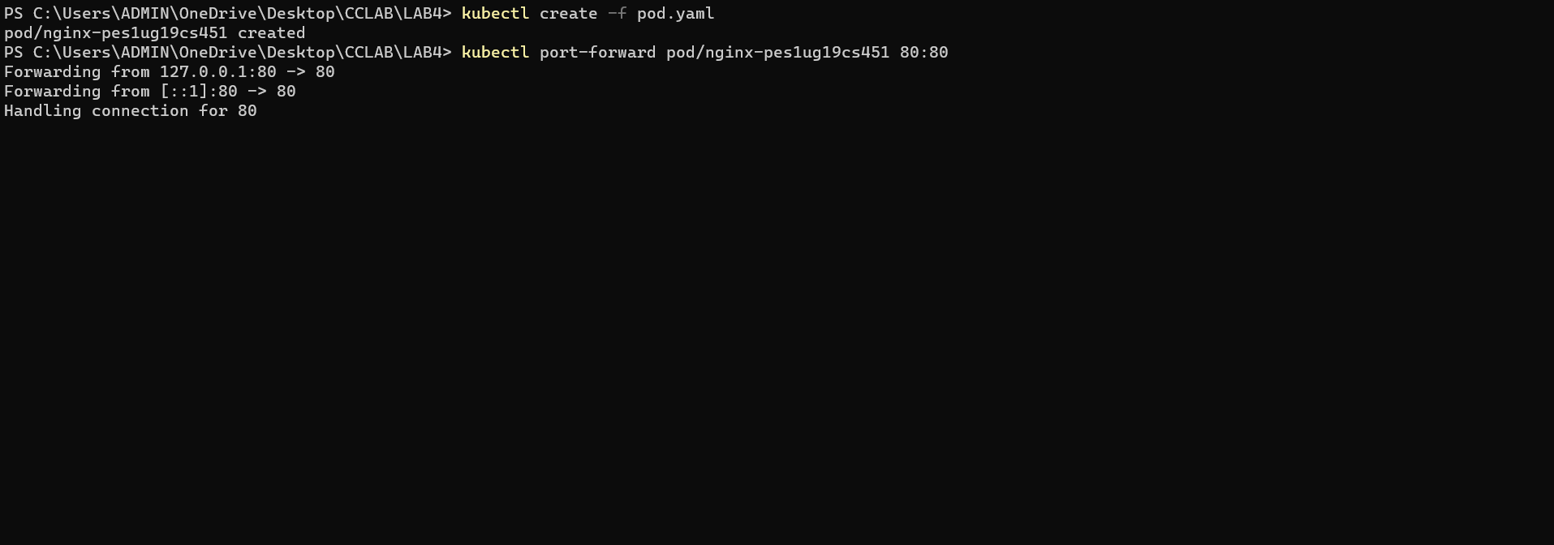

**2b**.jpg Nginx home page access through localhost.

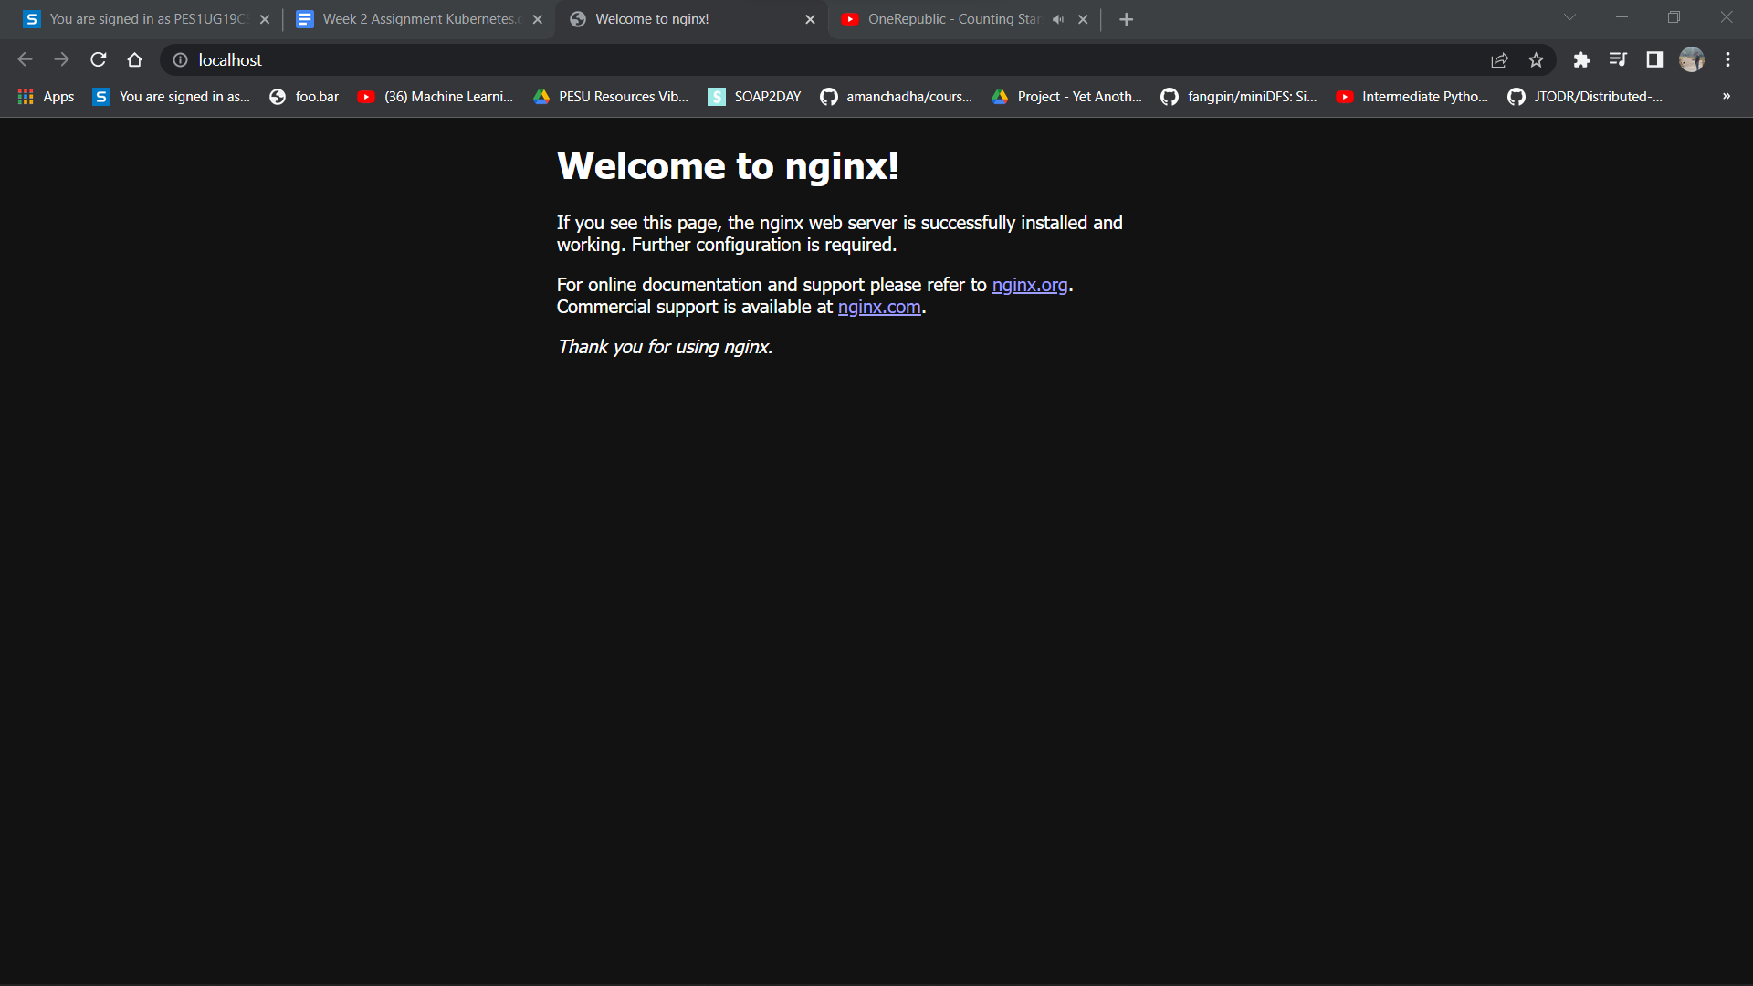

**3a**.jpg Screenshot showing deleted pod and seal healing of pods in a deployment.

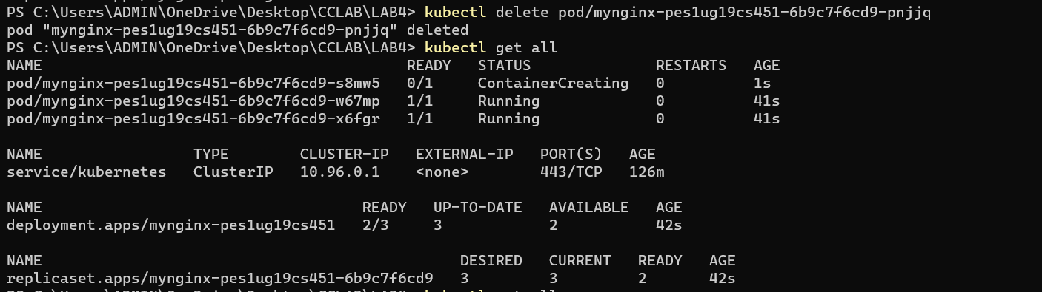

**3b**.jpg Screenshot showing updates and revision history of a deployment.

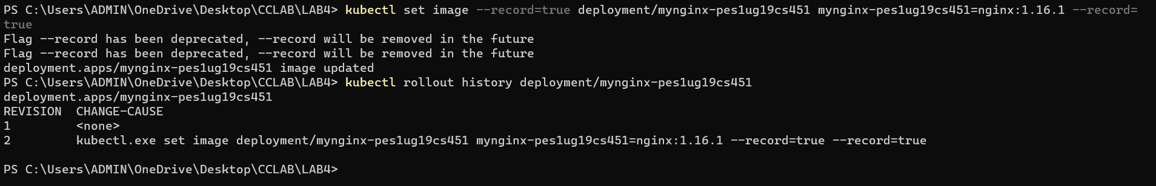

**3c**.jpg Screenshot showing rollback of deployment.

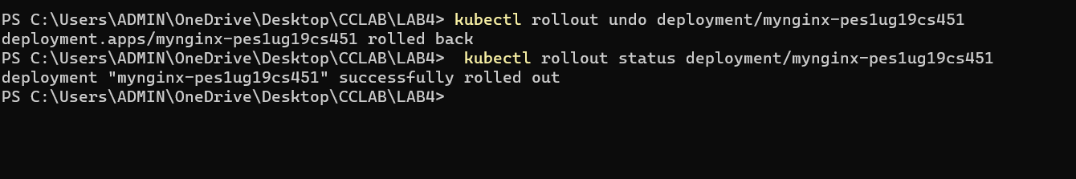

**4a**.jpg Screenshot showing deployment and service creation, port forwarding, Scaling deployment.

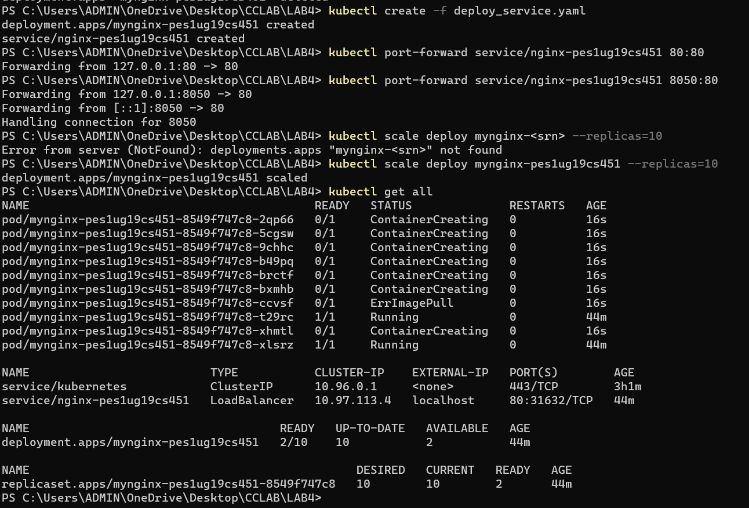

**4b**.jpg Nginx home page access through localhost.

