**CLOUD COMPUTING**

**LAB 3 - Introduction to Amazon Simple Storage Service (S3)**

*Name: Sharat Subray Hegde*

*SRN : PES1UG19CS451*

*Section: G*

**1a.png: Showing S3 bucket created. The name of the buckets should be: <Your SRN> Eg: pes1201900001.**

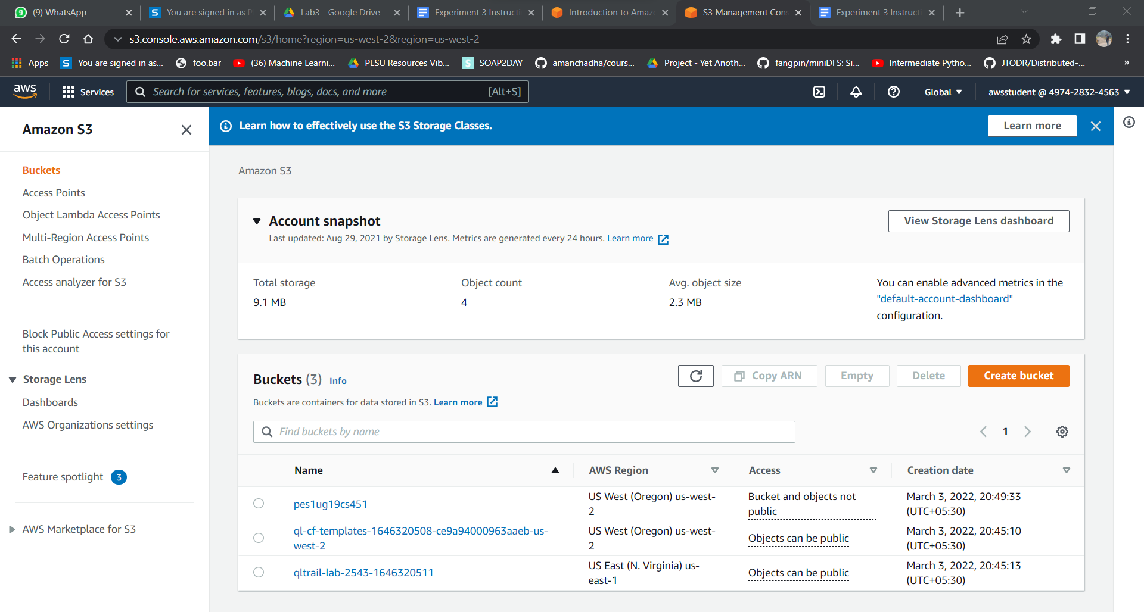

**2a.png: Showing the file upload successfully (Include Details).**

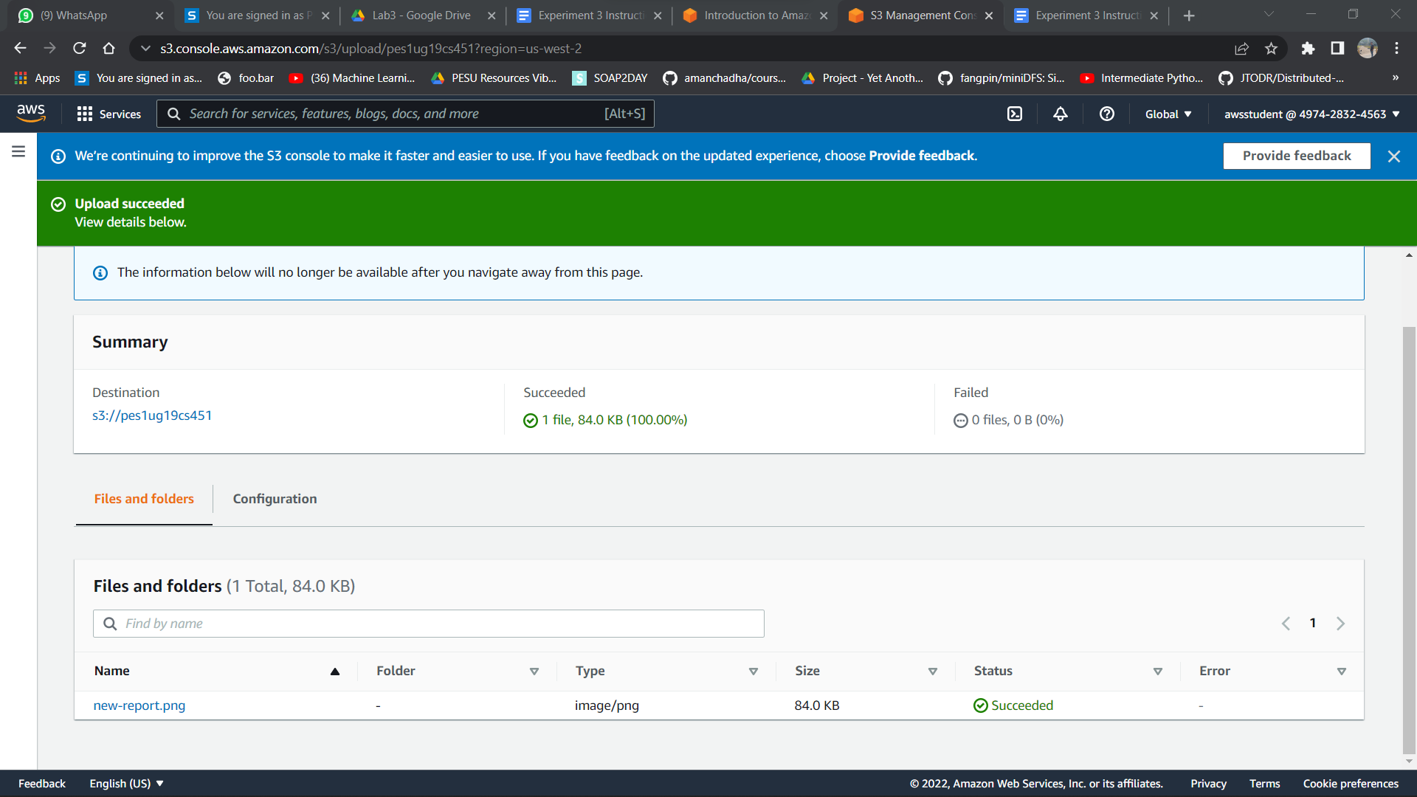

**3a.png: Showing the new-report.png successfully displayed on the browser tab.**

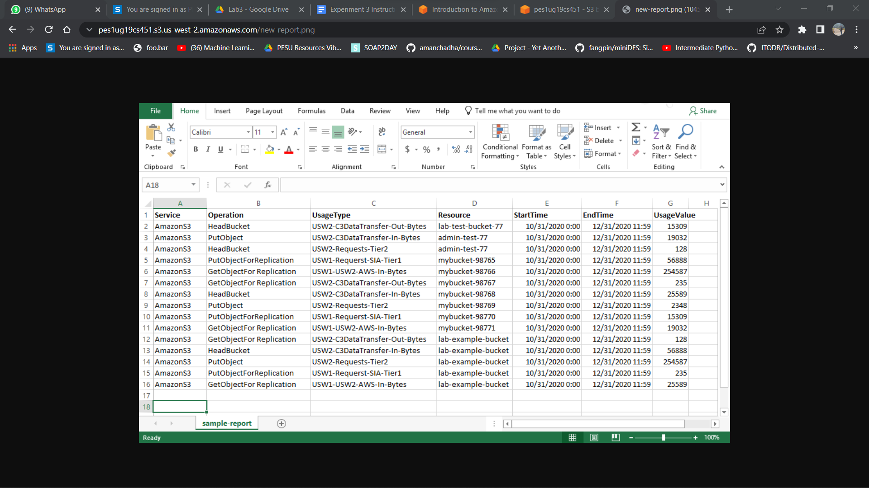

**4a.png: Showing all commands executed on the Bastion host including the upload failed error.**

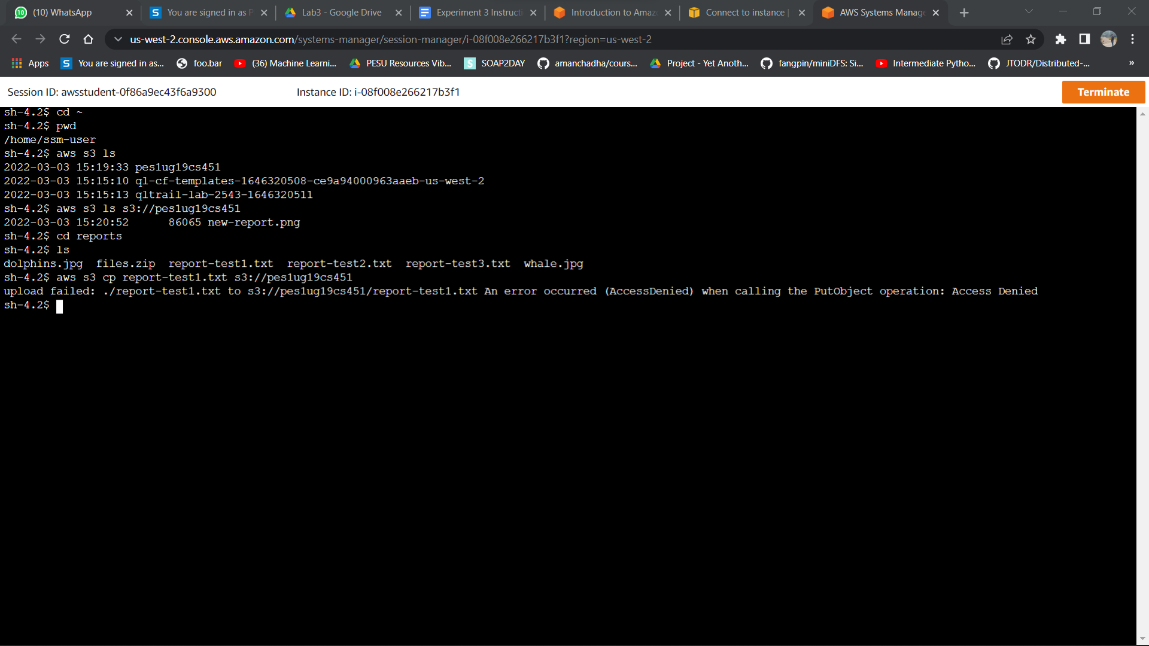

**5a.png: Showing all commands executed on the Bastion host including successful retrieval (GetObject) and upload (PutObject).**

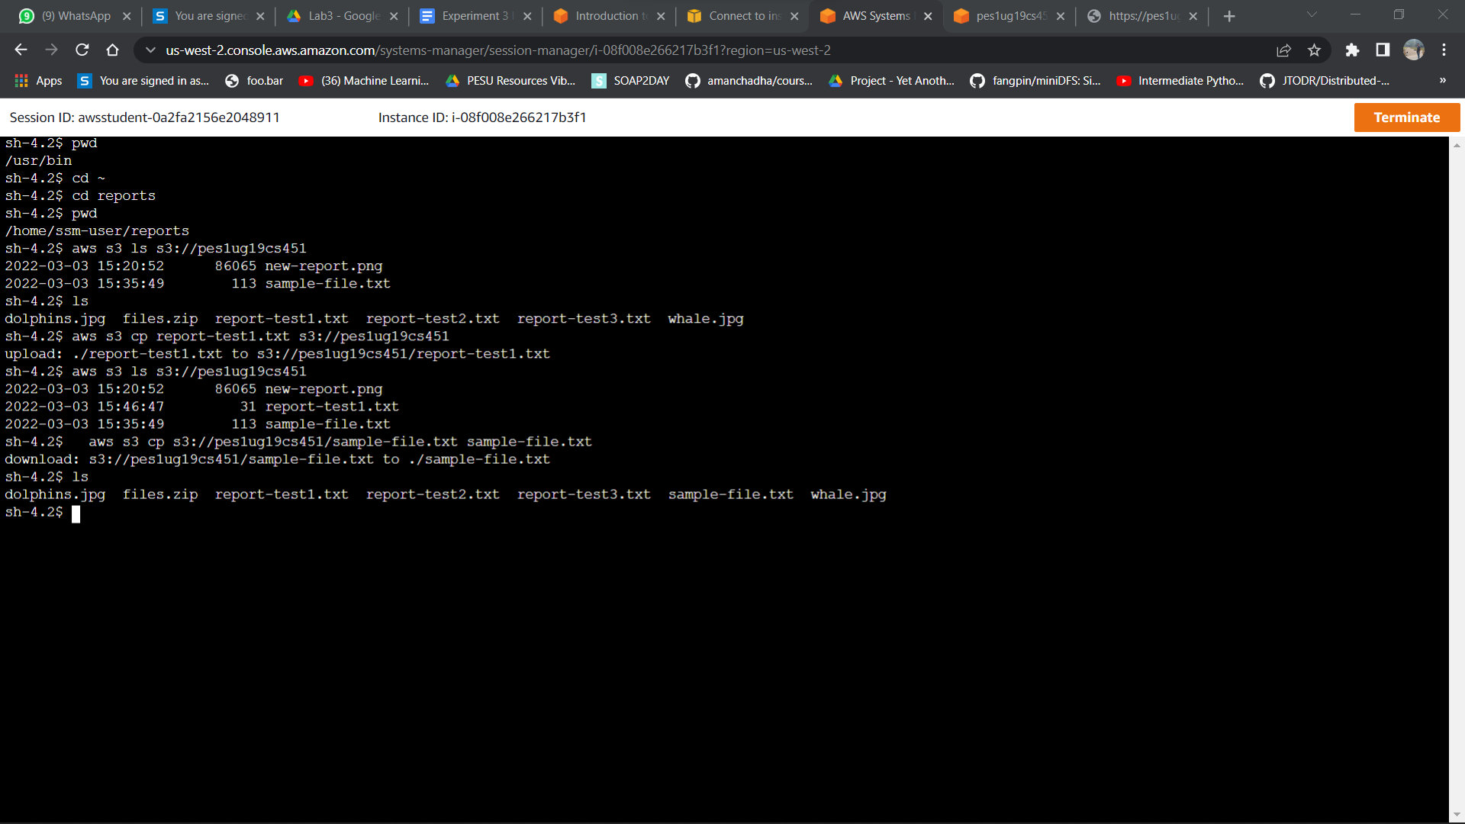

**5b.png: Showing the sample-file.txt displayed on the browser tab**

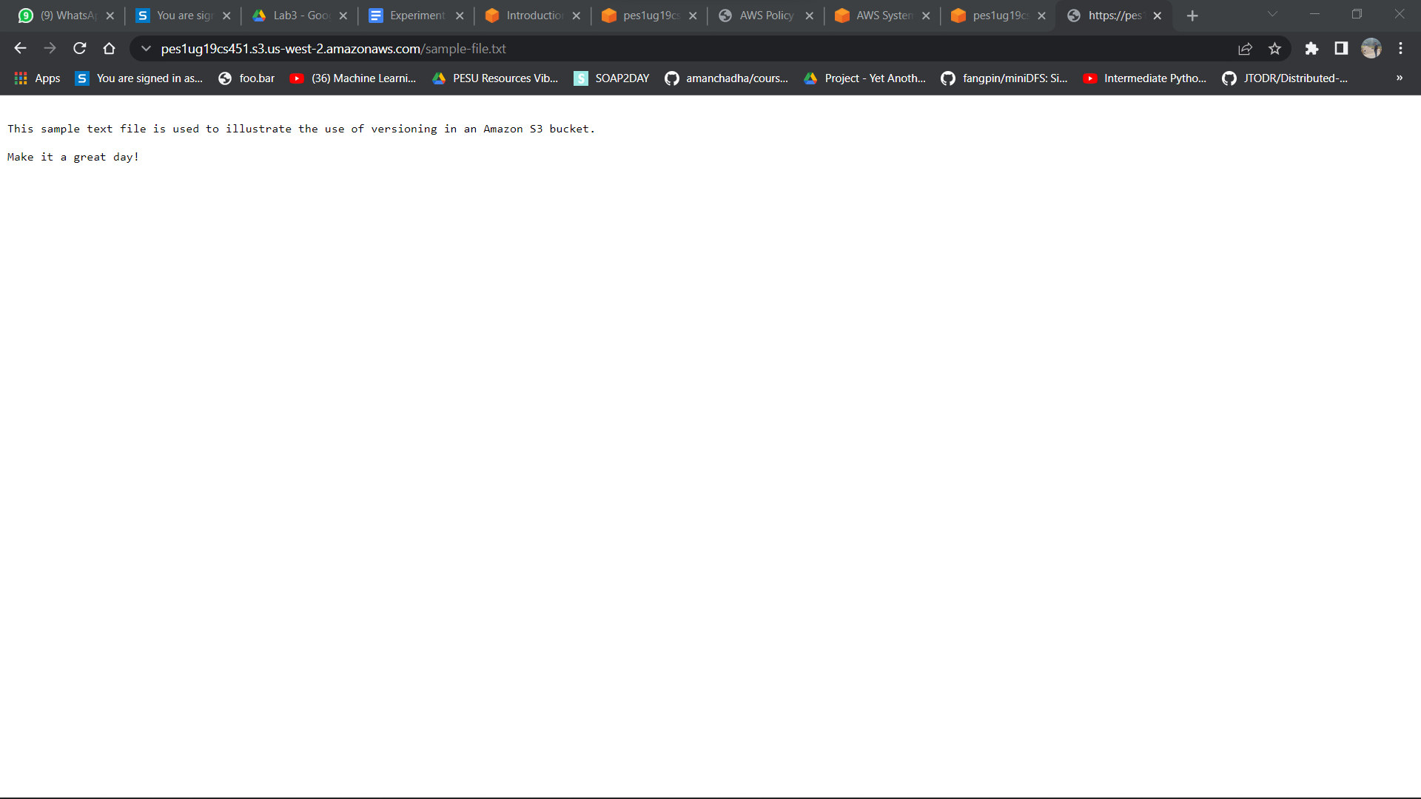

**6a.png: Showing the new contents of the sample-file.txt on the browser tab.**

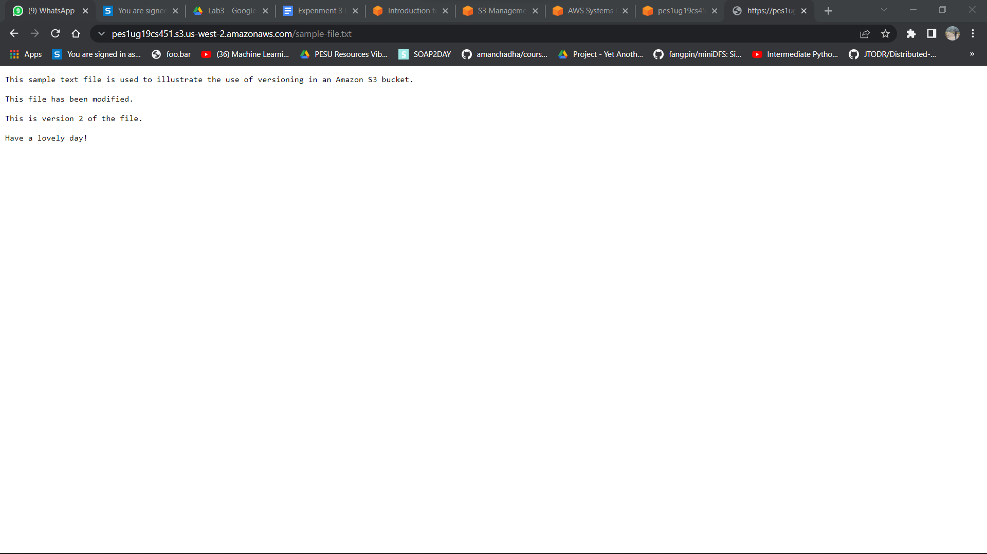

**6b.png: Showing the objects tab for the bucket created with the *Show versions* toggle on.**

