**CLOUD COMPUTING**

**Experiment 4 - Raft**

*Name: Sharat Subray Hegde*

*SRN : PES1UG19CS451*

*Section: G*

*(1-a.jpg)*

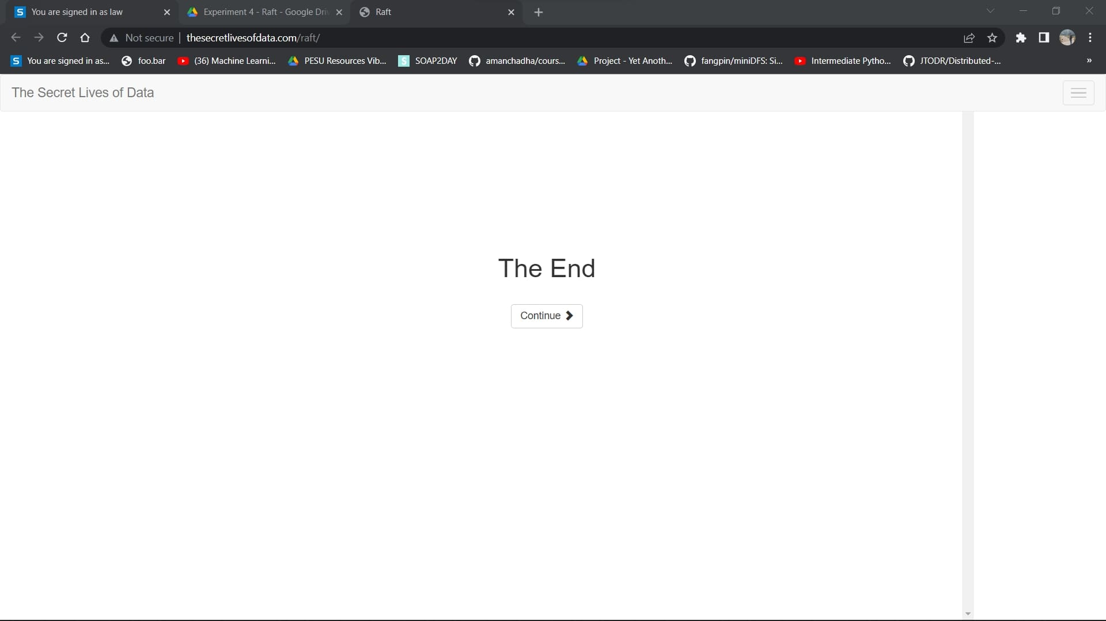

*(1-b.jpg)*

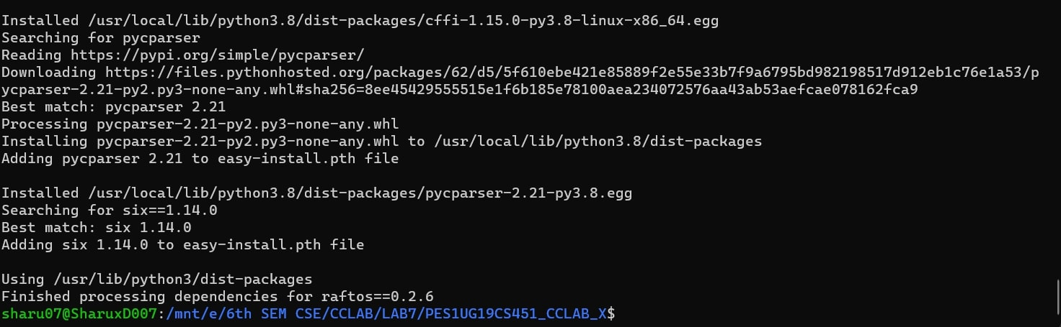

*(2-a.jpg)*

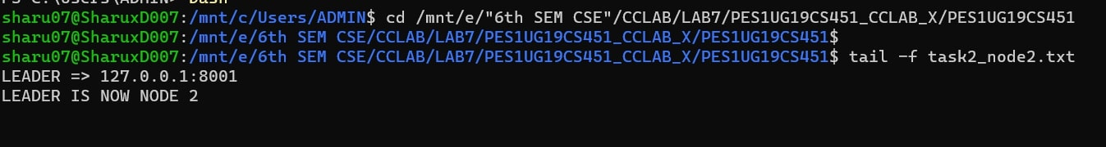

*(2-b.jpg)*

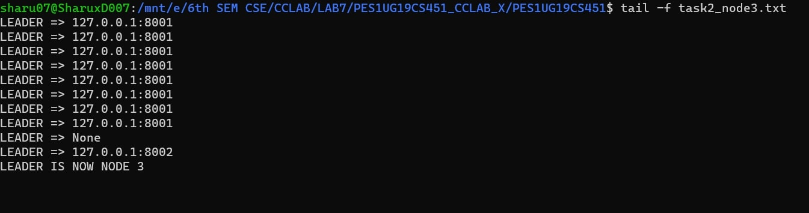

*(2-c.jpg)*

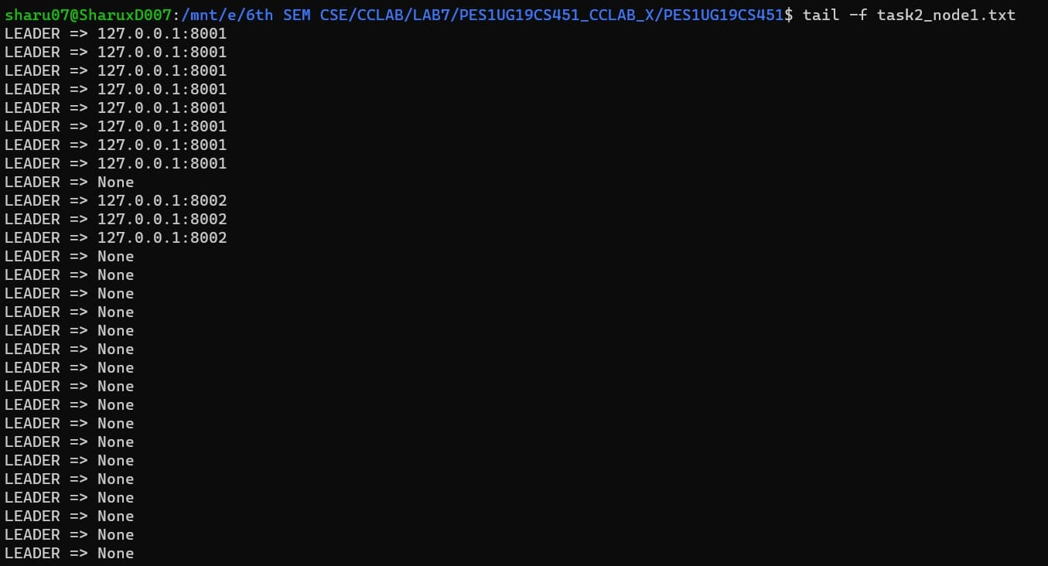

*(3-a.jpg)*

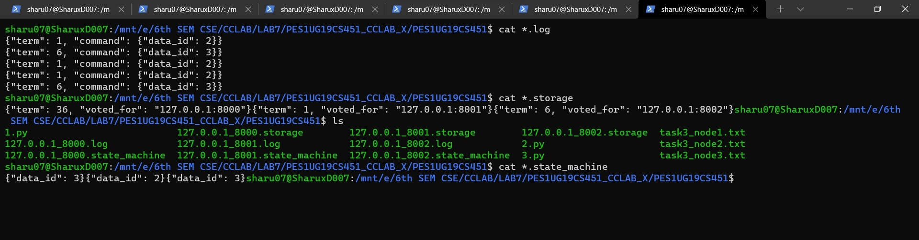

*(3-b.jpg)*

