### 

**INSTITUTO TECNOLÓGICO Y DE ESTUDIOS SUPERIORES DE MONTERREY**

Artificial Intelligence

### 

**Challenge: Mimicking a Guide Dog**



**Team:**

Melannie Isabel Torres Soto A01361808

Shara Teresa González Mena A01205254

Table of Contents

[**Justification**](https://docs.google.com/document/d/1fK9BO1rEgU4UFzOp4jb0rXTkyEXJgJj4dKsDgcq4T-w/edit#heading=h.7vbegr87yrmc)[**3**](https://docs.google.com/document/d/1fK9BO1rEgU4UFzOp4jb0rXTkyEXJgJj4dKsDgcq4T-w/edit#heading=h.7vbegr87yrmc)

**Documentation 5**

How to setup the Briko 5

How to use the Briko 8

**Analysis 9**

**References 10**

Justification

A guide dog is a working dog that has been trained to safely guide someone who is visually impaired or blind. We might have seen one, at least once in our lifetime, although surely many of us have not questioned about the story behind a guide dog.

The life of a guide dog starts approximately at 6 weeks of age and ends when they are around 9 - 10 years old. The first 2 years of their life they go through different stages of training to be ready to become the best friend of a blind or visually impaired person. This process that requires trainers, food and housing for the dog, equipment, among other things, makes the guide dog be offered at a range price of 40,000 - 50,000 American dollars.

By law, a dog must retire after 6 or 7 years guiding a person, so the investment of acquiring a guide dog would last only that amount of years, being necessary to have another dog after that time. So, how much does a blind person needs to pay to be able to be guided by a dog for more than 7 years? What if a person does not have the money to pay for a guide dog, or if they're allergic to dogs?

Briko Guide Dog is a robot that simulates the behavior of a guide dog to be a cheap and accurate option for people who can’t afford a guide dog, are allergic to dogs, or just prefer a robot. It requires less training and fewer cares than a dog.

This prototype of a guide dog doesn’t include an actual leash and it doesn’t receive voice commands as a guide dog does (for example, “go left”), but as a way of representing that voice commands, a control with buttons is used and each button is associated with one of the 4 different commands implemented for this prototype.

There are other proposals of guide dogs. for example, NR003, which is a robotic dog that gives support to go up and down stairs for the visually impaired. NR003 is not ready for real life usage, since it can’t lead somebody across the street.

Briko Guide Dog is built by using the principles of reactive agents and following the subsumption architecture shown below:



Figure 1. Subsumption architecture of Briko’s Guide Dog

|  |  |
| --- | --- |
| Conditions | Description |
| 1 | If button “right” is pressed and there is not an object less than 10 cm away from the right sensor |
| 2 | If button “left” is pressed and there is not an object less than 10 cm away from the left sensor |
| 3 | If button “stop” is pressed or there is an object less than 20 cms away from front sensor or if there is no floor ahead |
| 4 | If there is an object less than 10 cms away from the right sensor |
| 5 | If there is an object less than 10 cms away from the left sensor |
| 6 | If button “back” is pressed |

For this specific problem, AI is useful because it can represent the behavior of a guide dog which reacts after perceiving different signs (with the leash or by voice) given by a human and act accordingly to what it perceives in the environment by itself. This agent needs to perceive not only the place, but also the instructions of the human and act according to what it knows about each perception.

Documentation

How to setup the Briko Guide Dog:

The Briko Kit is a product by a Mexican business named “Briko”. This kit allows us to do simple projects focusing our attention to the main goal, rather than the technical aspects. Briko is a great option to validate an idea/learn a concept without having problems with out-of-date documentation, bugs when downloading the project, or having to learn a new language to develop your project.

We decided to use Briko for this project to avoid struggling with a new technology. To build your own Briko Guide Dog you will need a Briko Kit. You can buy one [here](https://brikorobotics.com/shipping). If you’re a student of ITESM Campus Querétaro, you can ask for one in the robotics warehouse.

Phase 1. Load the program to the Briko

1. Register in [https://Brikorobotics.com](https://brikorobotics.com) and download the Briko’s app. (3-5 min)
2. Download the file [Briko-dog.bkiq](https://drive.google.com/file/d/1RAv6OLLcxbW4d9IRtYcq1tYPtpdPgE2_/view?usp=sharing)
3. Open the app and select the option “Programar en código”.
4. Click on the folder to open the file you downloaded in step 2

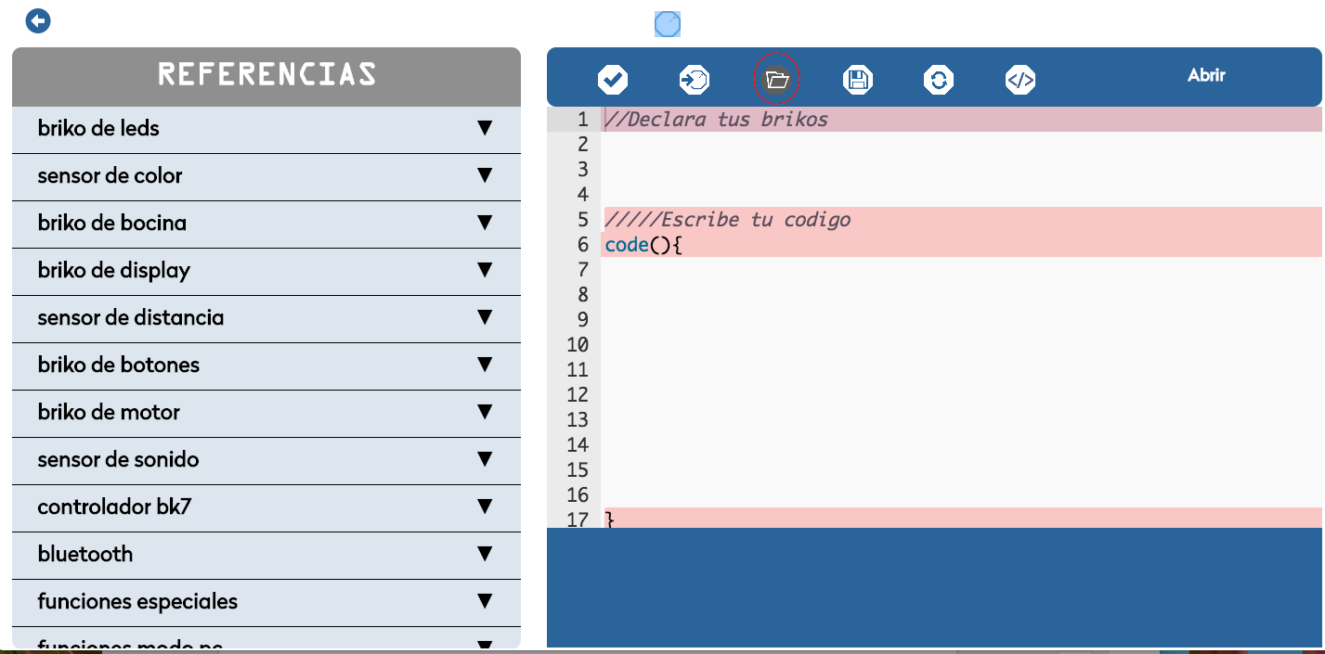

Figure 2. “Open file” button at Briko’s app.

1. Connect the Briko to your laptop/PC and click the button indicated in the image below to load the code to your Briko’s CPU.



Figure 3. “Load code” button at Briko’s app

Phase 2. Build your Briko

For this phase you’ll need:

* 4 distance sensors
* 2 wheels
* 2 motors
* 1 button controller
* 7 Briko’s ribbon cables
* 14 nuts and bolts
* Briko CPU with program loaded
* Portable 5V battery
* Cable USB mini
* 3 hexagonal bases
* 5 medium plate
* 16 90º unions

1. Ensemble the Briko to one of the hexagonal bases using nuts and bolts.
2. Ensemble the motors to the other hexagonal bases using nuts and bolts.
3. Add a wheel to each motor.
4. Ensemble each of the distance sensors to a medium plate using nuts and bolts for each distance sensor.
5. To create the top part, attach two of the medium plates and sensors the remain hexagonal bases
6. Add another plate and sensor to the hexagonal base with wheels
7. Build the three floor structure as shown in the figure using the corresponding unions and add the last sensor in 45° degrees as shown in the image
8. Connect the button controller to the PORT #7 on the Briko’s CPU.
9. Connect the left wheel to the PORT #1 on the Briko’s CPU.
10. Connect the left sensor to the PORT #6 on the Briko’s CPU.
11. Connect the frontal sensor to the PORT #2 on the Briko’s CPU.
12. Connect the right sensor to the PORT #4 on the Briko’s CPU.
13. Connect the right wheel to the PORT #5 on the Briko’s CPU.
14. Connect the 45° sensor to the PORT #3 on the Briko’s CPU
15. Connect the Briko’s CPU to the portable battery.

Your Briko should look like this:

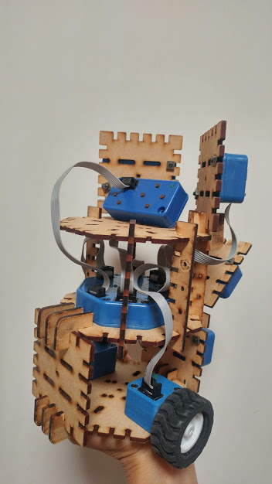

Figure 4. Back part of Briko Guide Dog.

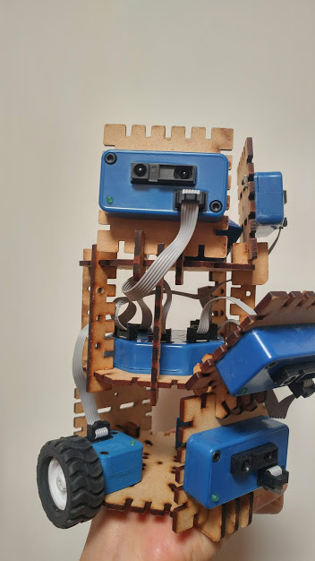

Figure 5. Front part of Briko Guide Dog

How to use the Briko

Briko Guide Dog needs to be controlled by a human. It will act after receiving instructions, and each instruction will come from the control connected to the Briko:

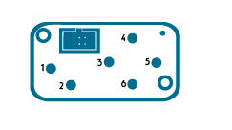

Figure 7. Briko’s control

1: Stop  
3: Turn left  
5: Turn right  
6: Turn around

Analysis

There isn’t enough information about similar projects to make a benchmark comparison. In order to analyze the response reaction of the Briko Guide Dog, we tested the reaction of the robot to objects near of it and how much it took it to detect the object. As unit of measure we used cm, and we prepared the test scenario as follows:



Figure 8. Test scenario

The measure lines had the size of the distance where the Briko was supposed to detect the object and execute the corresponding action. The delay of reaction was measured in terms of the cm’s it delayed detecting the object. For example, if we expected it to stop at 20 cm and it stopped at 18cm, it had an error of 2 cm. Each test was executed 5 times and from all the results, we calculated the average of delay. The results are shown below:

Front:

|  |  |  |  |  |  |  |
| --- | --- | --- | --- | --- | --- | --- |
| Test | 1 | 2 | 3 | 4 | 5 | 6 |
| Delay (cm) | 2 | 0 | 0 | 3 | 0 | 2 |

Average: 1.167 cm

Right:

|  |  |  |  |  |  |
| --- | --- | --- | --- | --- | --- |
| Test | 1 | 2 | 3 | 4 | 5 |
| Delay (cm) | 1 | 1 | 1 | 2 | 1 |

Average: 1.20 cm

Left:

|  |  |  |  |  |  |
| --- | --- | --- | --- | --- | --- |
| Test | 1 | 2 | 3 | 4 | 5 |
| Delay (cm) | 2 | 2 | 2 | 1 | 2 |

Average: 1.80 cm

As we can see, the maximum error average is 1.8 cm. Considering that the three sensors are supposed to be equal, the difference of performance among them can be a consequence of the previous usage of the sensors because they were borrowed from IT department and we do not know how long or in which way the sensors have been used. For a real implementation of the guide dog, the sensors should be carefully selected in order to guarantee the best performance of the robot.

References:

Ahamed, S. (2009). Mada AT Portal. Retrieved October 07, 2018, from http://madaportal.org/blogs/guide-dog-robot-future-mobility-aid-blind-and-visually-impaired

Colby. (17 de September de 2017). *Puppy in training*. Obtenido de How Much Does A Guide Dog Cost?: https://puppyintraining.com/how-much-does-a-guide-dog-cost/

Country life. (12 de May de 2017). *Country Life*. Obtenido de The seven stages of life for a guide dog, from puppy to retiree: https://www.countrylife.co.uk/out-and-about/dogs/seven-stages-life-guide-dog-puppy-retiree-156677

D. (2011, November 15). Robot Guide Dog. Retrieved October 07, 2018, from <https://www.youtube.com/watch?v=6dbfMoGuaeQ>

Fischler, B. (5 de February de 2014). *Dogster*. Obtenido de The 10 Biggest Misconceptions About Guide Dogs for the Blind: https://www.dogster.com/lifestyle/guide-dogs-for-the-blind-misconceptions

Guide dogs. (s.f.). *Guide dogs WA*. Obtenido de Guide dog program: https://www.guidedogswa.com.au/guide-dog-program/

Hornyak, T. (2011, November 18). Bad idea: Robot seeing-eye dogs. Retrieved October 07, 2018, from https://www.cnet.com/news/bad-idea-robot-seeing-eye-dogs/