# 2019 -CS352 - Assignment 1: SelfieLessActs on AWS

* Team : CC\_308\_313\_331\_352

|  |  |  |
| --- | --- | --- |
| **Member Name** | **USN** | **Section** |
| **Rohan** R | 01FB16ECS**308** | F |
| **Rohit** U Bogulla | 01FB16ECS**313** | F |
| **Sailesh** Gaddalay | 01FB16ECS**331** | F |
| **Sharath** N | 01FB16ECS**352** | F |

Date of Evaluation : Sat, **02nd Feb** 2019 Evaluator : **Mr.Akash Nagaraj**

1. AWS username on which demo was shown : [**vocstartsoft/user215984=rohan.achar.153@gmail.com**](mailto:vocstartsoft/user215984%3Drohan.achar.153@gmail.com)
2. Account ID : **2420-4831-8870**
3. Public IP address of web server : **100.24.77.155**
4. Put a screenshot of your home page GUI :

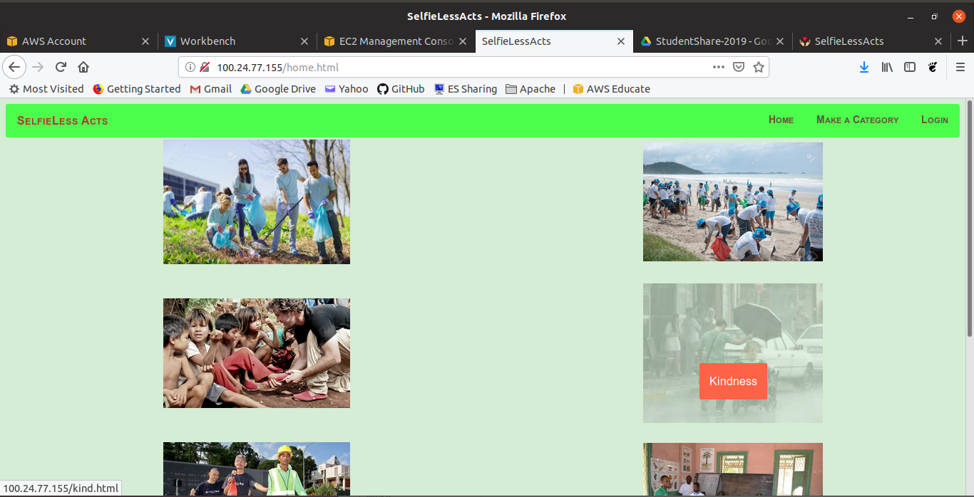

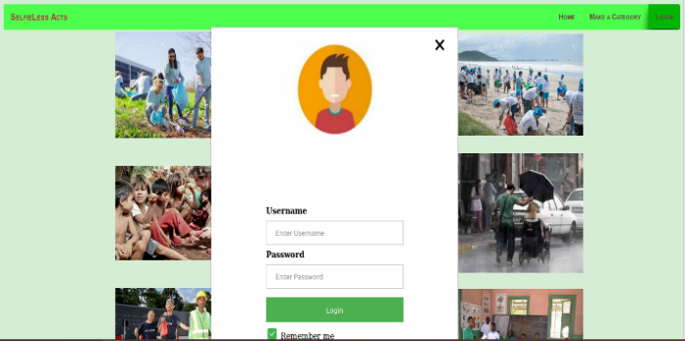 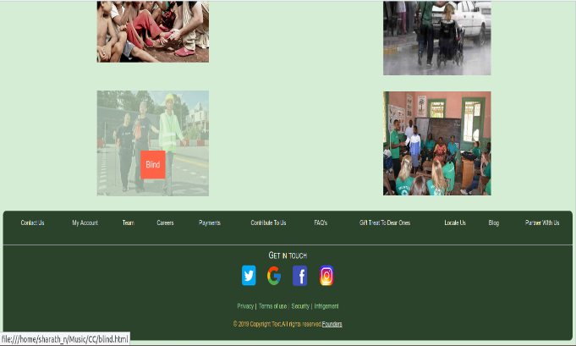

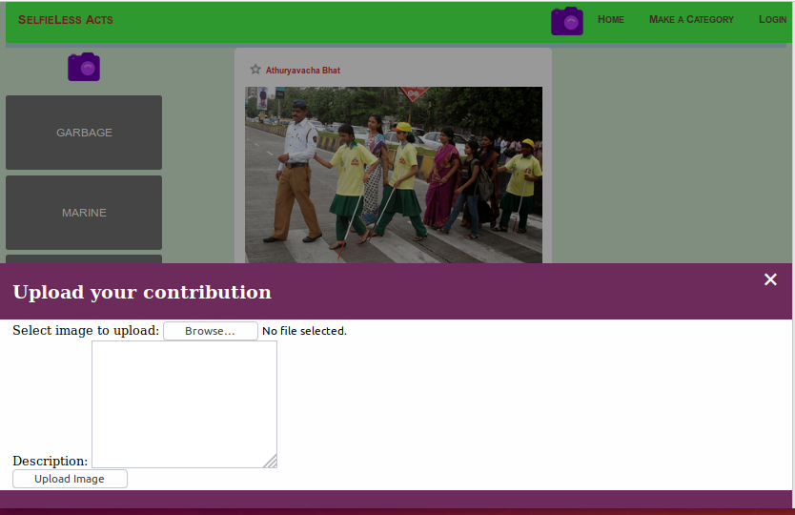 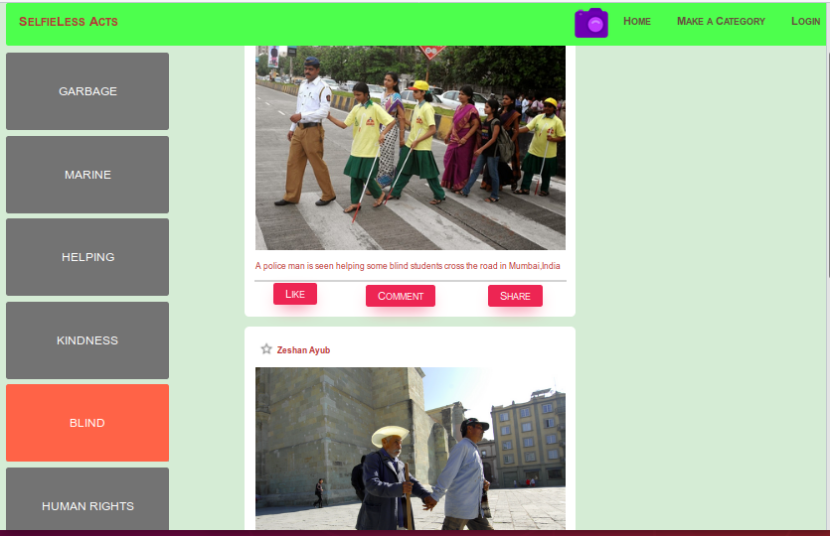

1. Summarize your learning as part of this assignment :

Majority of the learning tended towards the AWS, simply because we had a pre-requisite of Web Technology. So, we just had to brush-up and refresh which eventually brought-up the concepts that helped putting up this Website(Apache was installed later-on, after the instance creation). There-on for AWS, we directly followed the instructions mentioned for Assignment1 and most of the learning happened while launching an EC2 instance(Amazon Elastic Compute Cloud is a web service that provides resizable compute capacity on the cloud. Makes web development and deployment easier.).

Mainly we chose an instance t2.micro Ubuntu 18.04LTS with configuration: (Variable ECUs, 1 vCPUs, 2.5 GHz, Intel Xeon Family, 1 GB memory, 8GB storage EBS only).

While creating the instance, one major option is the Security Group(control the traffic of the instance). SSH is used for accessing the cloud VM through the local machine and HTTP allows traffic to our web server and gives unrestricted access to the contents. “Source” determines the type os traffic is allowed to our instance, for us, it is ’Anywhere’, meaning public. Finally, we generate a .pem file which is a BASE-64 DER encoded file that is like a password to our VM.

**ssh -i "rrs-trio.pem"** [**ubuntu@ec2-100-24-77-155.compute-1.amazonaws.com**](mailto:ubuntu@ec2-100-24-77-155.compute-1.amazonaws.com)

command is used to SSH to the instance and

**scp -i "rrs-trio.pem" \_source-file\_** [**ubuntu@ec2-100-24-77-155.compute-1.amazonaws.com: /destination\_location**](mailto:ubuntu@ec2-100-24-77-155.compute-1.amazonaws.com:    /destination_location)

command to transfer file from local machine to cloud instance.

The IP given(by default is IPV4) is dynamic and hence changes each and every time when we login, to prevent this we used Elastic IPs feature and associated the IP mentioned above with our instance. This means, even after several logins the IP of the instance won’t vary.

The Elastic Cound Storage(EBS) is similar to Buckets in GCP and are storage units in AWS that can be accessed across the AWS among the instances.

As a conclusion, the fusion of web development and AWS’s EC2 gave raise to the current presented, foreground look and feel of the website.

Any other observations/challenges/comments :