Mechanical Engineering is vast field. In current era software has become an integral part of mechanical engineering. There are lots of software according to application person can use. Some of the software which are a must for a mechanical Engineering are:

1. **Designing software**
2. **Analysis software**
3. **Coding**

**1. Designing software :**Designing software is essential for one who makes his/her career in designing field.

* **list of designing software**
  + **Autocad -** Drafting and two dimentional drawning
  + **Pro-E/Creo -**Advance solid modelling and 3d designing
  + **Solidworks -**Advance solid modelling and 3d designing
  + **Alibre-**Advance solid modelling and 3d designing
  + **Catia -**Advance solid modelling and 3d designing

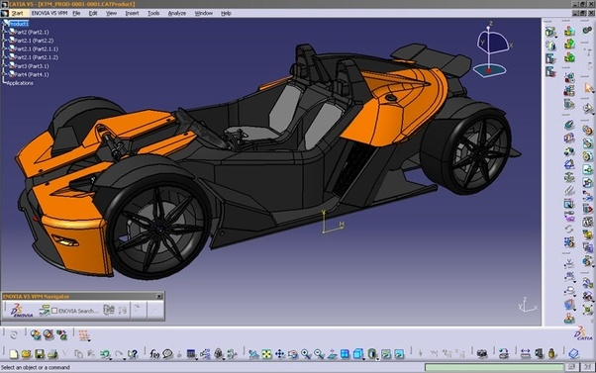

-Pro-E/Creo, CATIA, SolidWorks and Autodesk Inventor are very similar software. Knowing one of them is sufficient to work on all the other software.

2. **Analysis or Simulation Software :**With the help of simulation and analysis designers can visualise their products better, and thereby maintain high quality standards in design.Higher standards of quality and visualisation further lead to better innovations.Physical testing has its own limit but with the help of this software any company can produce reliable quality.

* **List of Analysis software:-**
  + **Ansys -**Fenite Elelment Analysis (FEM) , Computationla fluid dynamics (CFD) Analysis
* **Matlab -**Matlab is very good and in fact an industry standard for data acquisition and mathematical modelling.When it comes to mathematical modelling in all Aerospace, Automobile, Control system domain it is an industry standard. Almost in all the universities, students and professors use it for research purposes.

3. **Coding software/language:-**.Generally **python** is used if you are dealing with very complex computational fluid dynamics (CFD) problem which can not be solved by using multi physics software like (Ansys and Abaqus).

* **List of coding/ language software:-**
  + Python
  + Java
  + C++

-As a mechanical engineer you must know atleat one software from each. I would like to give you one advice as a mechanical engineer you must pick up any one of them software and try to learn it invest 1 hour per day

-Give your first priority to **auto cad.** I admit that I haven't tried all of these to decide. Again, it also depends on the resources including tutorials, practice models etc, also. And above all, the most important thing is your interest to learn these software.

All The Best.