**Advanced C module 1 answers**

**4.** Write an equivalent pointer expression for fetching the value of array element a[i][j][k][2]

**Ans:** *(*(*(*(a + i) + j) + k) + 2)

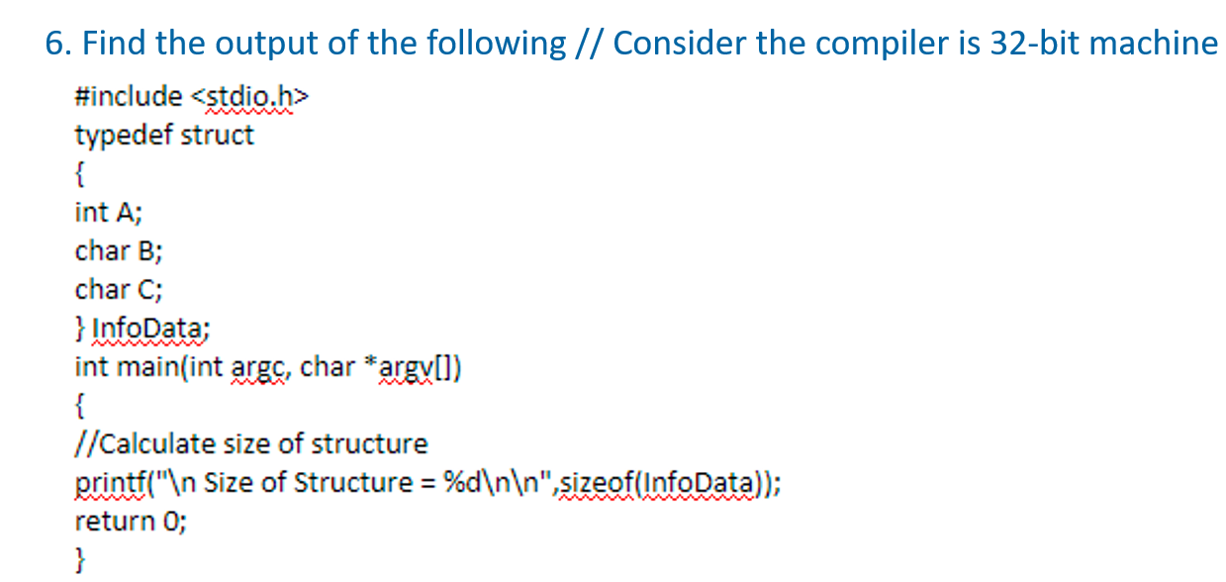

**Ans: 8**

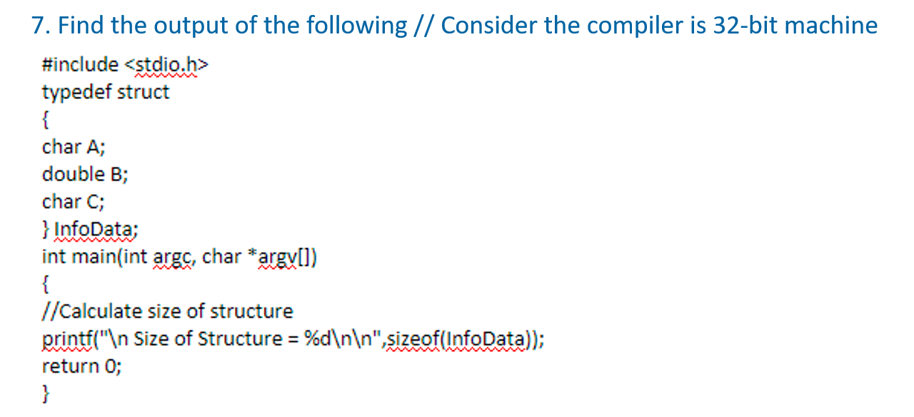

**Ans: 24**

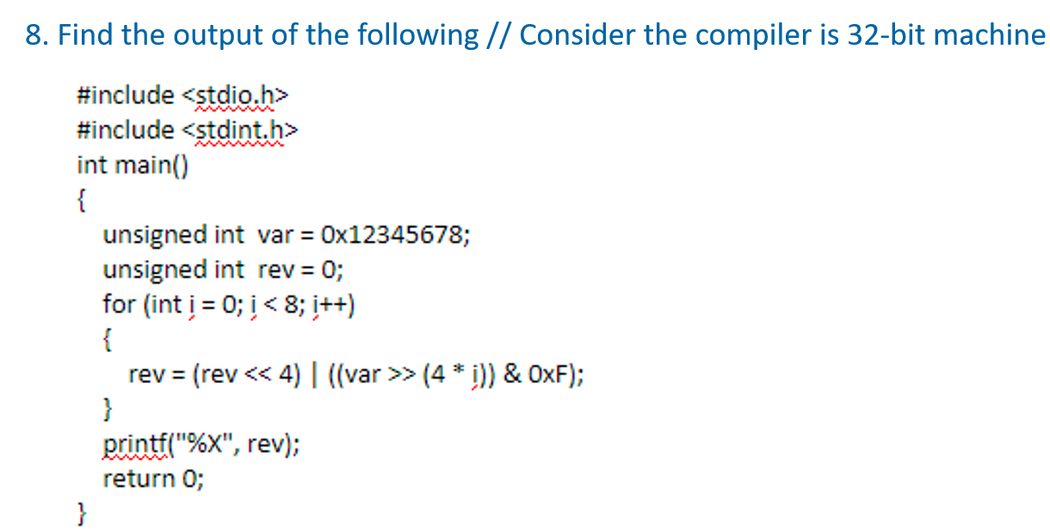

**Ans: 87654321**