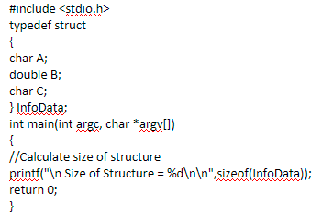

**OUTPUT**: Size of Structure = 24