Q4. Guess the output for the following program.

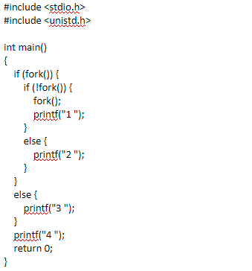

Output: 3 4 1 4 1 4 2 4

Considering that – the child gets completed first, the output of the program can vary each time due to random nature of process scheduling