Spoken Tutorials - Linux Assignment
Indian Institute of Technology Bombay,
http://spoken-tutorial.org

Basic Commands in Linux

1) Commands are actually files containing programs, often written in C. How will you find out in which directory does the file corresponding to the man command resides?

2) How will you find out what is the use of the ps command.

Answers:
1 -->
The man command is used to display manual pages for various commands, functions, and system calls. It invokes the system's pager to display the contents of the manual pages.
If we want to find out where the executable file corresponding to the man command resides, we can use the “which” command.
Syntax: which man
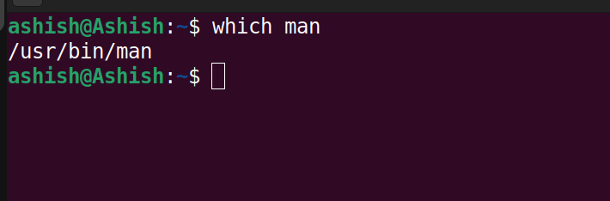

2 -->
To find out the use of ps command, we can use the following commands:
1) man ps: It will show us a detailed manual for the ps command
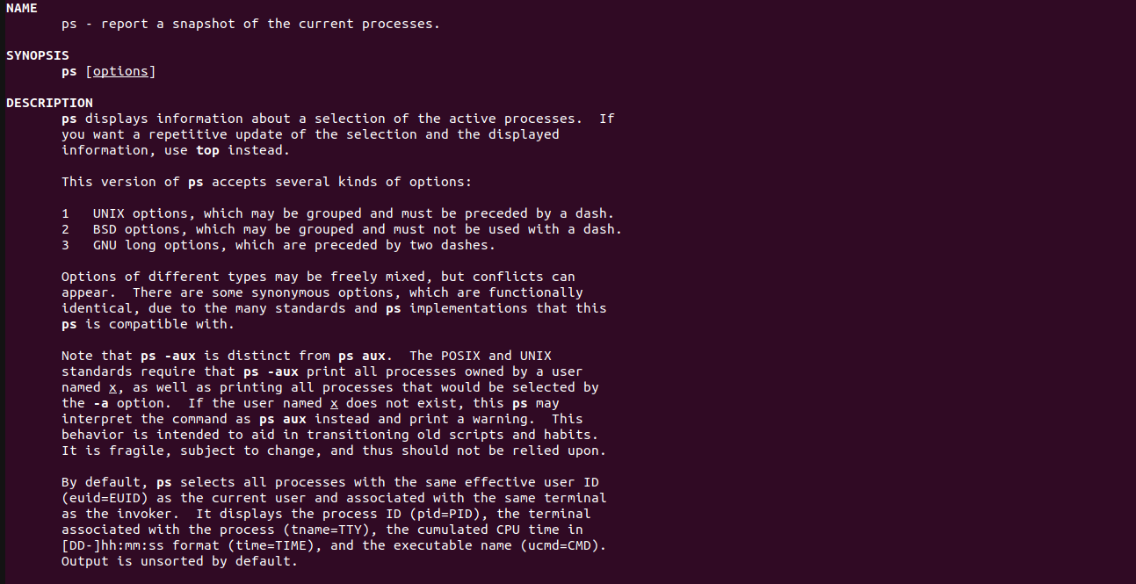
2) whatis ps: It will show a single line basic description of the ps command
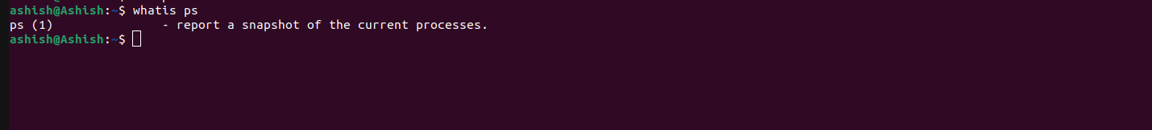
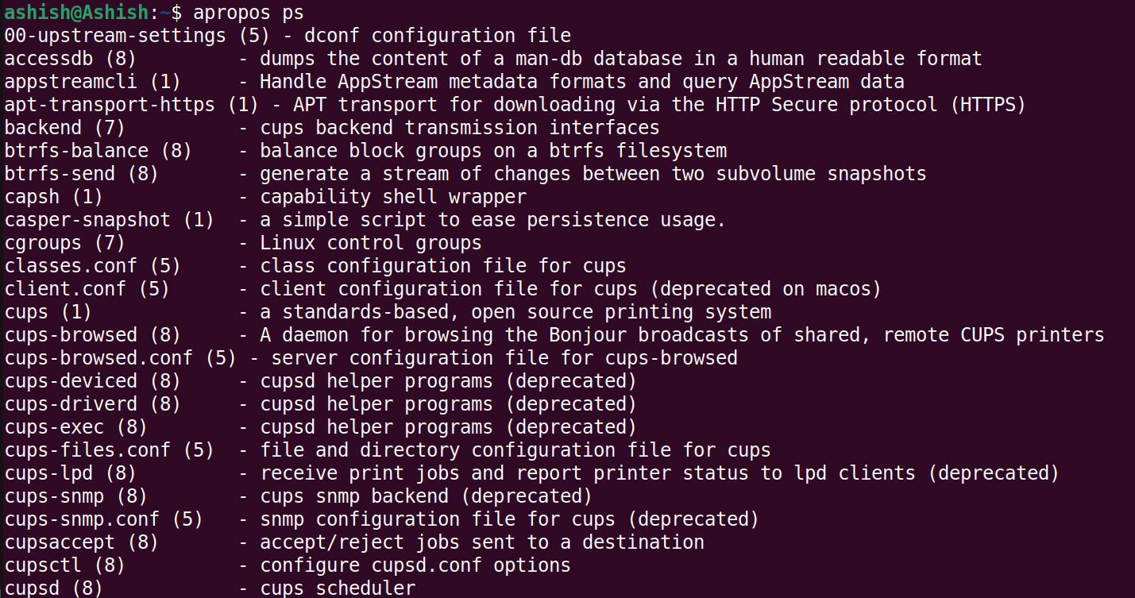
3) apropos ps: It will show all the relevant pages from the manual about the ps command

