Spoken Tutorials - Linux Assignment
Indian Institute of Technology Bombay,
http://spoken-tutorial.org

General Purpose Utilities in Linux

1) Display the calender for the month of March 2012

2) List all the files and directories of the directory
/usr/lib on the terminal. Now put the same information in
a file named results. Display the contents of the file results now.

Answers:
--> 1
Command : cal 03 2012
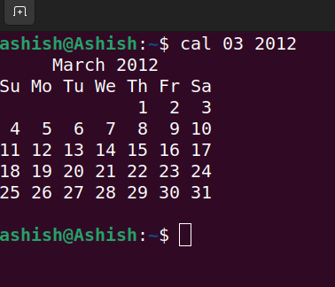

--> 2
- To see our own directory, we use the command pwd.
- To list all the files and directories of the present directory,
we use ls. To see hidden files as well, we use ls –aall.
- To store this data in a file name “results”, we use
ls l>results.
- To show the contents of the file “results”, we can use
cat results

