MODULE 3
1. Write a config file so that wpa_supplicant can associate to FT Dot1x WLAN

Answer:
network={
ssid="module3"
proto=RSN
key_mgmt=FT-EAP
eap=PEAP
identity="username”
client_cert="path of client certficate”
private_key="path of private key”
}

2.Bring up a Freeradius, wpa_supplicant in linux machine, use "eapol_test" utility in wpa_supplicant and try connecting successfully to the Freeradius. Also, please capture the radius packets that is exchanged between eapol_test and Freeradius using "tcpdump" command.

Answer:
In clients.conf file
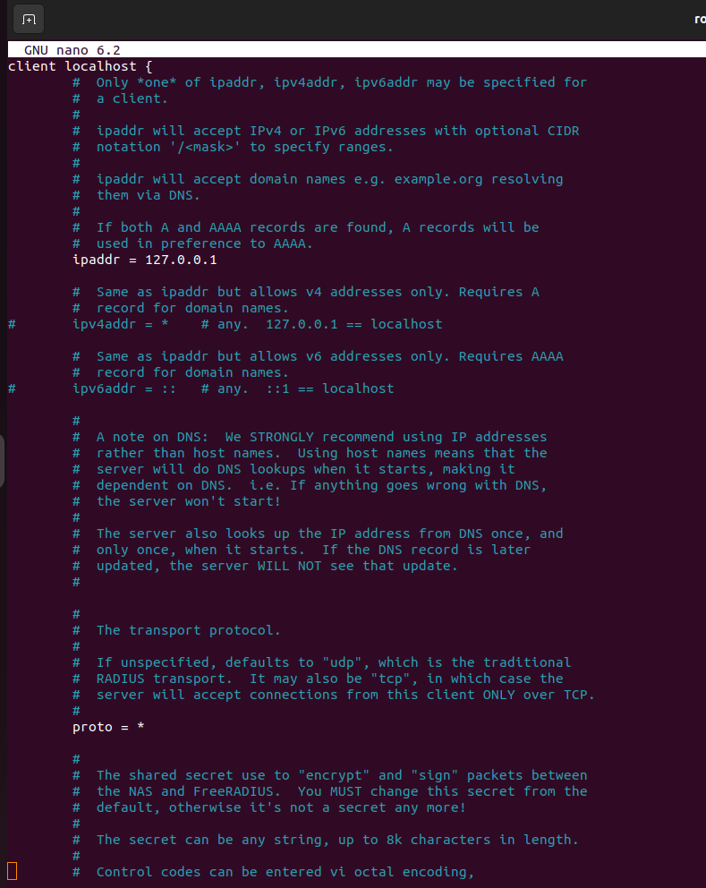
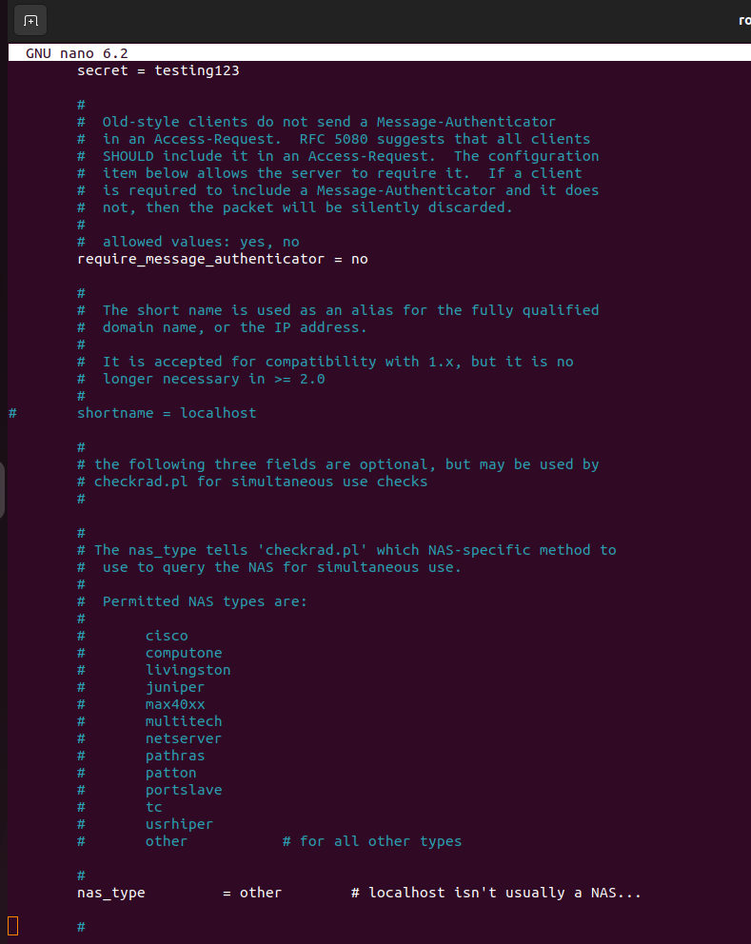
In wpa_supplicant.conf file,
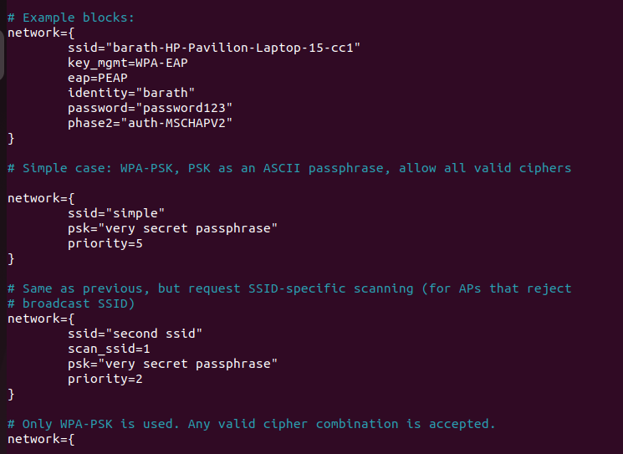
In user file,
“identity and password” were added.

“sudo freeradius -X > freerad_log.txt” for starting radius server

“sudo eapol_test -c /etc/wpa_supplicant.conf -s 127.0.0.1 -s testing123 -N 30 > wpa.txt” for connecting to freeradius

“sudo tcpdump -i 2 udp port 1812 -w capture.pcap” for capturing radius frame and stored into capture.pcap file

The reference logged files were added to repository.

