Assignment – 1
1.Git

1.Git repository with README.md file
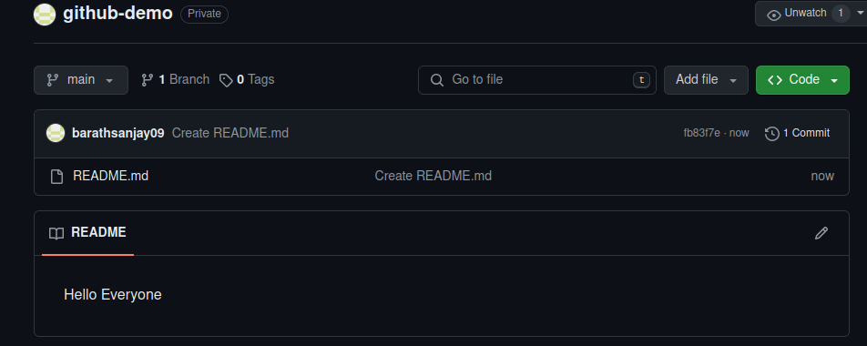
2.Clone Git repository into local repository
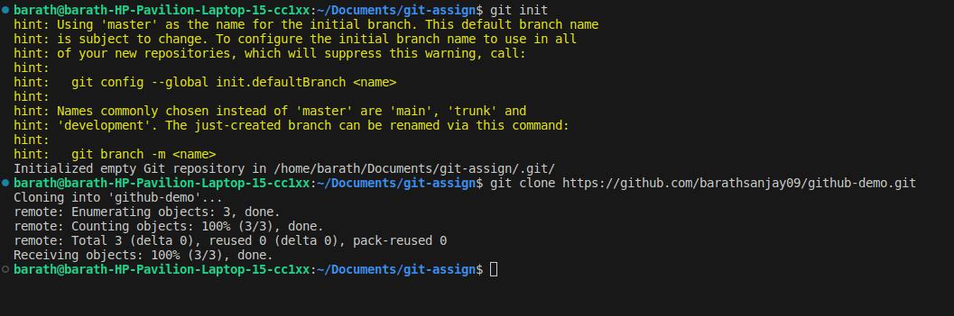

3.Parallel changes on both branches and commit and push into same git repository
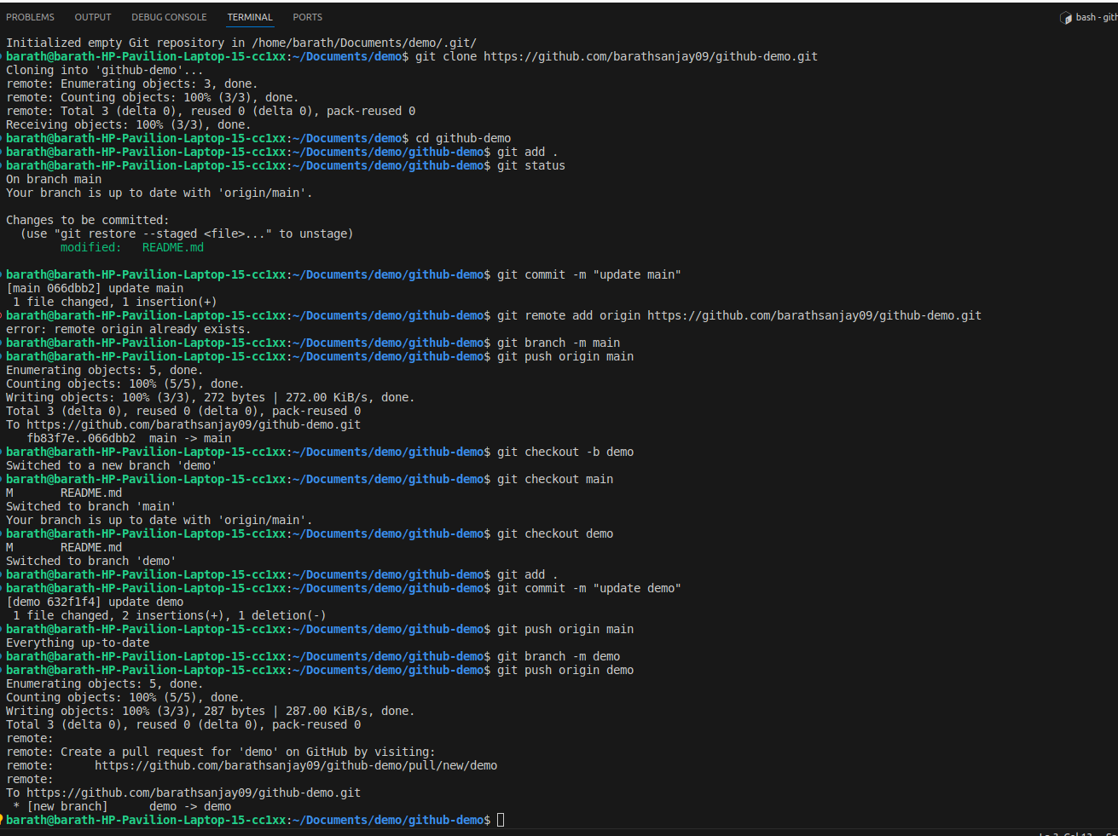
4.Merging
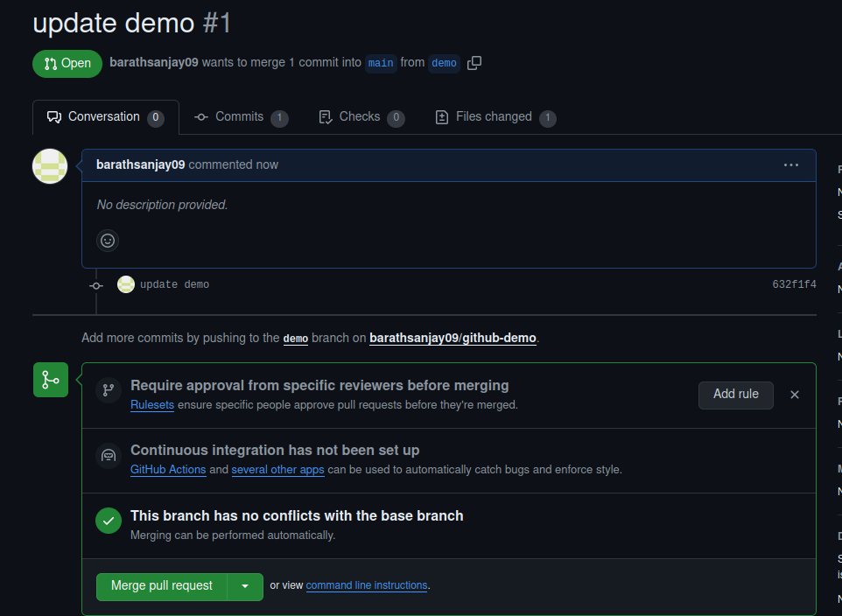

5.Commit log
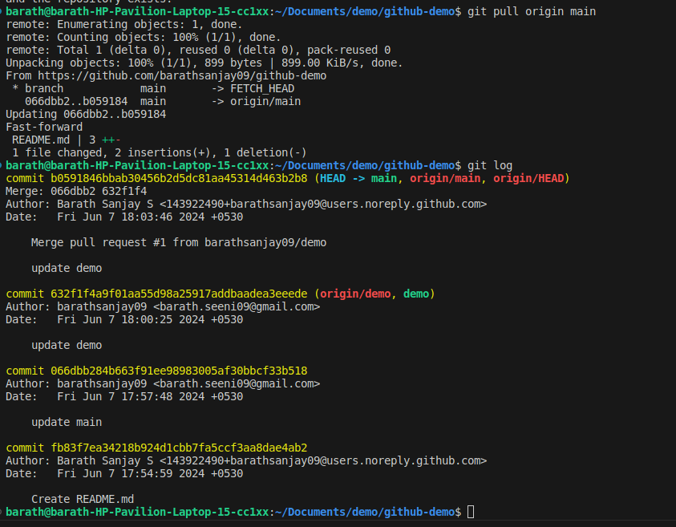

2. Vim Editor

1.Replace fox with wolf (cmd : %s/fox/wolf/g)
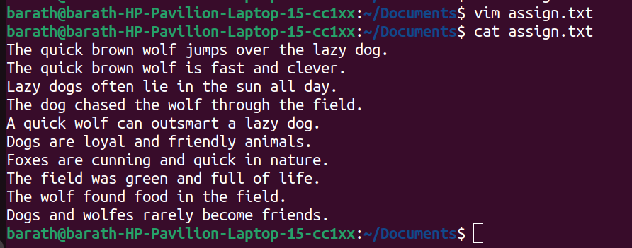
2.Search “field” and moving to next and previous occurence

Command : s/field for searching, normal mode +n for prevoius and normal mode + N for next occurence
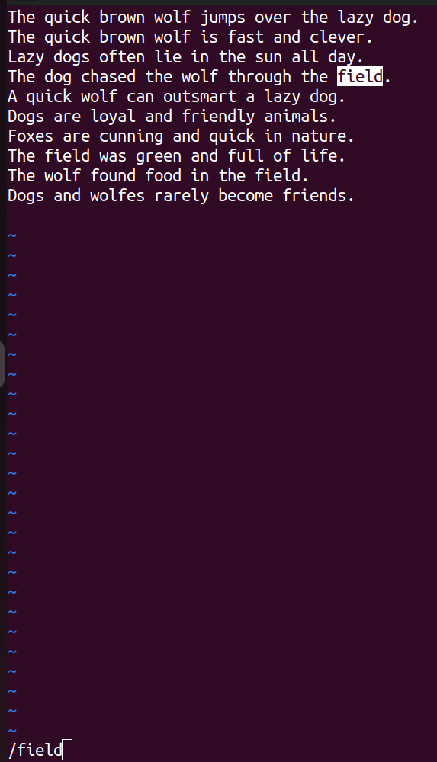

3.Copy the entire line "A quick fox can outsmart a lazy dog" and paste at the end of file and save it.

Command : “yy” in normal mode to copy the line under cursor and “p” in normal mode to paste it.
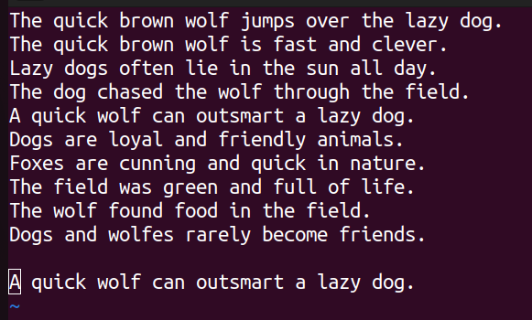

4. Replace all the vowels with letter "x" in the file.

Command : %s/a\|e\|i\|o\|u/x/g
