Assignment – 2 (Moudule – 2)
2. Iperf

1. TCP Traffic

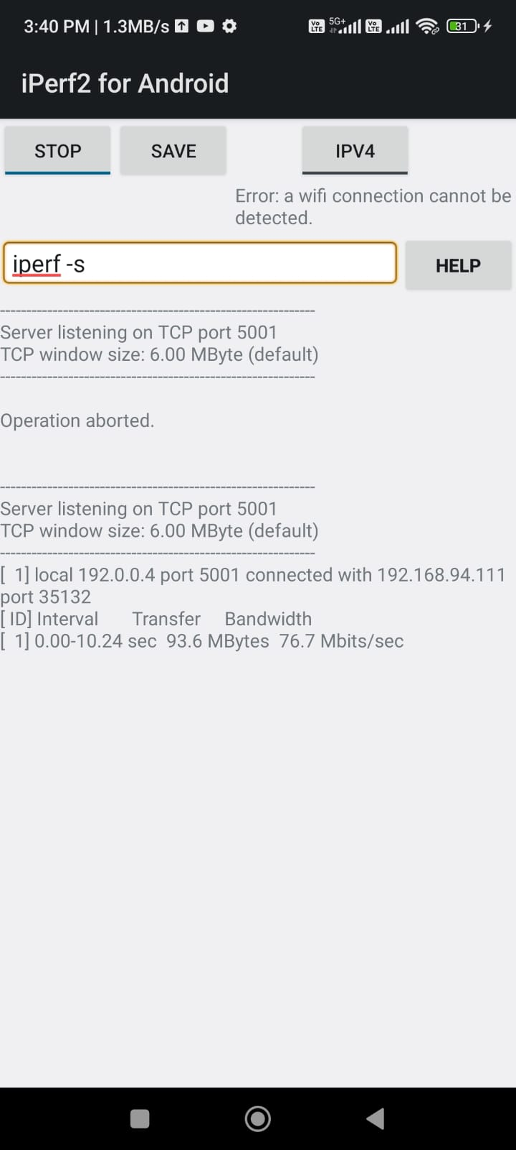
TCP Server

TCP Client
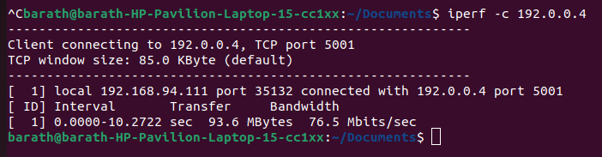

UDP Traffic:

UDP Server:

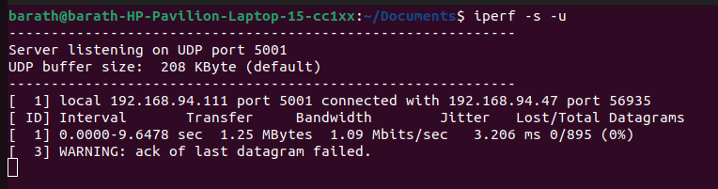
UDP Client:
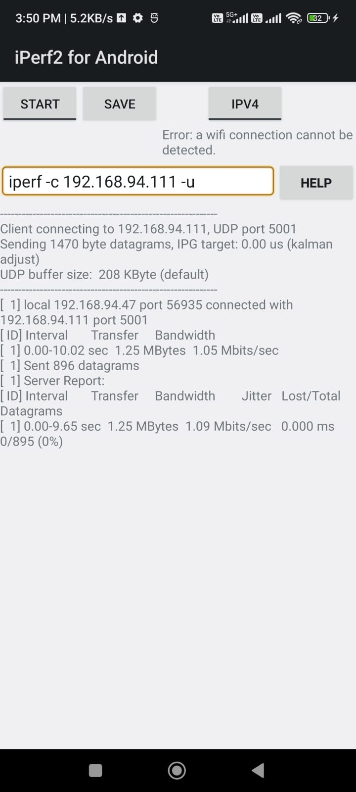

1.Wireshark

