MODULE 4:

1) Using Valgind identify memleaks in the given program. Explore optional flags in Valgrind.

Answer:
Cmd: valgrind –leak-check=full –show-leak-kinds=all –log-file=valgrind_op.txt ./a.out
Logged file “valgrind_op.txt” which has the output of the valgrind command and has memleak info which is uploaded in repository.
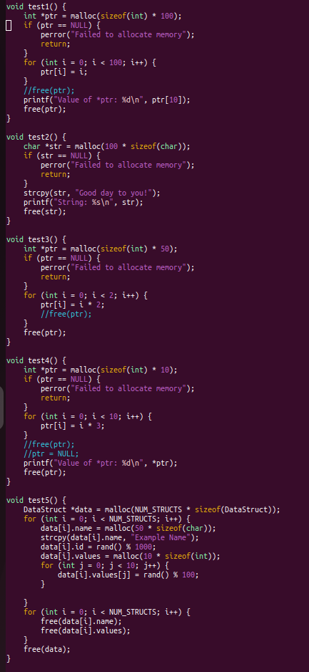
Corrected program:

2. With the same program, using GDB, set breakpoints, run the program, list the code, run from one breakpoint to another, print the value of variables while execution, check assemble code, disable breakpoints, check registers info, explore optional flags.

Answer:
1.Setting breakpoints at function test1
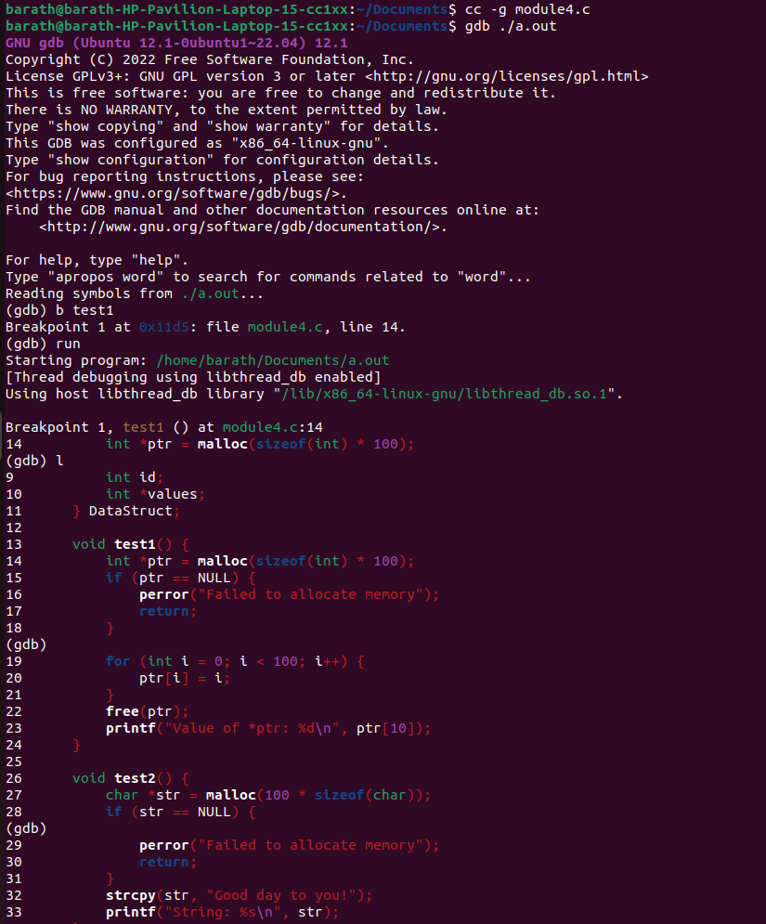
2. list the code from breakpoint
3.Setting another breakpoint and continue to another breakpoints
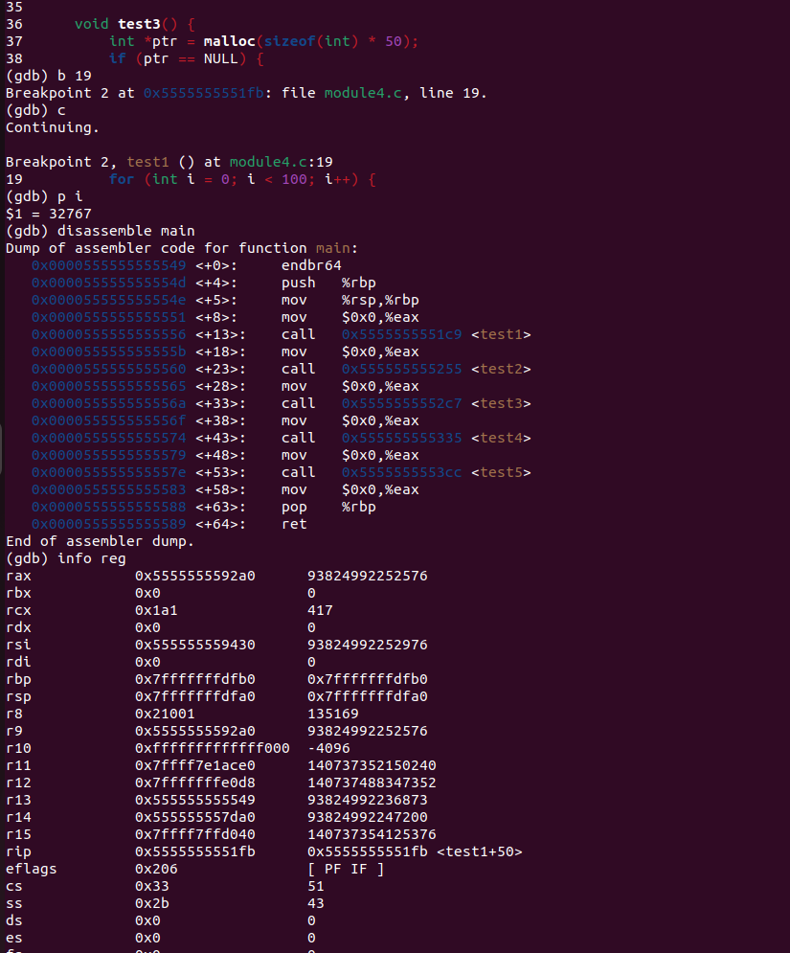
4.printing the value of variable
5. checking assemble code of main
6. Checking register info

7. Disable Breakpoints
