GNS3 (GRAPHICAL NETWORK SIMULATOR)

INTRODUCTION :

1. GNS is the open source software that allows to design, configure and test the complex network either by simulated or by real networking devices (with real NOS (Network Operating System)) with various topologies.
2. With the support of QEMU (Quick Emulator) (or KVM in linux) , it is used to emulate the real networking L2 and L3 devices with NOS support for configuration and maintaining the networking device.
3. QEMU also used to emulate Linux PC’s in the network.
4. With the help of VirtualBox / VMWare , it enables the connectivity of virtual machines in the network.
5. However, it also allows the pick and place components as in Cisco Packet Tracer to check the functionality.
6. Support packet capture natively with Wireshark if installed and also supports network automation scripting
7. Basically, QEMU can be used to enable the emulation of any pc or networking device. But with Virtualbox (VMWare) it works smoothly.

DEMONSTRATION:

1. To access the inbuilt vpcs and ethernet switch to use the native packet capturing.

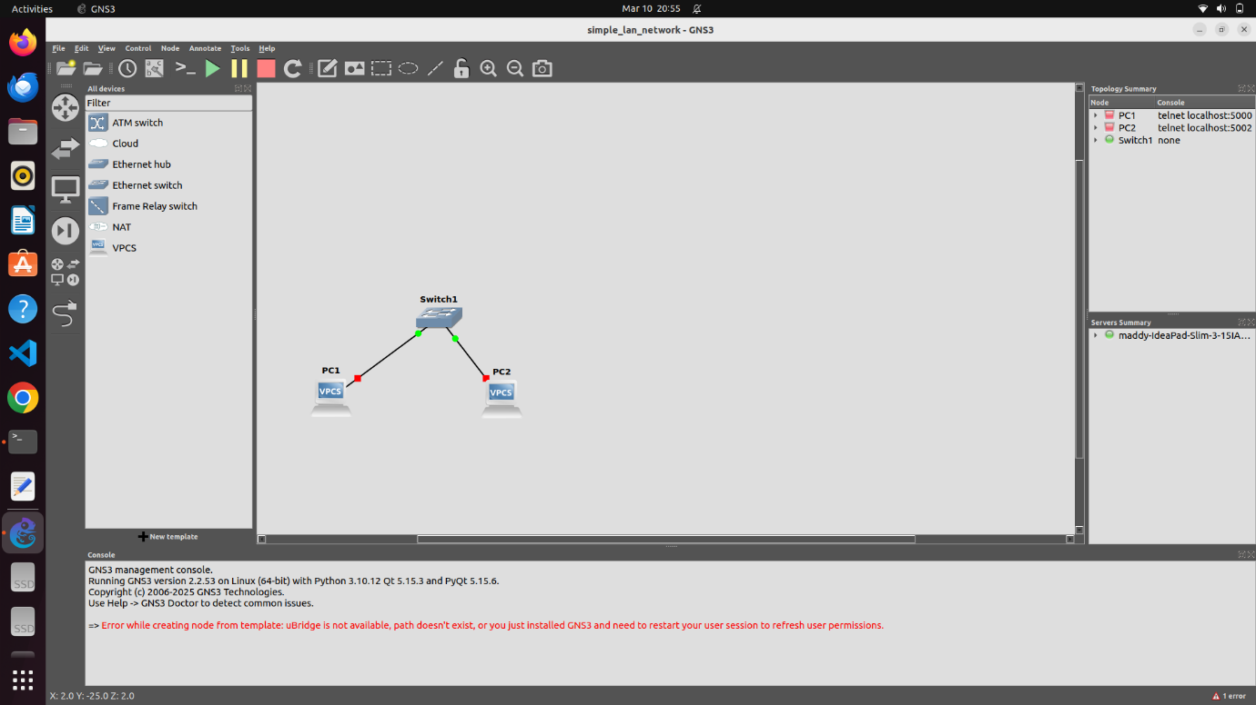

Two virtual pcs (built in ) and ethernet switch (built in) are dragged to workspace and connected as above.

1. From pc 1, via console option, virtual terminal access can be obtained from which IP for this pc can be assigned and another pc can be pinged as follows :

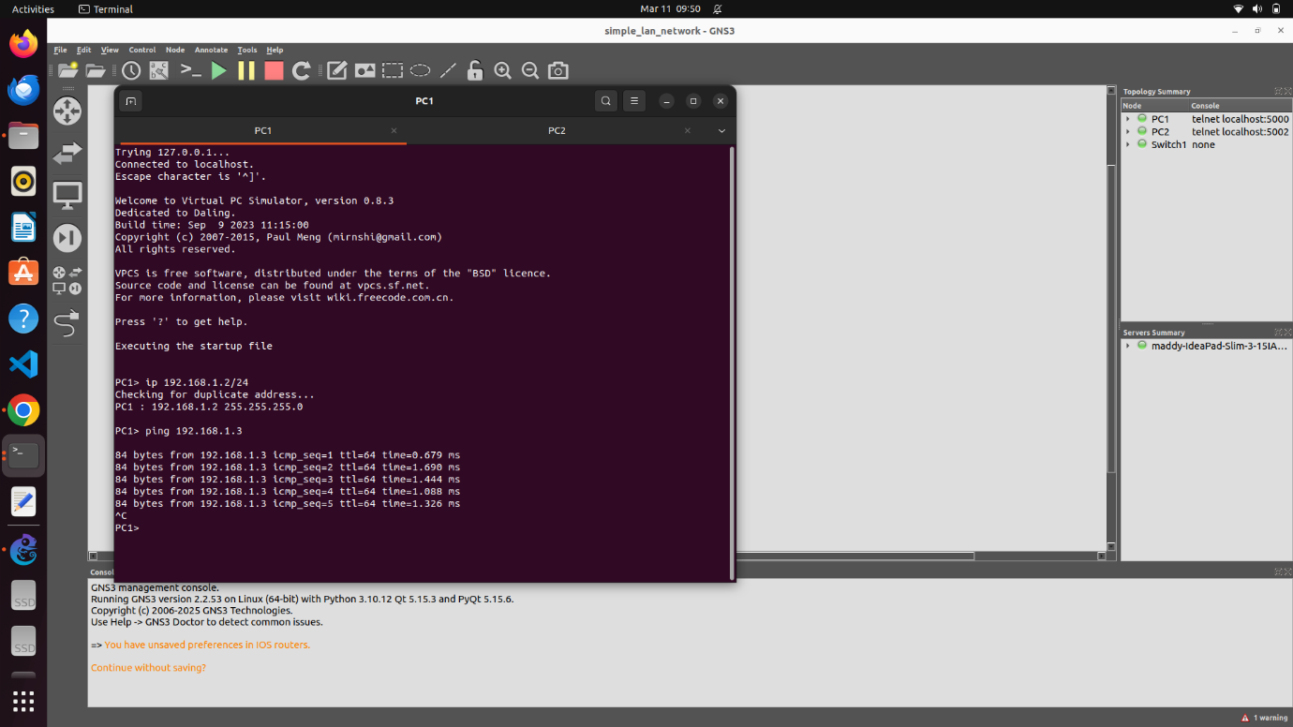

1. ARP learning of any pc can be viewed as follows:

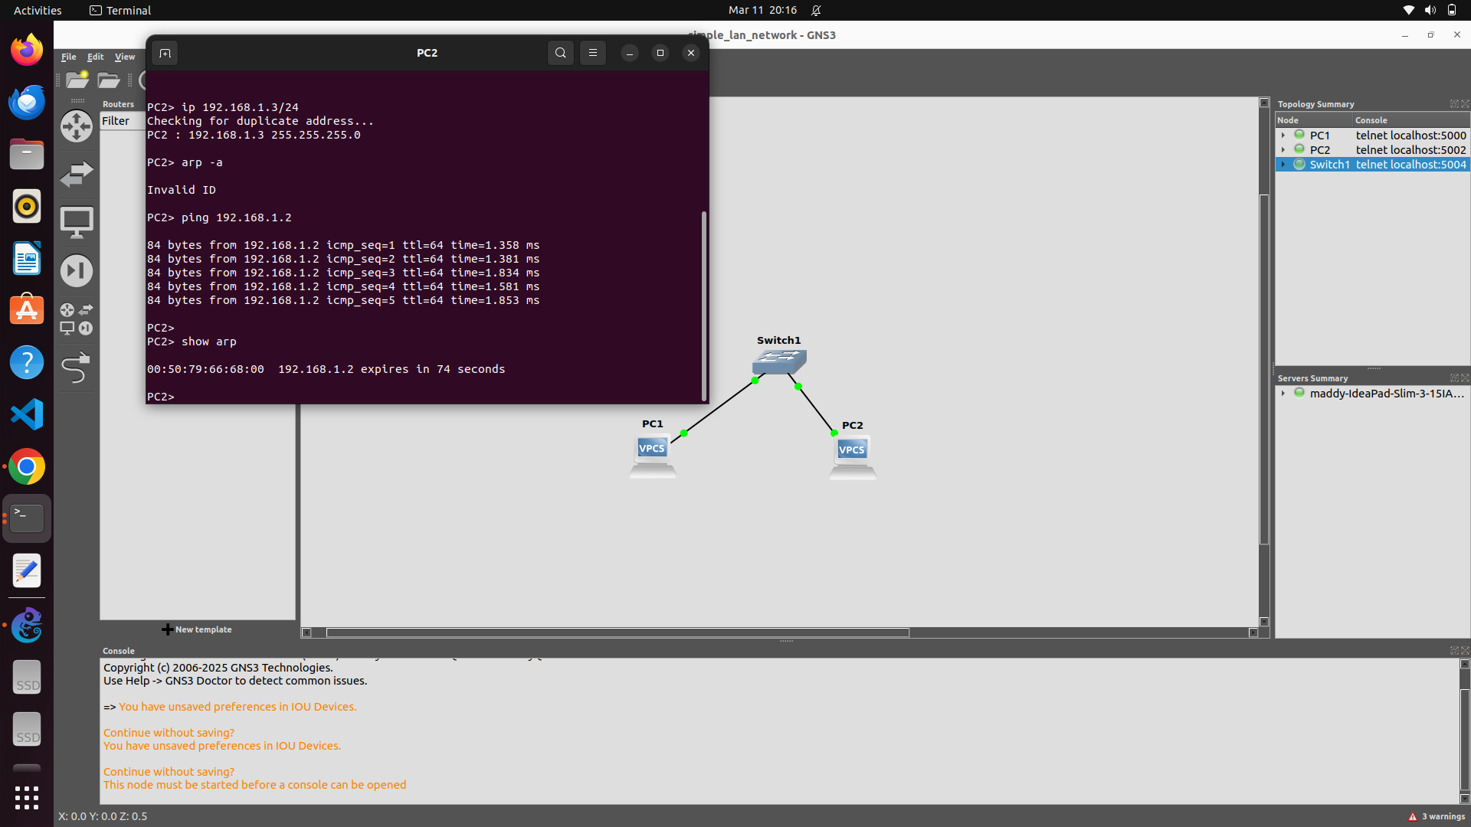

1. Once the network with appropriate IP (with subnet mask) is made ready, traffic capturing can be done by applying “capture packets” option on any particular interface (link) can be applied and when started , it by default opens wireshark window for capturing as follows :

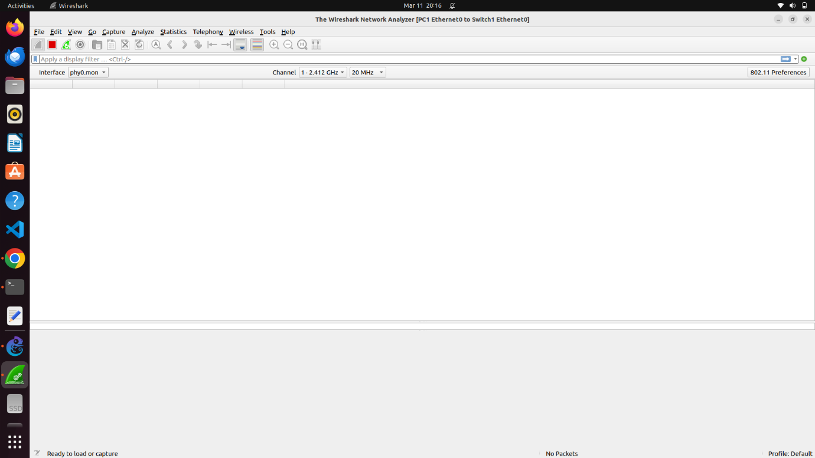

1. When all nodes are started via PLAY button in the gui, and if ping is applied from one pc, parallely wireshark can be observed for capturing packets as shown below

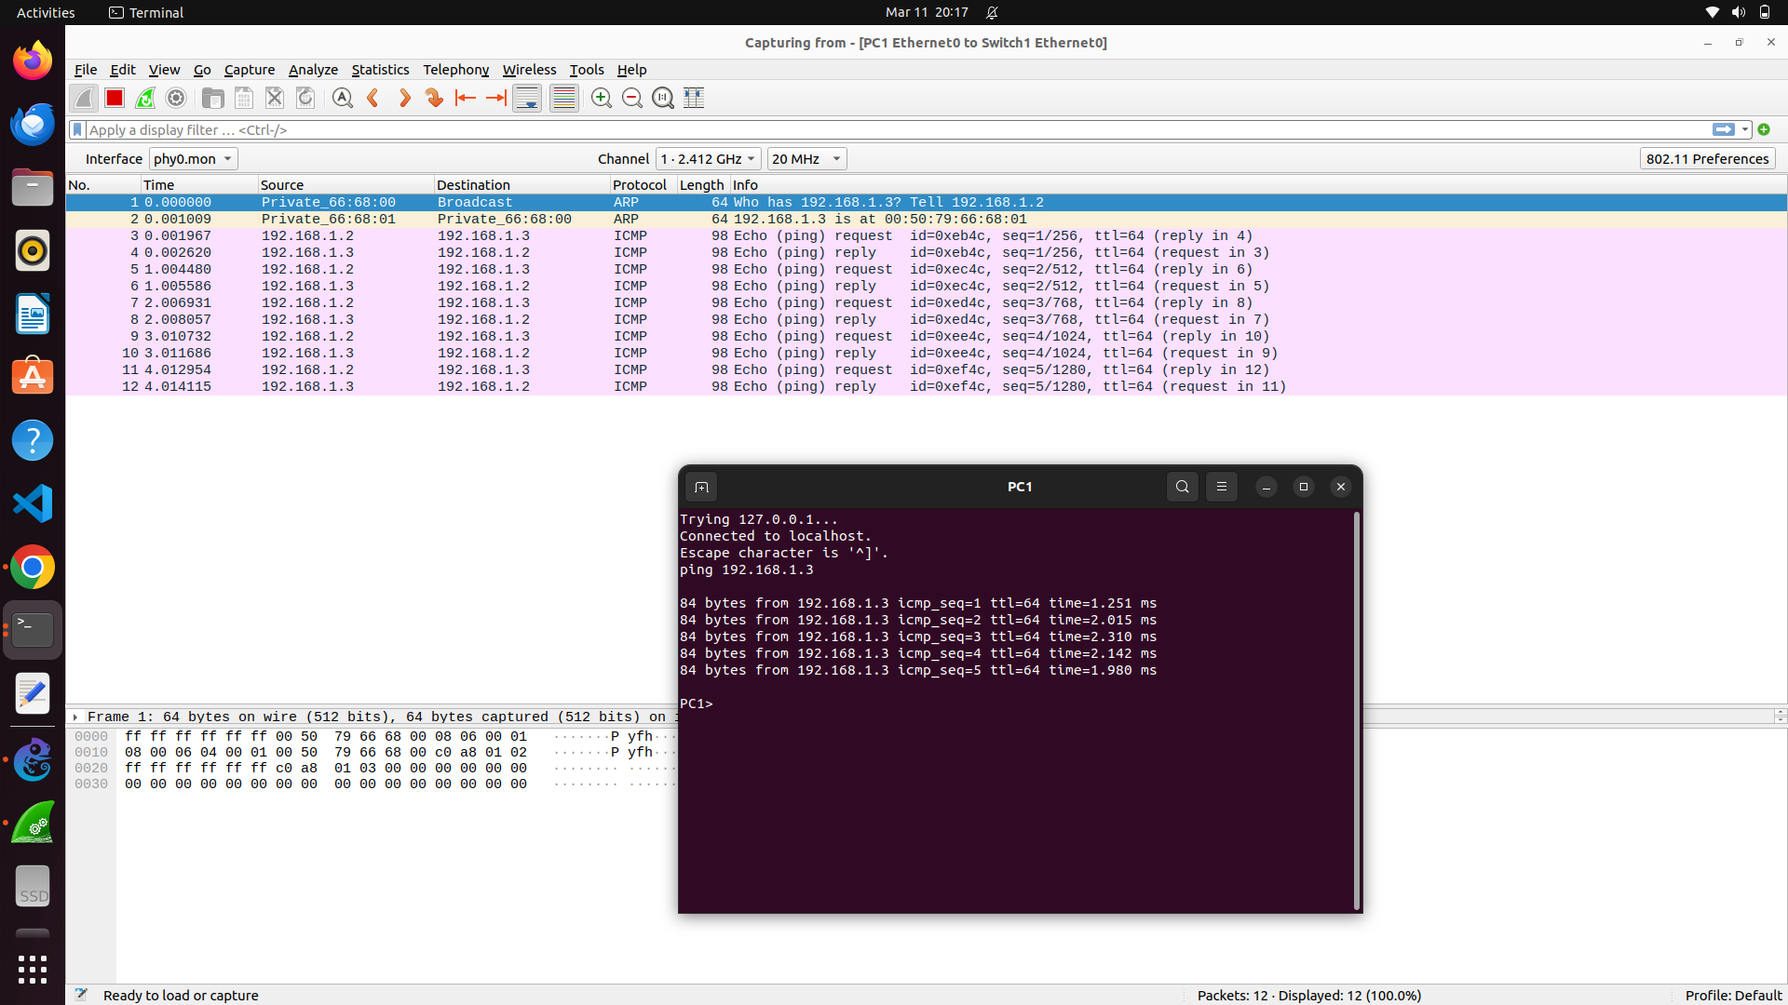

1. However, cisco-l2 switch (inbuilt) doesn’t have mac address table displaying option.

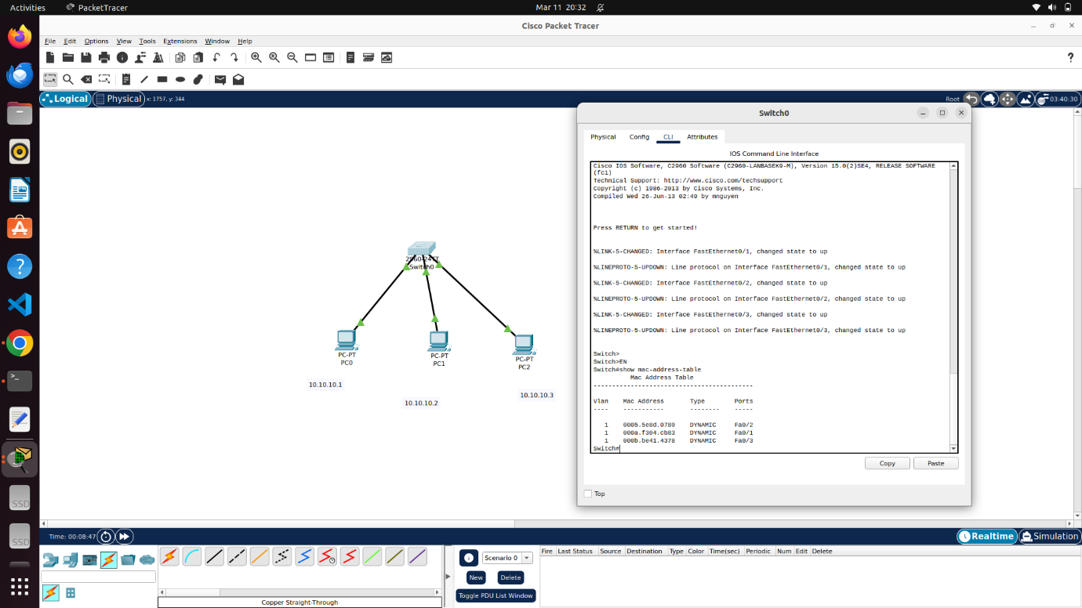

1. MAC address of pc can be changed via available GUI in cisco packet tracer as shown:

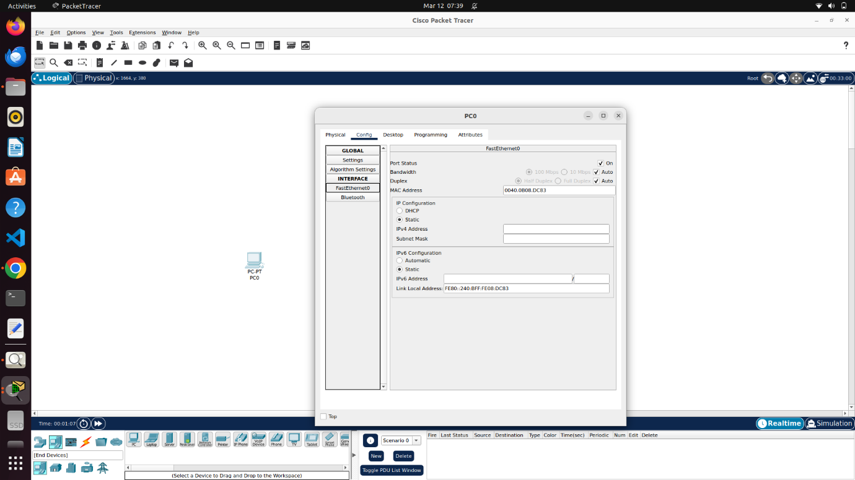

1. Mac address change can be reflected in switch mac address table and also in ipconfig /all as shown

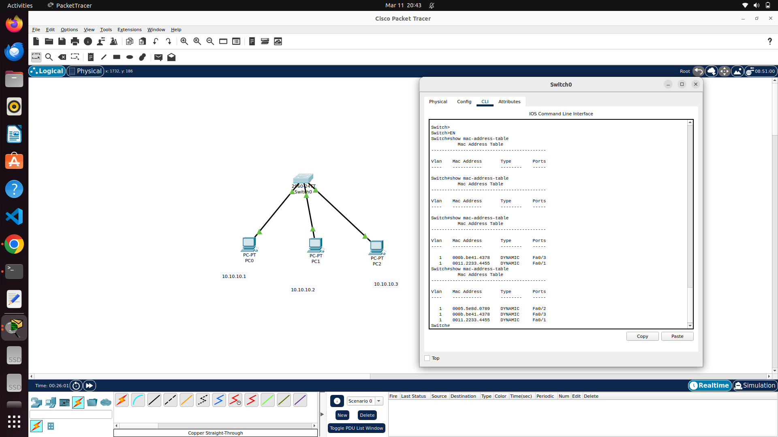

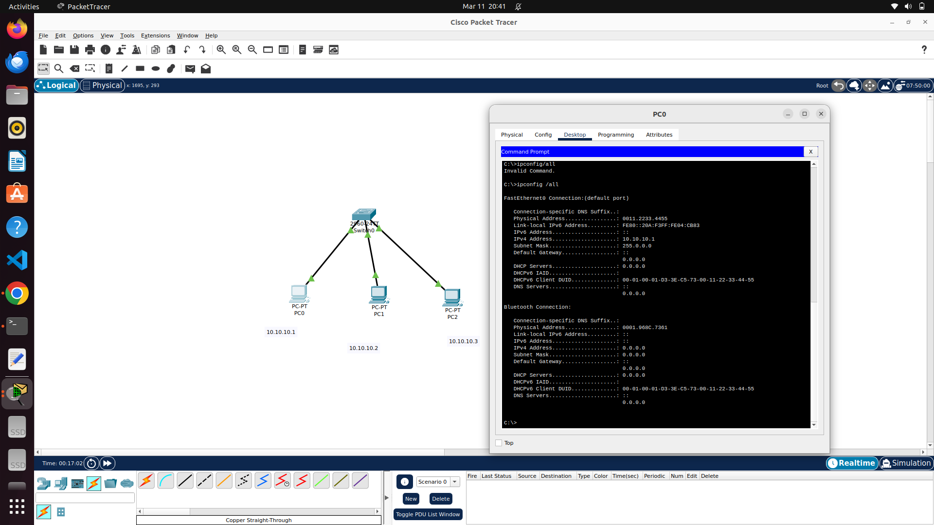

ETHERNET :

1. Ethernet is a widely used LAN (Local Area Network) technology that provides high-speed communication between devices.
2. It follows the IEEE 802.3 standard and uses packet-based communication with the CSMA/CD (Carrier Sense Multiple Access with Collision Detection) mechanism in older implementations (modern Ethernet uses full-duplex and switching to avoid collisions).
3. Ethernet frames are the fundamental data units transmitted over an Ethernet network. The frame structure ensures proper data encapsulation, addressing, error detection.
4. Ethernet frames has 7 major fields. They are as follows

* Preamble - Synchronization pattern for receivers (101010... repeated).
* Start Frame Delimiter (SFD) - Marks the beginning of the frame (10101011)

(NOTE: Ethernet follows Ethernet II (DIX Ethernet) for framing which is different from other framing protocol like HDLC – for WAN , PPP, BiSync etc and also uses TYPE field to identify higher layer protocols like ipv4,6,arp,vlan etc.)

* Destination MAC Address - Identifies the recipient device.
* Source MAC Address – identifies source device.
* EtherType / Length - defines higher layer protocols / 46-1500 bytes of data can be transmitted in ethernet. Length field explicitly mentions the length in case of length encapsulation to add padding if required in case if length is smaller than recommended 46 bytes to sustain during collision. If higher, should be fragmented.
* Payload (Data) - Contains the encapsulated data from higher layers.
* Frame Check Sequence (FCS) - CRC (Cyclic Redundancy Check).