SUBNETTING :

1. Subnetting is the process of dividing a large network into smaller, more manageable sub-networks (subnets).
2. It helps optimize IP address allocation, improve network security, and enhance performance by reducing congestion.
3. Each subnet functions as an independent network, reducing broadcast traffic and improving efficiency.
4. Isolating networks makes debugging easier and enhances security among subnets.
5. Subnetting process is majorly depending on SUBNET MASK which uses the important property of IP address that is HOST and NETWORK parts of IP address.
6. Either based on number of subnets or / and number of hosts per subnet , subnetting can be done from the given network address with initial subnet mask.
7. Types of subnetting is described as follows :

* Classful Addressing – by default, subnet masks are fixed leading to IP wastage and heavier broadcast domain thus increasing network congestion and endangers the security and isolation on the sub-domains if required. Eg. Class A (/8) , B (/16) , C (/24)
* Fixed length subnetting – this is the process by which subnets of fixed number of hosts per subnet can be achieved for as many subnets as required. Though efficient, it may lead to spare IP’s per subnet if number of hosts in any subnet is less than the available IP
* Variable Length Subnetting – This process uses VLSM (Variable Length Subnet Mask) to create subnets with flexible number of hosts per subnet as per requirements thereby reducing spare IP’s and thus standing as common choice of subnetting in modern networking.

Given the network ID 192.168.1.0/24 -> create 4 equal subnets.

1. Default subnet mask = /24 = 255.255.255.0
2. To create 4 nets -> 2^2 = 4 -> 2 extra host bits required
3. Thus new subnet mask = /26 = 255.255.255.192

Treating the host part of the IP as follows to create subnets.

First subnet : (00 000000 to 00 111111) -> 192.168.1.0 to 192.168.1.63

* Network address = 192.168.1.0/26
* Usable ip = 192.168.1.1/26 to 192.168.1.62/26
* Broadcast address = 192.168.1.63/26

Second subnet : (01 000000 to 01 111111) -> 192.168.1.64 to 192.168.1.127

* Network address = 192.168.1.64/26
* Usable ip = 192.168.1.65/26 to 192.168.1.126/26
* Broadcast address = 192.168.1.127/26

Third subnet : (10 000000 to 10 111111) -> 192.168.1.128 to 192.168.1.191

* Network address = 192.168.1.128/26
* Usable ip = 192.168.1.129/26 to 192.168.1.190/26
* Broadcast address = 192.168.1.191/26

Fourth subnet : (11 000000 to 11 111111) -> 192.168.1.192 to 192.168.1.255

* Network address = 192.168.1.192/26
* Usable ip = 192.168.1.193/26 to 192.168.1.254/26
* Broadcast address = 192.168.1.255/26

The below image demonstrates the construction of two subnets using first and second subnets that were created above (for demonstration , in each subnets, only two devices considered managed by switch with two intermediate routers)

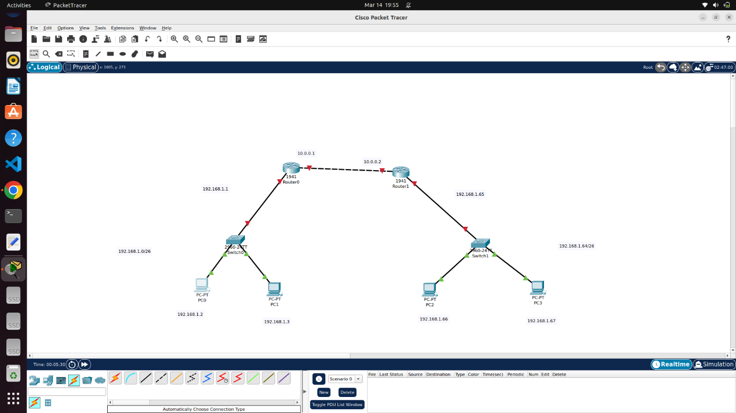

Sample PC configuration Sample Router configuration

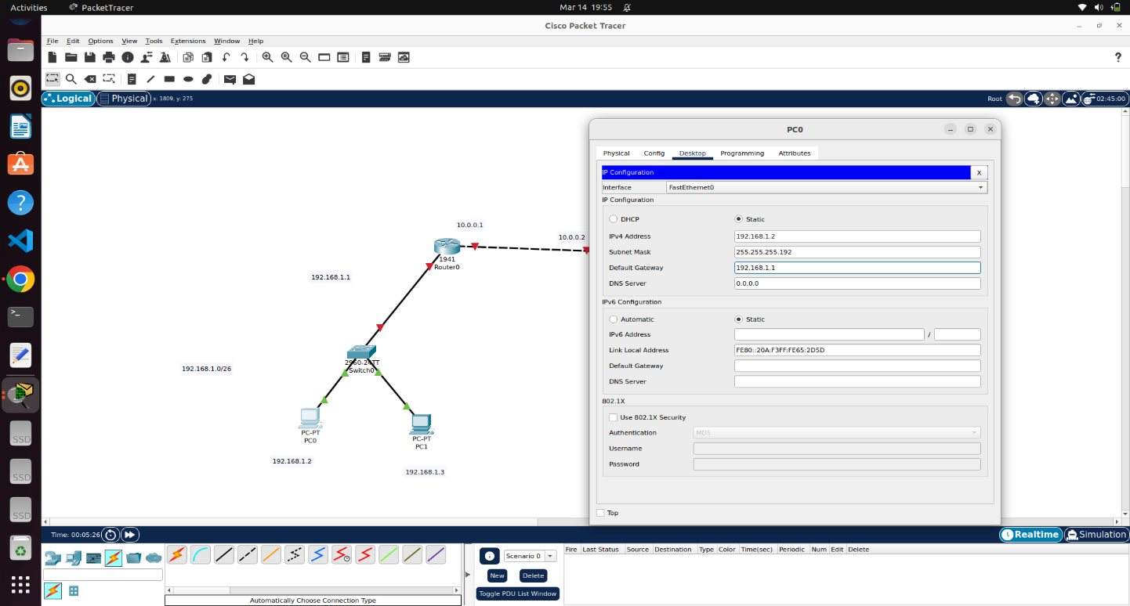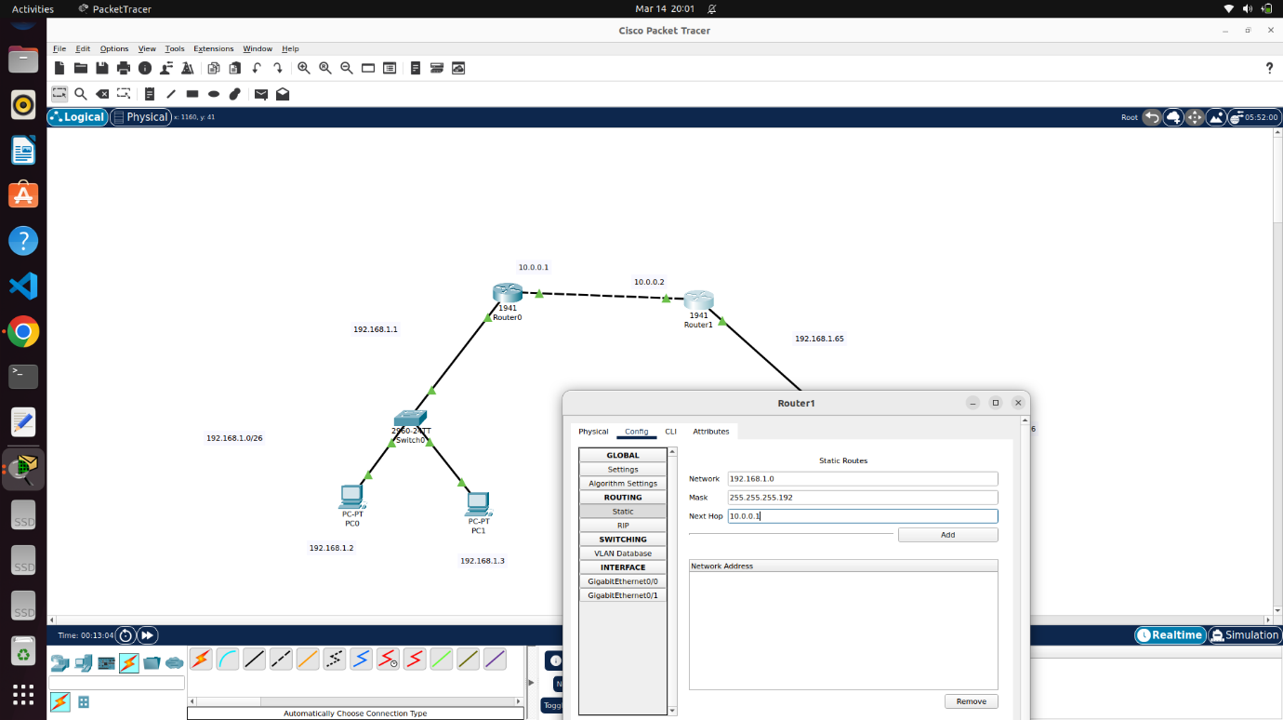

RESULT (BY PINGING A DEVICE IN OTHER SUBNET)

