ARP (ADDRESS RESOLUTION PROTOCOL) :

1. It works on layer 2 in OSI model
2. Used to resolve mac address for given IP address inside same network.
3. Packet structure for request and reply cases in ARP looks similar with following fields:
4. Hardware type and Protocol type
5. Hardware address length (mac) and protocol address length (ip)
6. Options (1- request and 2- reply)
7. Hardware and protocol addresses for sender and receiver
8. Use cases for ARP protocol is discussed below :
9. Sending packets to destination in same network.

* At first, sender ensures destination node in same network by doing logical AND between dest IP and subnet mask to obtain its own network ID. If both matched, it proceeds.
* It sends ARP request to switch (or hub too) (switches always learn from source mac to switch port mapping) and request will have all “F” mac address of target indicating broadcast
* Intended dest device responds by unicasting the reply for ARP via switch.
* With this information, actual data transmission happens further.

1. Sending data to external network

* Here, source device knows that dest IP is not in the same network.
* Thus, in order to forward the request to external network , it uses default gateway
* However, to send actual data to default gateway, it requires its mac. Thus it does the same process above with IP of default gateway in this case.

1. Gratuitous ARP

* It is the case where before and after DHCP to ensure IP assignment is valid.
* Before assigning IP to requesting device , dhcp server issues this request confirming for the absence of any other device with same IP (requesting device in dhcp can suggest IP too for dhcp server to assign possibly if present, in this case, this check will be helpful)
* After the offer issue, client will also perform this to re ensure the same.
* Sometimes, client instead of checking, announces in the network that it is going to hold this IP by having in both src and dest IP as it holds with target mac all “0” to distinguish gratuitous packet.

ARP REQUEST PACKET :

This particular image demonstrates the case -b discussed above.

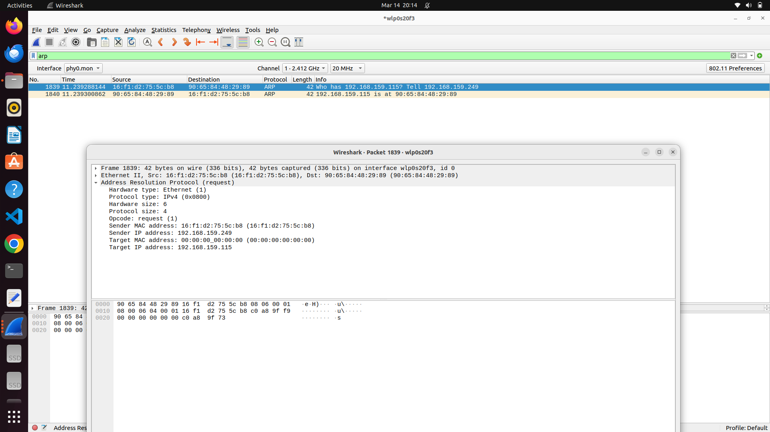

ARP REQUEST :

