STATIC ROUTER CONFIGURATION :

1. Router is the layer-3 device which works on the basis of IP addressing.
2. Its main task is to forward the data packets to the best possible interface to it with the help of routing table.
3. Routing table typically consists of Destination Network ID , subnet mask , next hop as columns
4. It by default has one entry which routes to its default port leading to ISP router in case no entries got matched during packet check. It means that data packet should go to external network or internet not to the neighboring networks.
5. Routing protocols are classified into interior and exterior based on domains where domain is the single autonomous system which has many networks and routers in it and managed as a single entity.
6. Routing Information Protocol (using distance vector routing) and Open Shortest Path First (OSPF) are two important routing protocols under interior gateway routing.
7. RIP algorithms works by considering only distance as metric and leads to delayed convergence since it sends the routing info about all nodes to neighbors.
8. OSPF algorithm works by considering practical routing metrics like hop, propagation delay, bandwidth , traffic etc. it disseminates the information about neighbors to all leading to quick convergence.

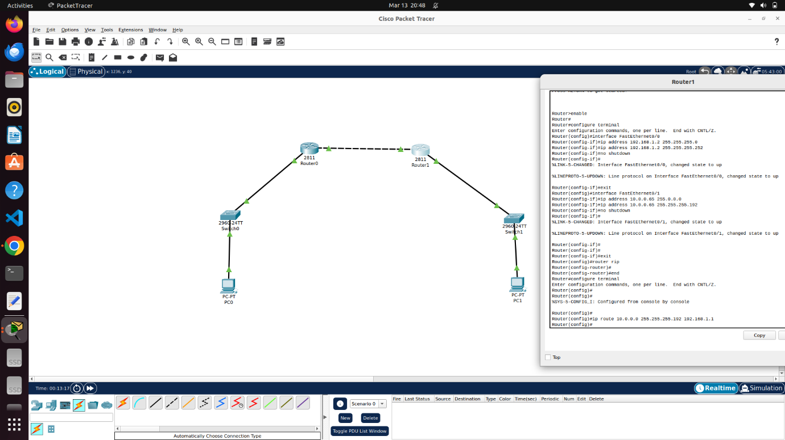

Each interface of router to be defined with its own IP, subnet mask.

Here, to add routing table statically, following syntax to be used :

ip route <dest net id> <subnet mask> <next hop>

