SUBNETTING :

1. Subnetting is the process of dividing a large network into smaller, more manageable sub-networks (subnets).
2. It helps optimize IP address allocation, improve network security, and enhance performance by reducing congestion.
3. Each subnet functions as an independent network, reducing broadcast traffic and improving efficiency.
4. Isolating networks makes debugging easier and enhances security among subnets.
5. Subnetting process is majorly depending on SUBNET MASK which uses the important property of IP address that is HOST and NETWORK parts of IP address.
6. Either based on number of subnets or / and number of hosts per subnet , subnetting can be done from the given network address with initial subnet mask.
7. Types of subnetting is described as follows :

* Classful Addressing – by default, subnet masks are fixed leading to IP wastage and heavier broadcast domain thus increasing network congestion and endangers the security and isolation on the sub-domains if required. Eg. Class A (/8) , B (/16) , C (/24)
* Fixed length subnetting – this is the process by which subnets of fixed number of hosts per subnet can be achieved for as many subnets as required. Though efficient, it may lead to spare IP’s per subnet if number of hosts in any subnet is less than the available IP
* Variable Length Subnetting – This process uses VLSM (Variable Length Subnet Mask) to create subnets with flexible number of hosts per subnet as per requirements thereby reducing spare IP’s and thus standing as common choice of subnetting in modern networking.

Given the network ID 10.0.0.0/24 -> create 4 equal subnets.

1. Given subnet mask = /24 = 255.255.255.0
2. To create 4 nets -> 2^2 = 4 -> 2 extra host bits required (64 hosts)
3. Thus new subnet mask = /26 = 255.255.255.192

Treating the host part of the IP as follows to create subnets.

First subnet : (00 000000 to 00 111111) -> 10.0.0.0 to 10.0.0.63

* Network address = 10.0.0.0/26
* Usable ip = 10.0.0.1/26 to 10.0.0.62/26
* Broadcast address = 10.0.0.63/26

Second subnet : (01 000000 to 01 111111) -> 10.0.0.64 to 10.0.0.127

* Network address = 10.0.0.64/26
* Usable ip = 10.0.0.65/26 to 10.0.0.126/26
* Broadcast address = 10.0.0.127/26

Third subnet : (10 000000 to 10 111111) -> 10.0.0.128 to 10.0.0.191

* Network address = 10.0.0.128/26
* Usable ip = 10.0.0.129/26 to 10.0.0.190/26
* Broadcast address = 10.0.0.191/26

Fourth subnet : (11 000000 to 11 111111) -> 10.0.0.192 to 10.0.0.255

* Network address = 10.0.0.192/26
* Usable ip = 10.0.0.193/26 to 10.0.0.254/26
* Broadcast address = 10.0.0.255/26

Image below is the demonstration of implementing four different subnets using VLAN (Virtual LAN) concept. It is the way by which single switched network can be logically segmented into multiple networks thereby reducing the broadcast domain and enhancing security inside LAN. Traffic within same VLAN can be managed by switch but inter-VLAN traffic is maintained by router (vlan enabled).

Types of VLAN :

1. Default VLAN – type of VLAN all switch ports by default allocated with (mostly vlan - 1). This is the reason why without specifying vlan, broadcast domain is the entire switched network.
2. Native vlan – type of vlan where all untagged (tagging is the process by which vlan data forwarding with IEEE 802.1q Standard encapsulation with Ethernet frame with unique vlan number) traffic will be allocated with a specific vlan number (native vlan number – can be changed)
3. Data , voice , management vlan – a logical segmentation inside LAN to carry only user data, user voice and managing networking devices respectively.
4. Router-on-a-stick (Roas) is the possible implementation by which sub interfaces for this router can be configured to handle each vlan traffic as like having two or more subnets managed by more than one intermediate routers.
5. Access ports are the switch ports which carry untagged frames typically by end hosts.
6. Trunk ports are the switch ports which carry tagged traffic between switch to switch or to routers for inter vlan routing.

VLAN BASED NETWORK CONSTRUCTION FOR IMPLEMENTING ALL THE CREATED SUBNETS USING SINGLE SWITCH AND ROUTER

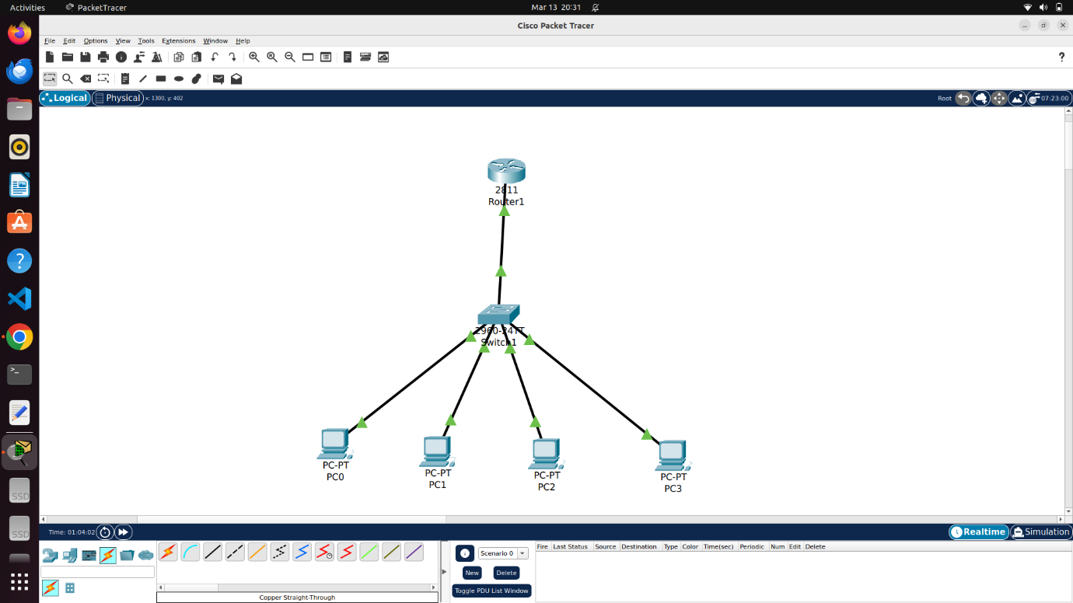

PC0 – 10.0.0.2

PC1 – 10.0.0.66

PC2 – 10.0.0.130

PC3 – 10.0.0.194

For switch, individual VLAN to be declared with its tag and each switch port to be either marked as access or trunk port.

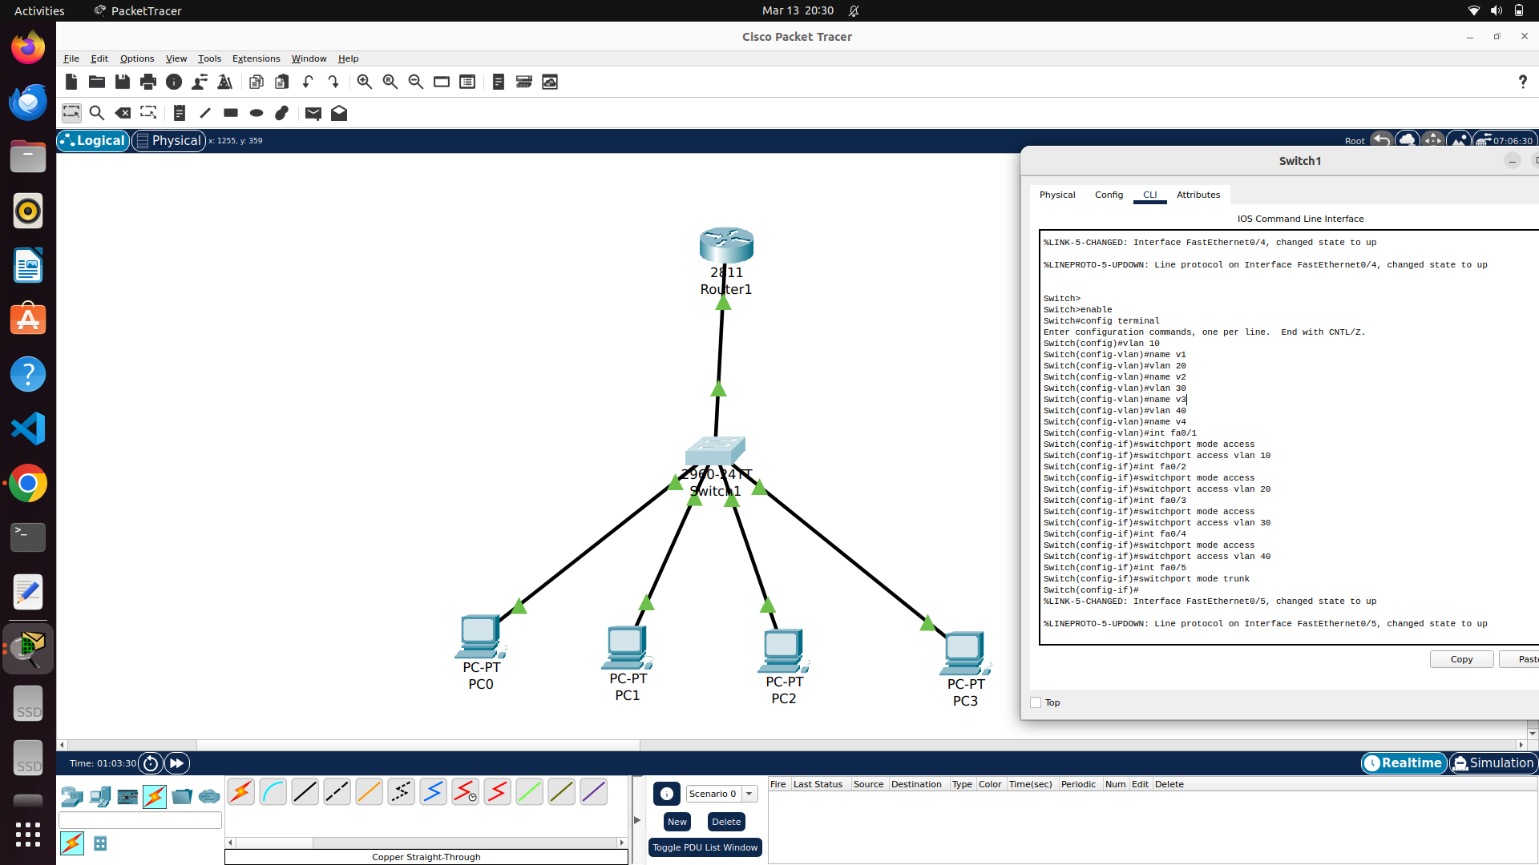

For router, each interface to be defined and should made up , followed by creating sub interfaces as per IEEE 802.1Q and assigning with available vlan and provide IP and subnet mask.

