MANAGEMENT VIRTUAL LOCAL AREA NETWORK

1. It is a type of vlan which is specifically to access and manage the networking devices like switch, router etc.
2. To test SSH access to the switch, following are to be done:

* Assign a vlan as management vlan
* Assign IP and subnet mask for that vlan interface in switch
* Connect pc to that vlan interface with the IP that belongs to same network as configured for that vlan (vlan interface ip should be the default gateway)
* Label the pc connection vlan port as access port.
* Set a hostname for the switch
* Set a domain name
* Generate RSA keypairs for SSH (1024 bit keys can be preferred)
* Username, password and priviledge of SSH login to be provided
* Enable SSH on virtual terminal and limit number of devices that can participate in SSH session
* From the pc, request ssh access with username , IP and give password when prompted.
* To troubleshoot if any errors, “show users” to check active ssh users and “sudo ip interface brief” to check whether the vlan interface is up or not.

DEMONSTRATION :

1. Image showing necessary switch configurations (in cli commands) with the network made.

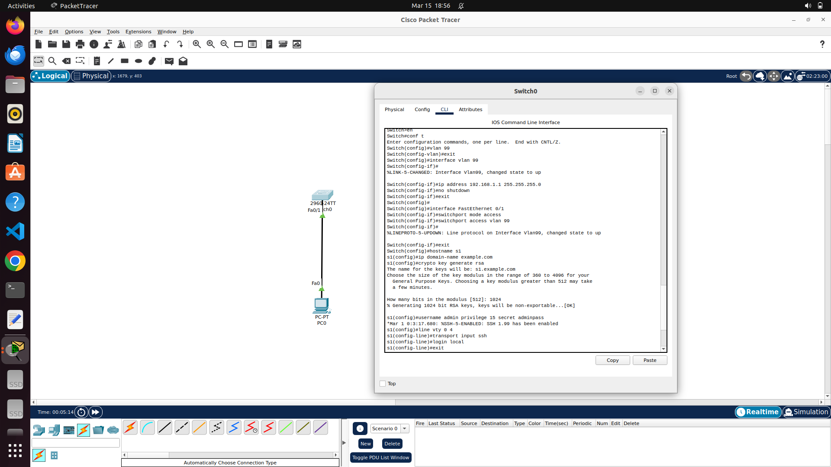

1. Image showing PC IP configuration as stated above.

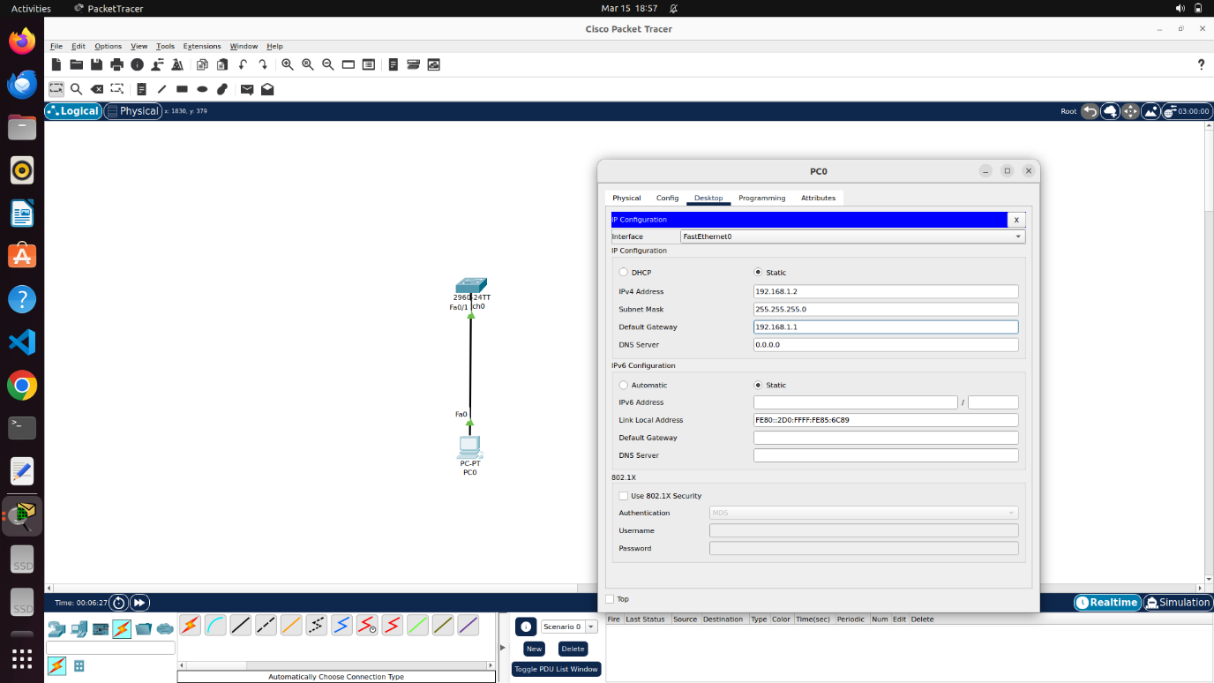

1. Image showing both ping and ssh results from PC to switch (management vlan interface)

