TELNET (TELECOMMUNICATION NETWORK) :

INTRODUCTION :

1. It is one of the application layer protocols as like SSH , used for remote access (using TCP).
2. By default, it works on port 23.
3. However, telnet is insecure since it doesn’t include any encryption mechanisms thus transmitting the data as plaintext making it vulnerable to security attacks like man in the middle attack.

DEMONSTRATION :

1. To enable telnet server in linux, xinetd and telnetd should be installed and it can be started by using sudo systemctl start xinetd as follows: (should yield “Active (running) when status is checked) , can also confirm by checking the port usage using netstat command (uses port 23 by default)

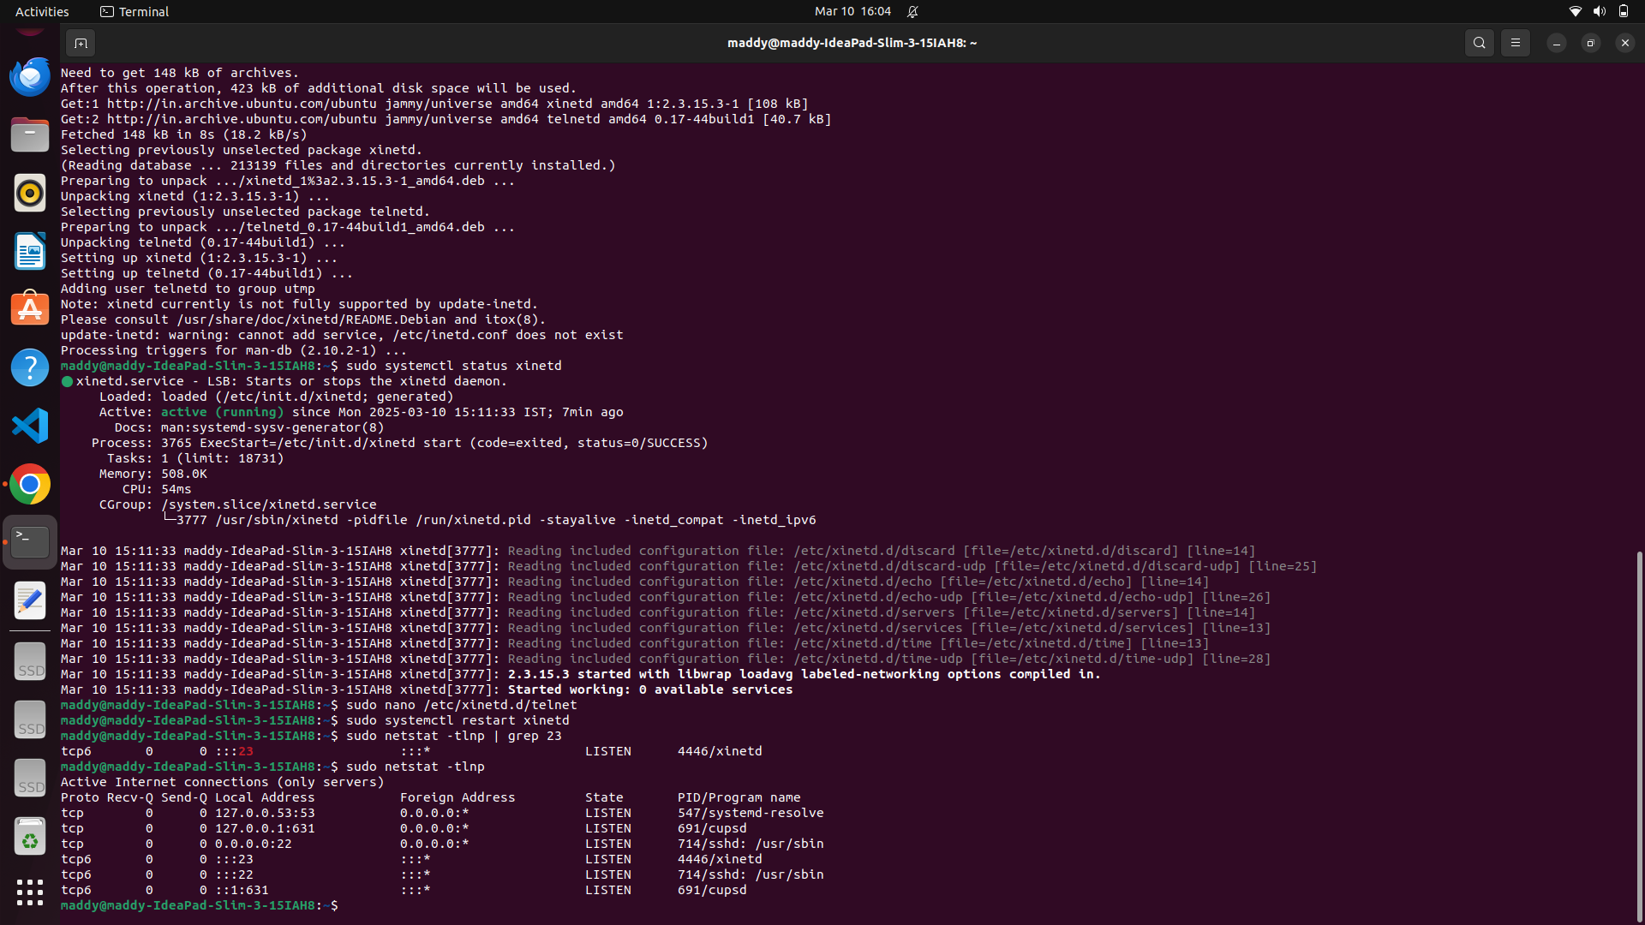

1. Now from client machine, (ensure all the above packages are installed), use the following syntax : telnet <IP or hostname> (Here, localhost is demonstrated) as follows:

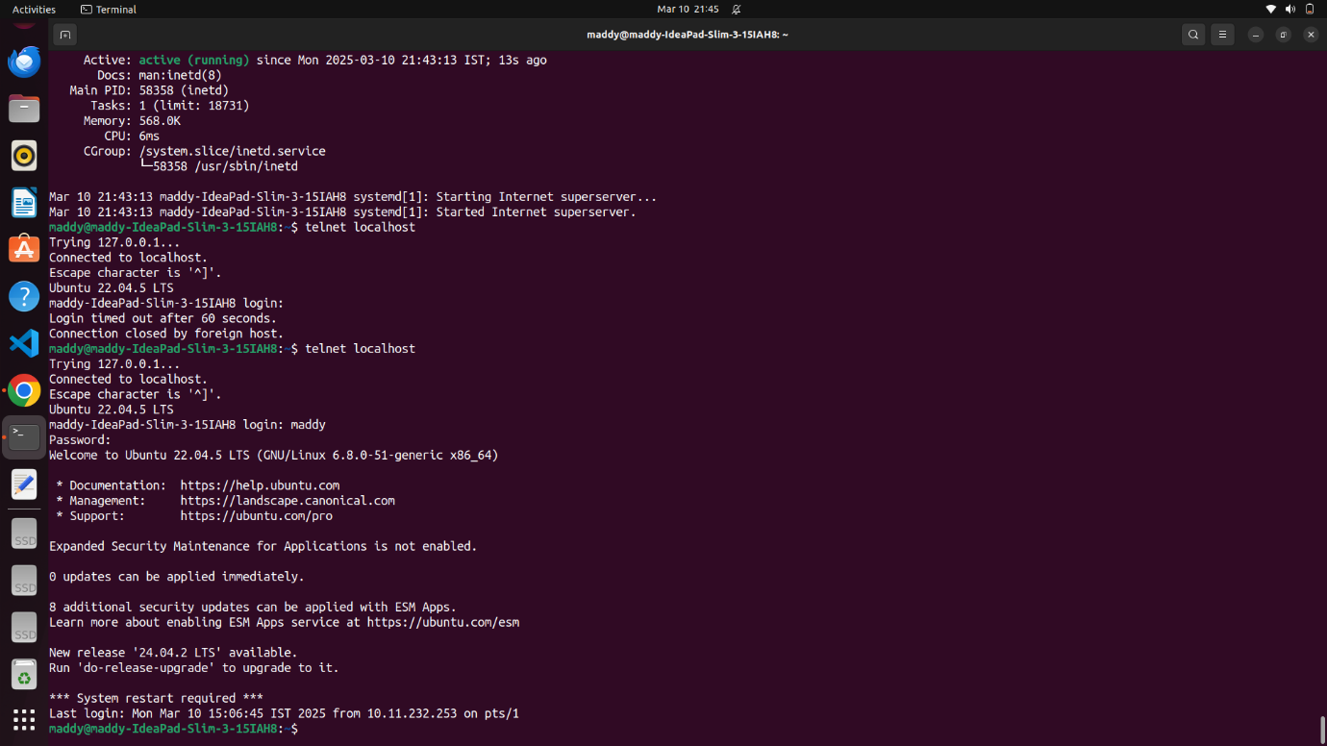

(It asks for username and password if enabled and will be checked in server side, if matches, then it allows client machine to have remote access to execute commands)

1. To exit the session, use “exit” command or ctrl + ‘[‘ in client terminal.