ASSIGNMENT-2

Environment Variable

1. How can you know what is the secondary command prompt set your system ?
How can you change the secondary command prompt from the default to your username ?

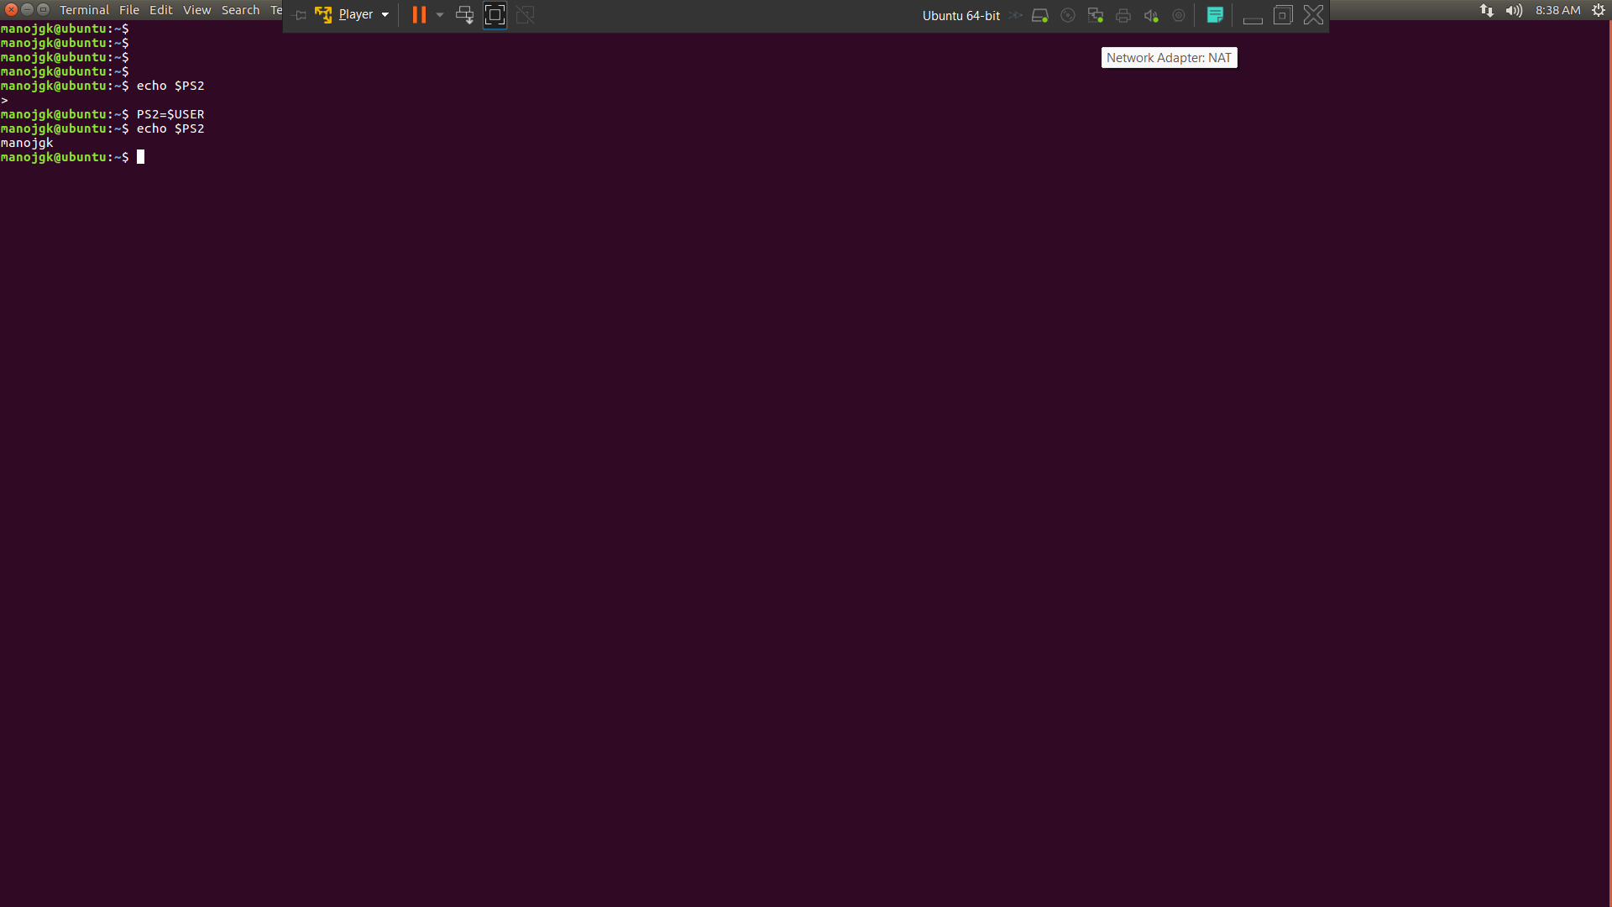

Basics Of System Administration in Linux

1) Create a new user account and home directory called "Duck"

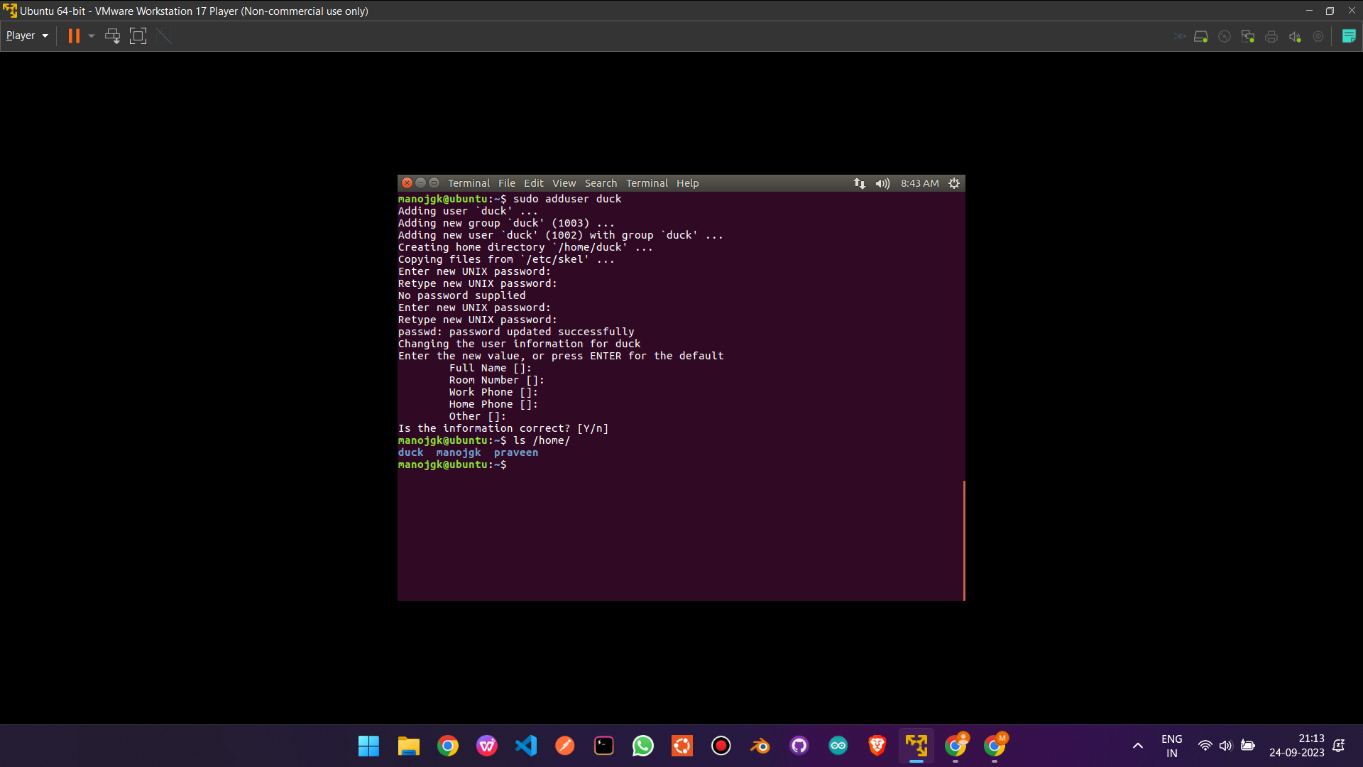
3) find the id of the user account "Duck"
4) Type df and du commands and see the output on your terminal.

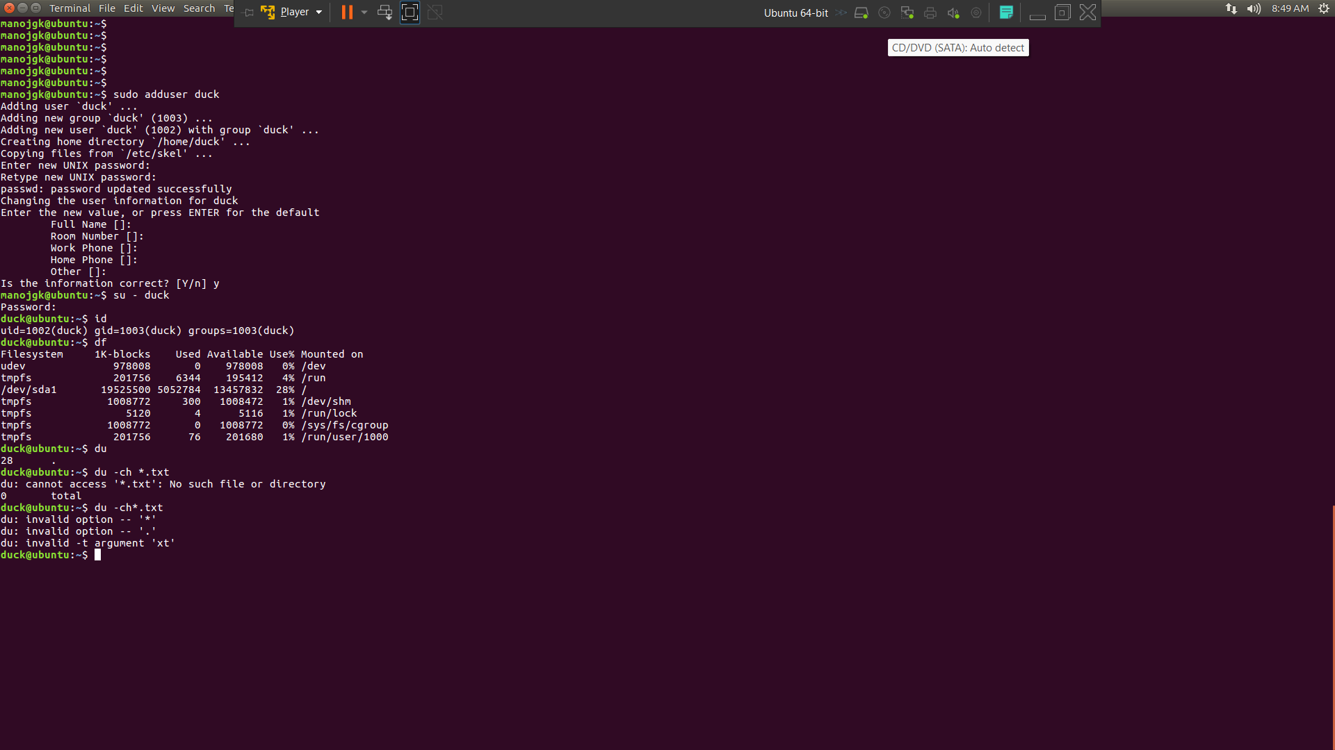
2) Set the user account "Duck's" expirey date as 07 - 01 - 2015
5) Type this command on the terminal and see the output :
du -ch *.txt
- Delete the user account "Duck" permanently along with its home folder.
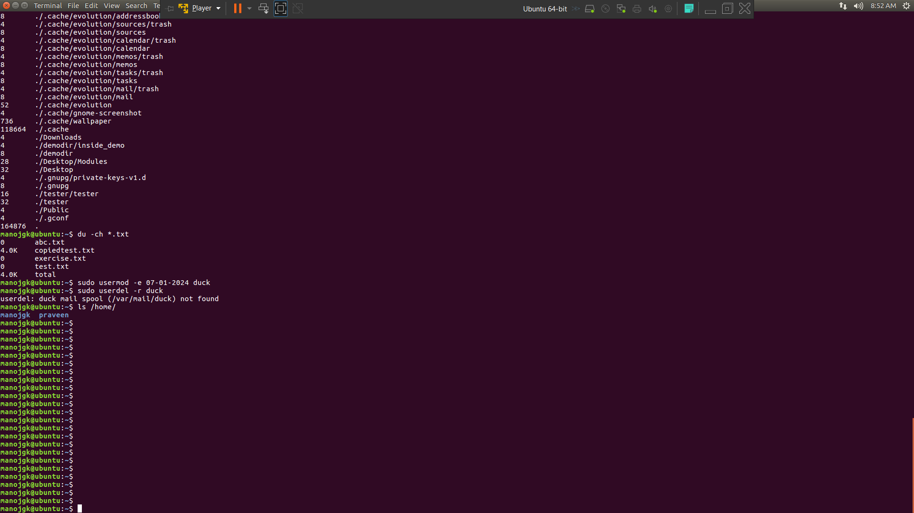

SIMPLE FILTERS

HEAD
- Try to get the first 10 lines from /etc/passwd
- Try to get just the first 3 lines from /etc/passwd
TAIL
- Try to get the Last 10 lines from /etc/passwd
- Try to get just the Last 3 lines from /etc/passwd
- Try to follow the log file /var/log/auth.log
SORT
- Try to sort the file /etc/passwd in ascending order.
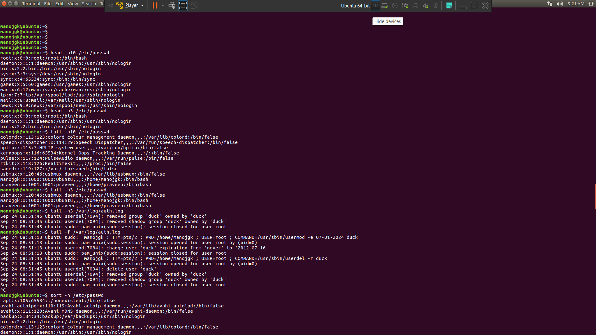
- Try to sort the file /etc/passwd in decending order.
- Try to sort the file /etc/passwd in assending order based on the 3rd column.
4.Try to sort the file /etc/passwd in assending order based on the 3rd column and ask sort to look at the thrid column as a whole number

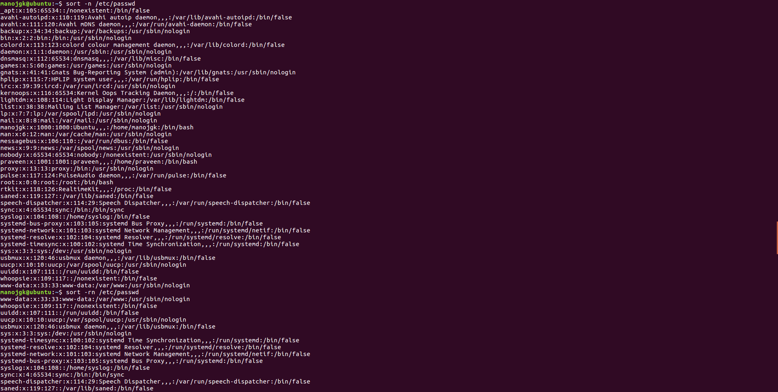

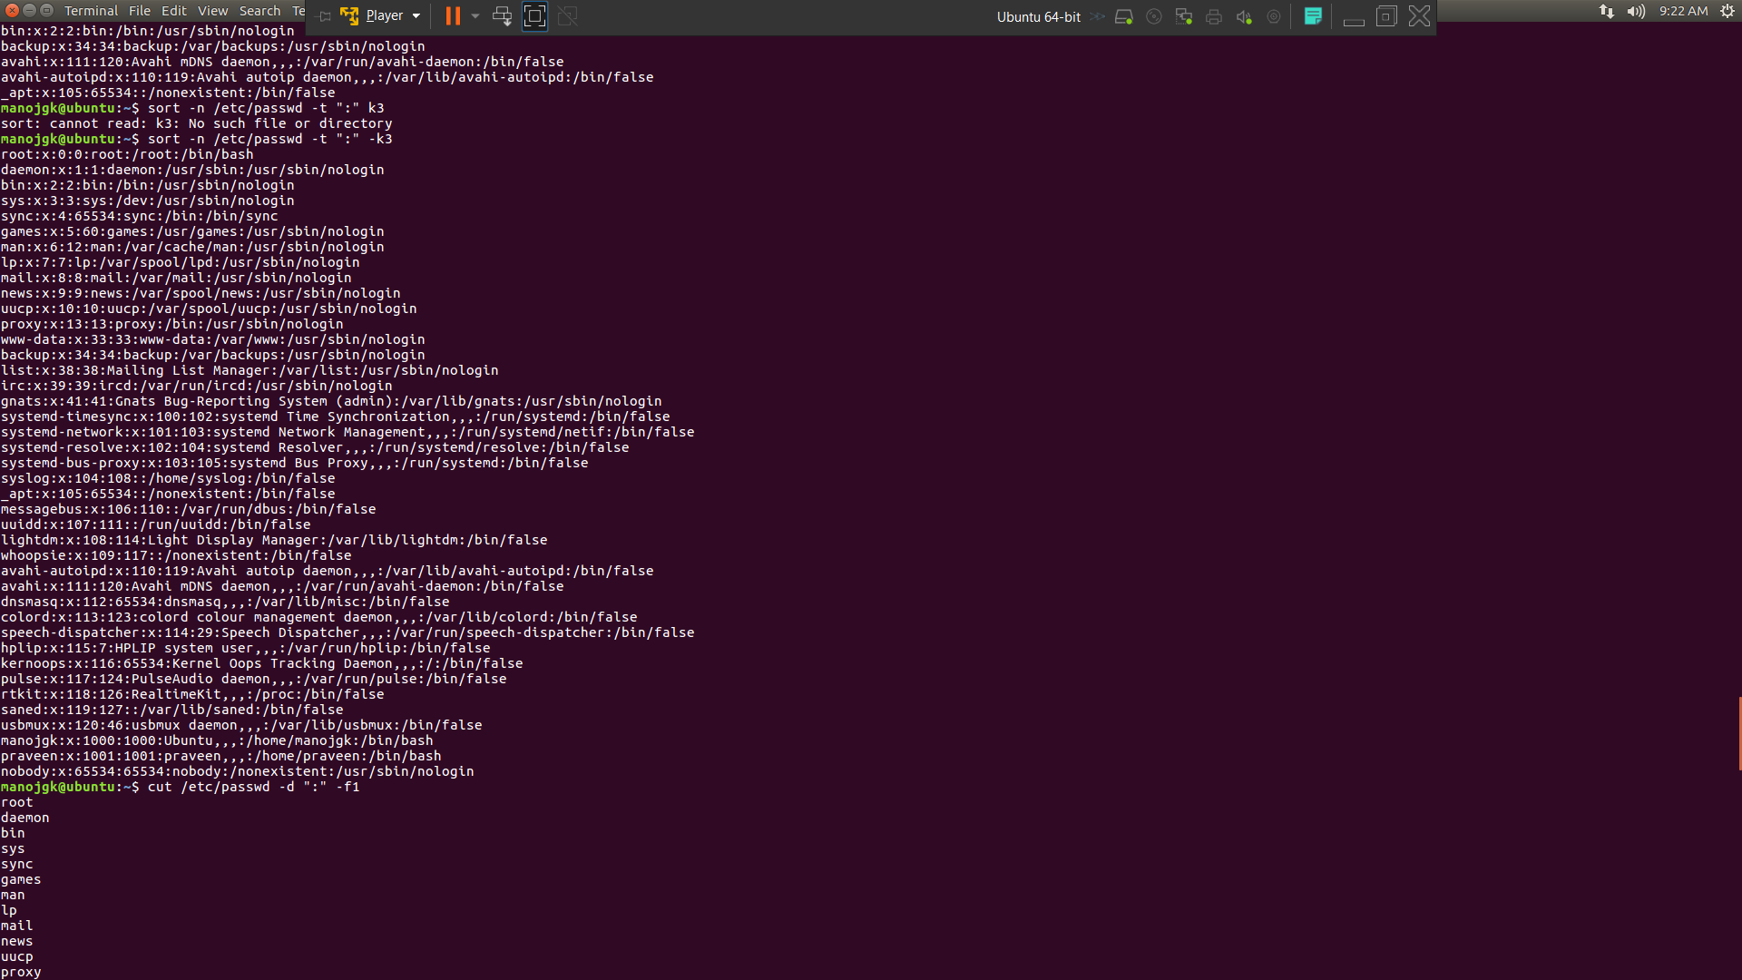

CUT
Try to cut just the usernames from the file /etc/passwd
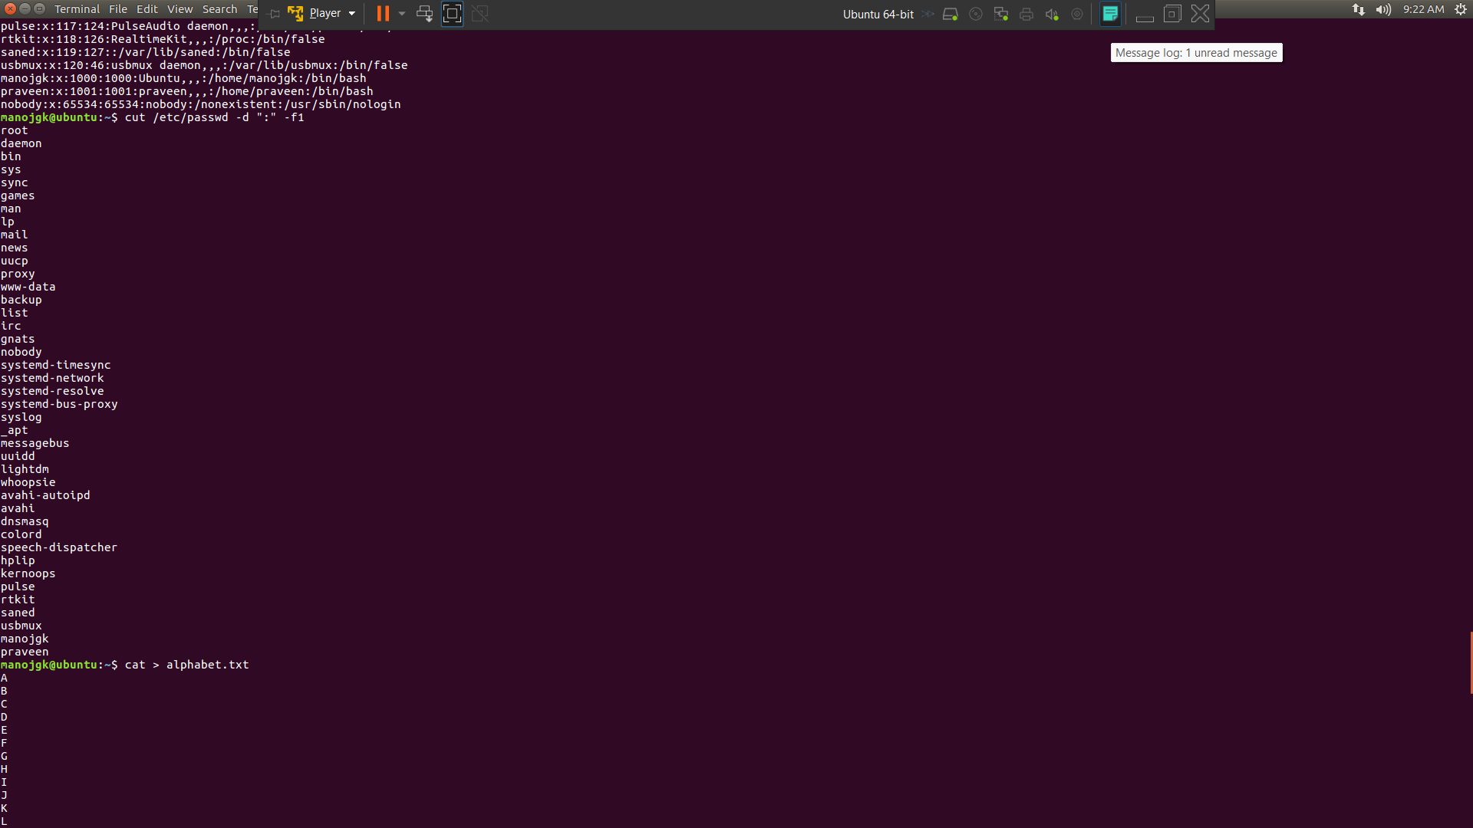
PASTE
- Create a file alphabets.txt and key in all the 2\6 alphabets each one in a new line.
- Create a file number.txt and key in 1 to 2\6 each one in a new line.
- Try to paste those two files, to see which letter appears at what number. Paste alphabets.txt numbers.txt

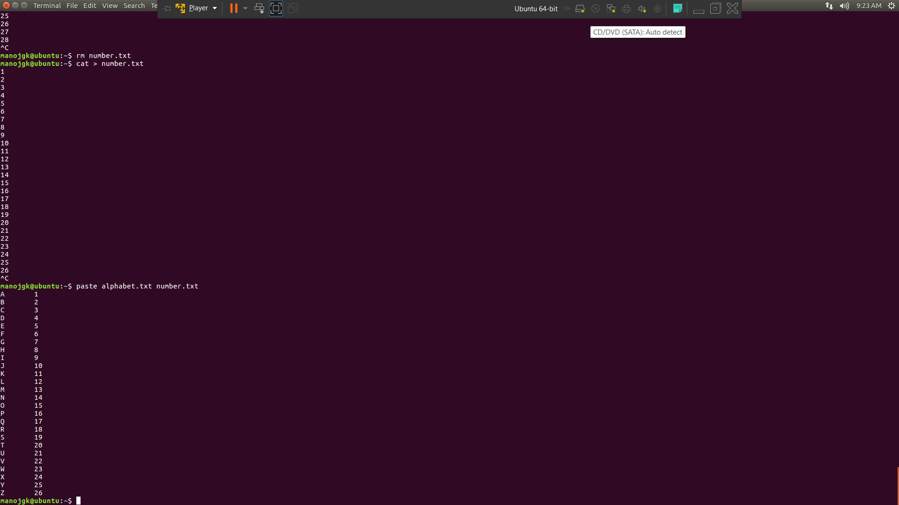
GREP
- Explore some other commands like -E, + and ?

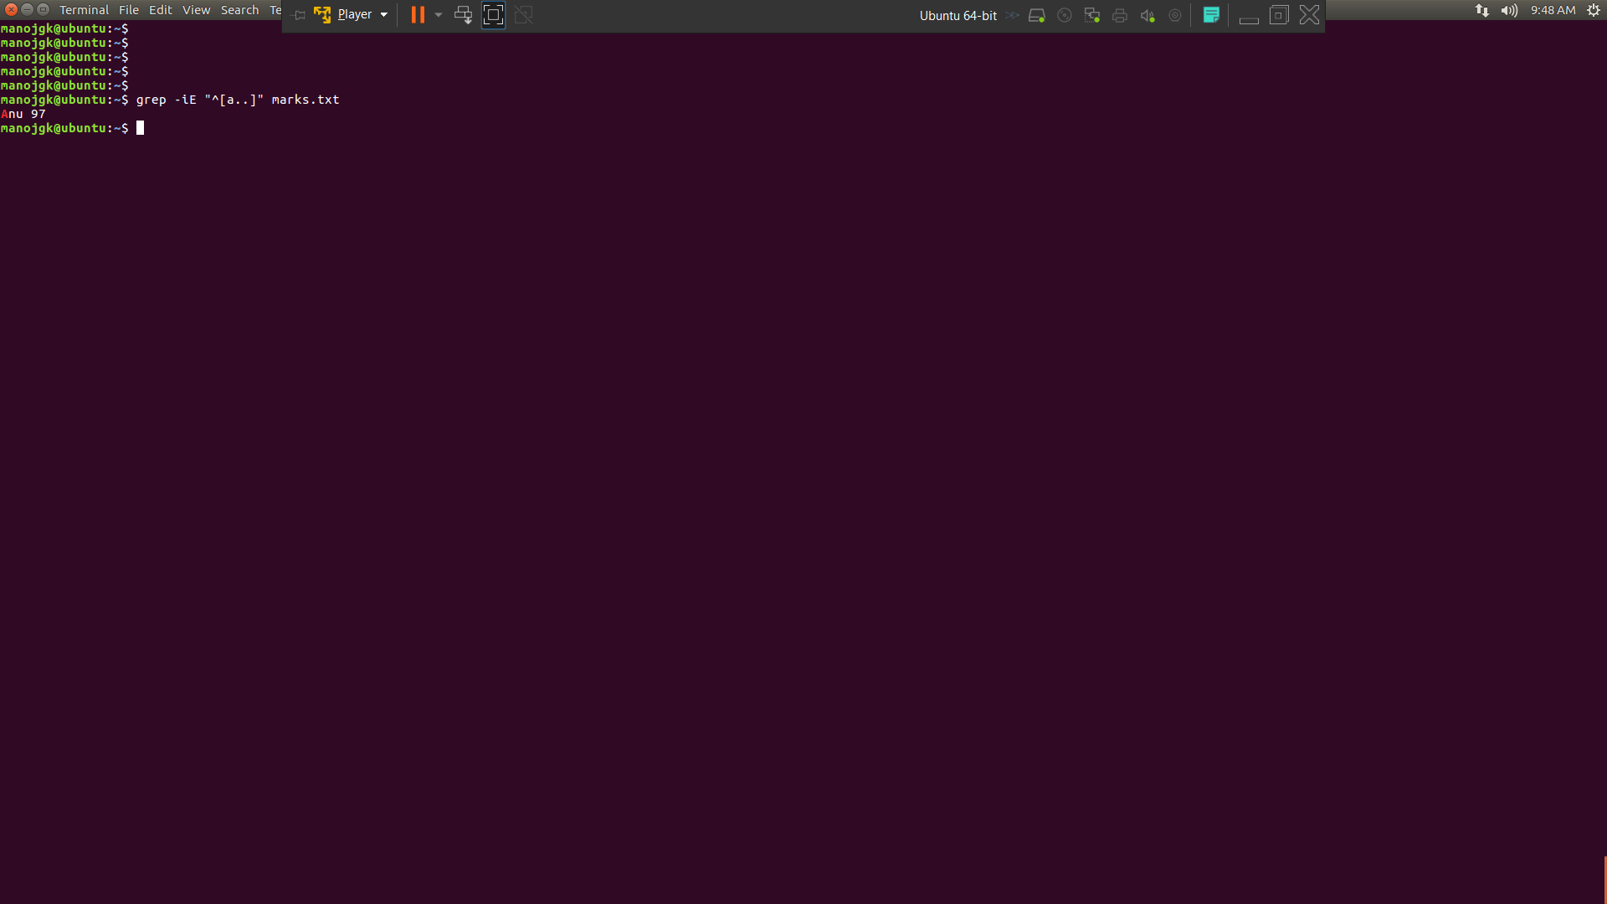

MORE ON GREP
- List those entries that are 5 letters long and starts with Y

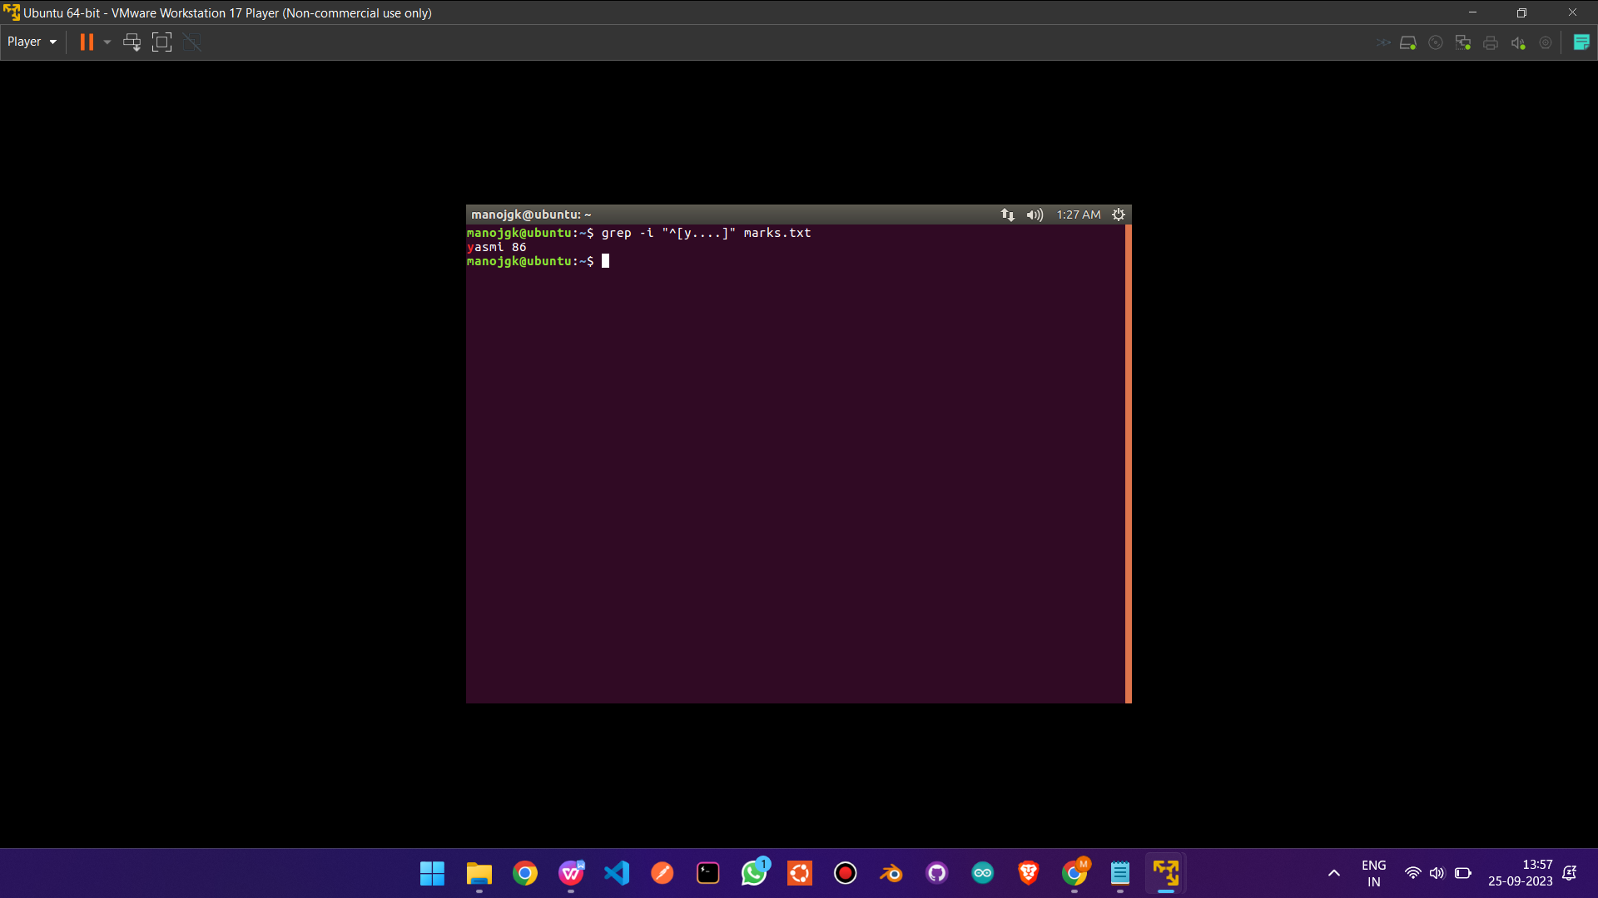

SED:
1) Use the same text file seddemo.txt
2) Try to print records from 6th to 12th line.

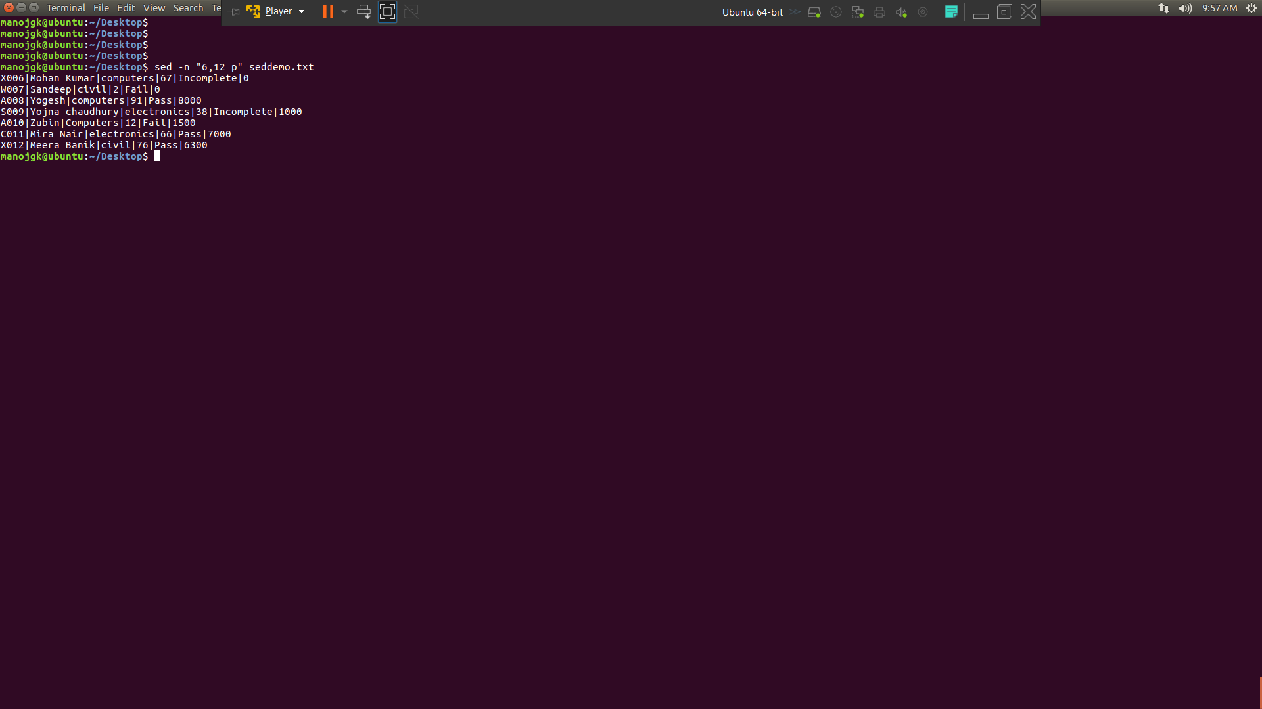
MORE ON SED:
1) Use the same text file seddemo.txt
2) Try to replace or substitute name Ankit with Ashish
