4.Troubleshoot Ethernet Communication with ping and traceroute -> Using cisco packet tracer

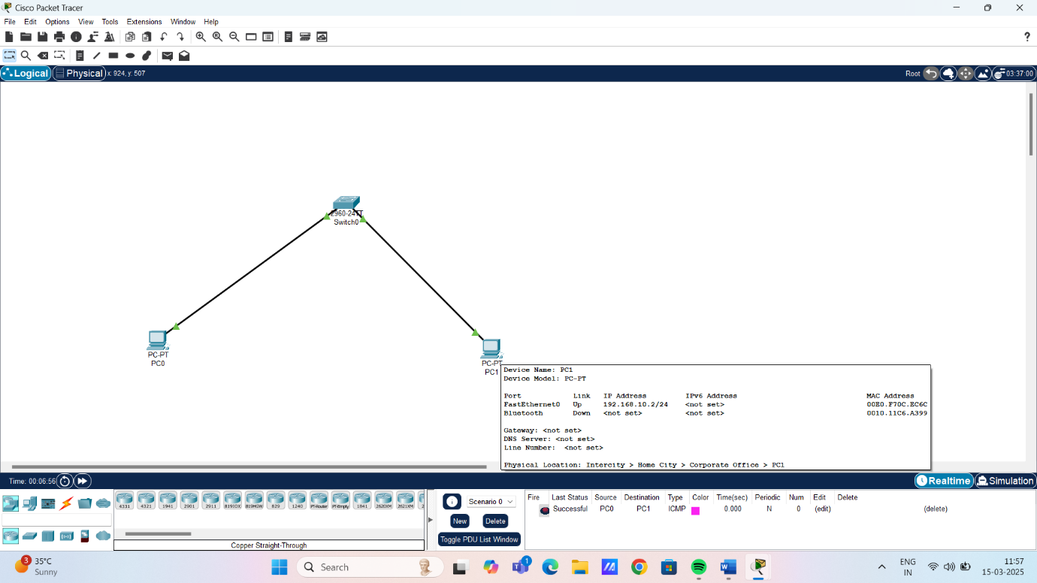

Using ping and tracert command:

