Create a simple LAN setup with two Linux machines connected via a switch.

Adding both the Linux machines to GNS3:

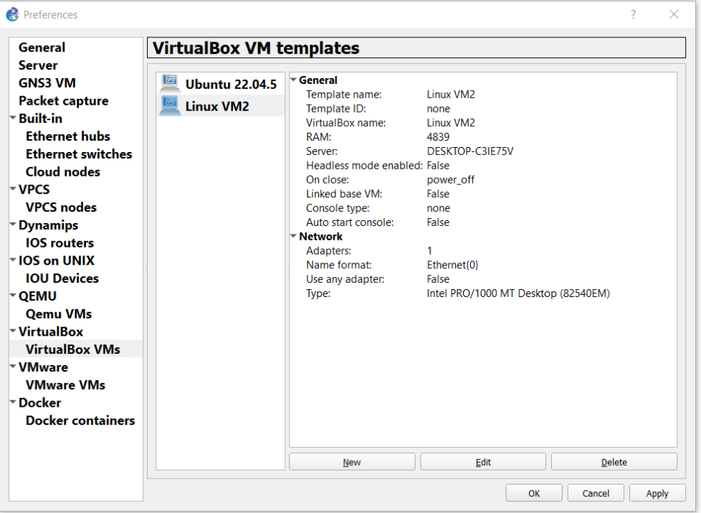

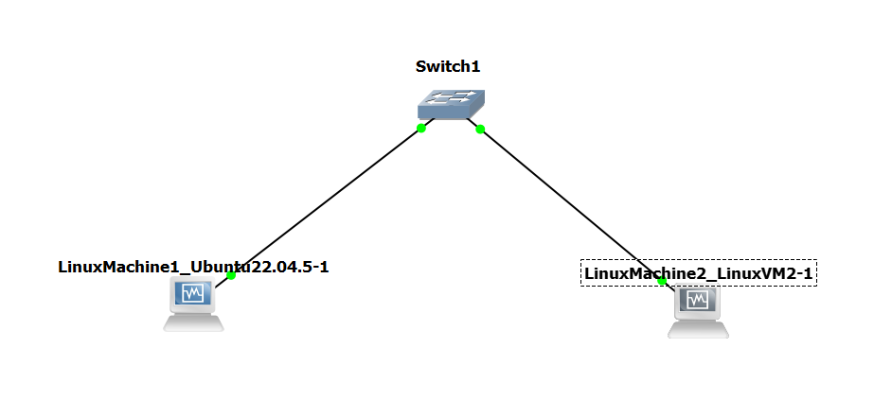

Pinging Machine1 from Machine2:

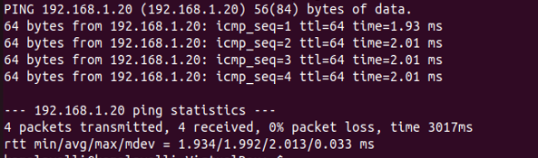

Pinging Machine2 from Machine1:

