Ping from one machine to the other. If it fails, use ifconfig to ensure the IP addresses are configured correctly.

Machine 1: Windows

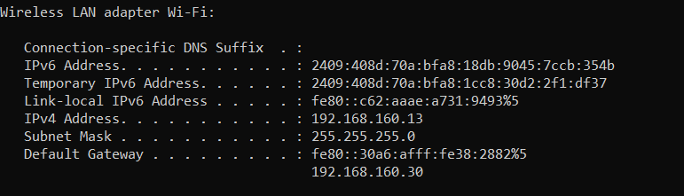

Machine 2: Linux

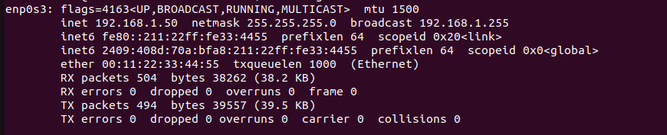

Pinging Machine1 🡪 Machine 2 Fails:

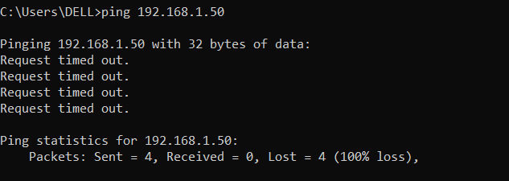

Fixing Configuration:

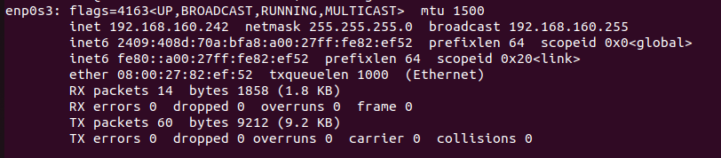

Pinging is Successful:

Machine1 🡪 Machine2

