1.Capture and analyse ARP packets using Wireshark. Inspect the ARP request and reply frames, and discuss the role of the sender's IP and MAC address in these packets.

Using ping command to find the MAC address with the help of IP:



Capturing the destination MAC of broadcasted ARP request by the sender:

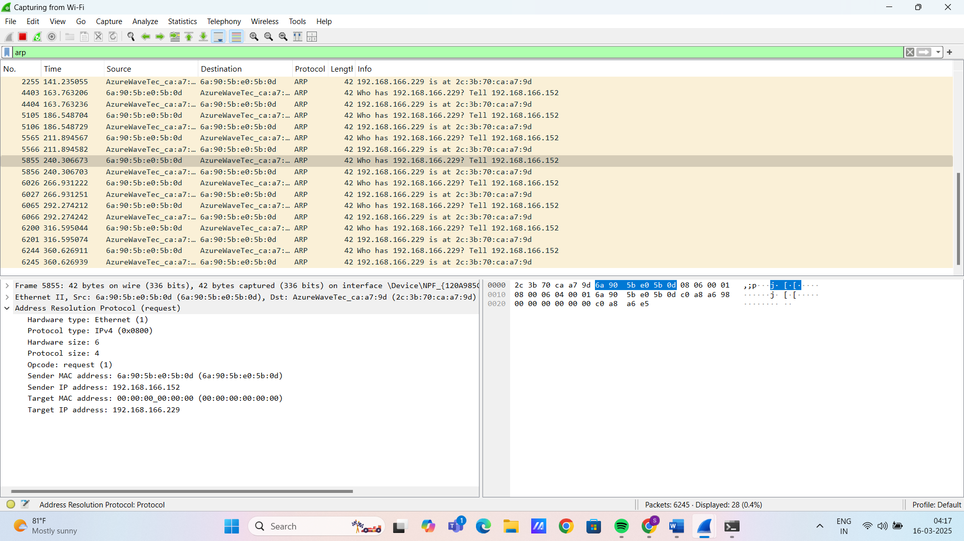

* The MAC address of IP 192.168.166.229 is found to be 2c:3b:70:a7:9d:ca from wireshark.