2.Using Packet Tracer, simulate an ARP spoofing attack. Analyse the behaviour of devices on the network when they receive a malicious ARP response.

Here PC 2 is victim and PC 1 is attacker.

Setup of a router, switch and 2 pc’s:

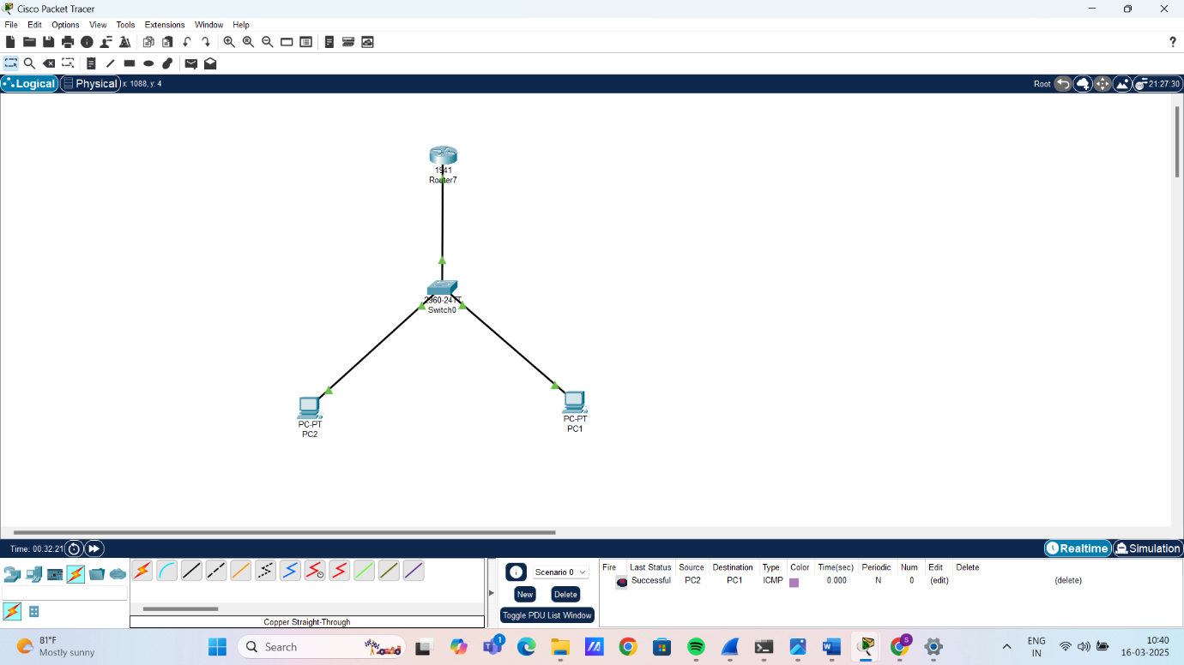

Configuring the router with the victim’s IP:

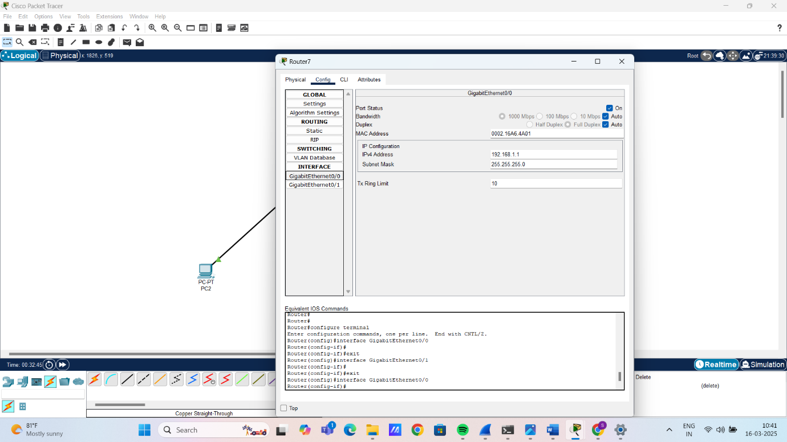

Configuring router connection for up status with switch:

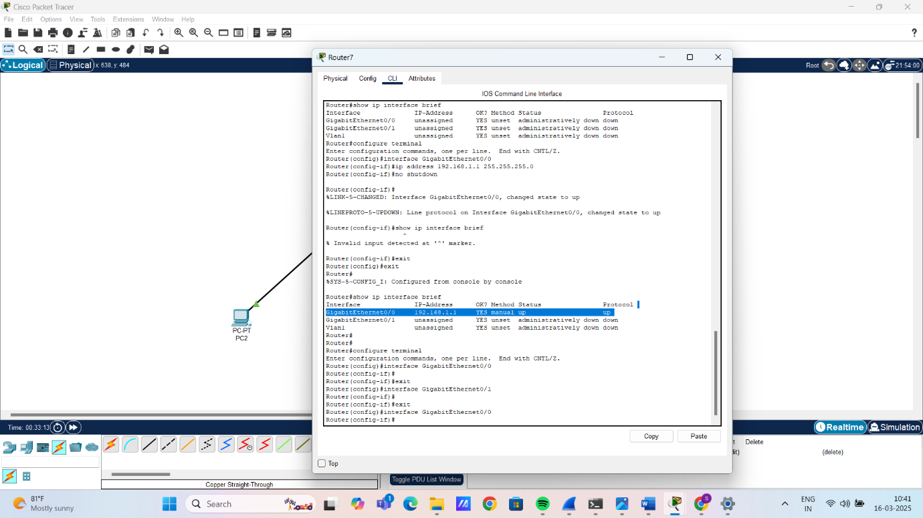

Ensuring VLAN connectivity and router with switch:

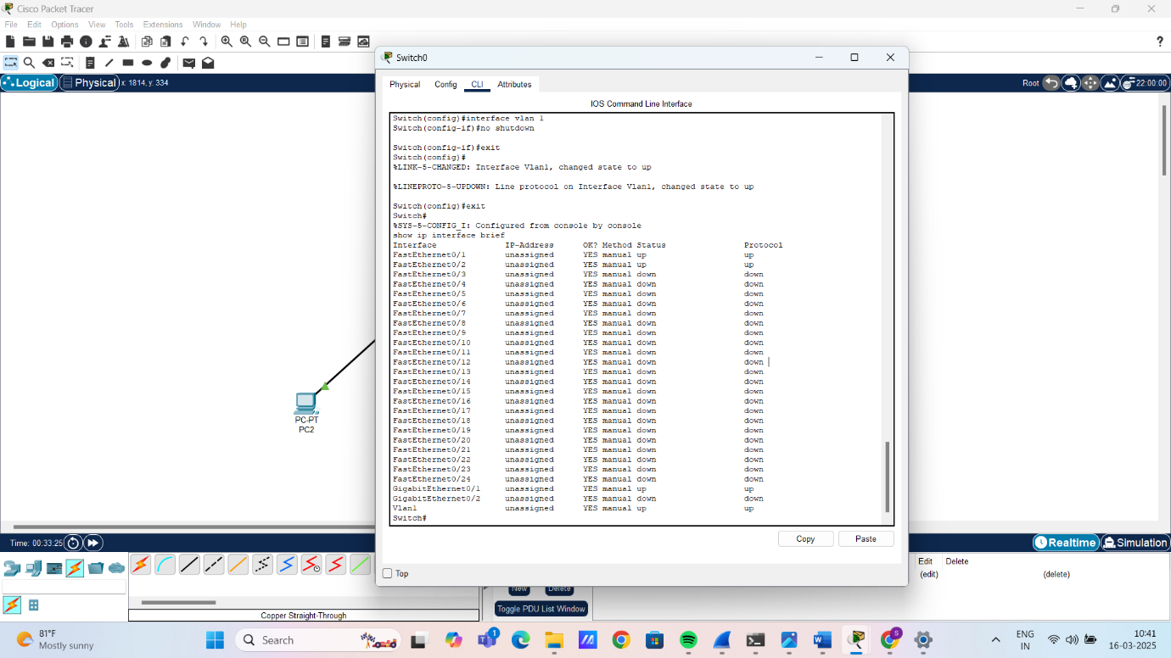

ARP table has been updated after pinging the router with its IP:

