3.Manually configure static IPs on the client devices (like Pc or your mobile phone) and verify connectivity using ping.

Configuring the static IP on my system:

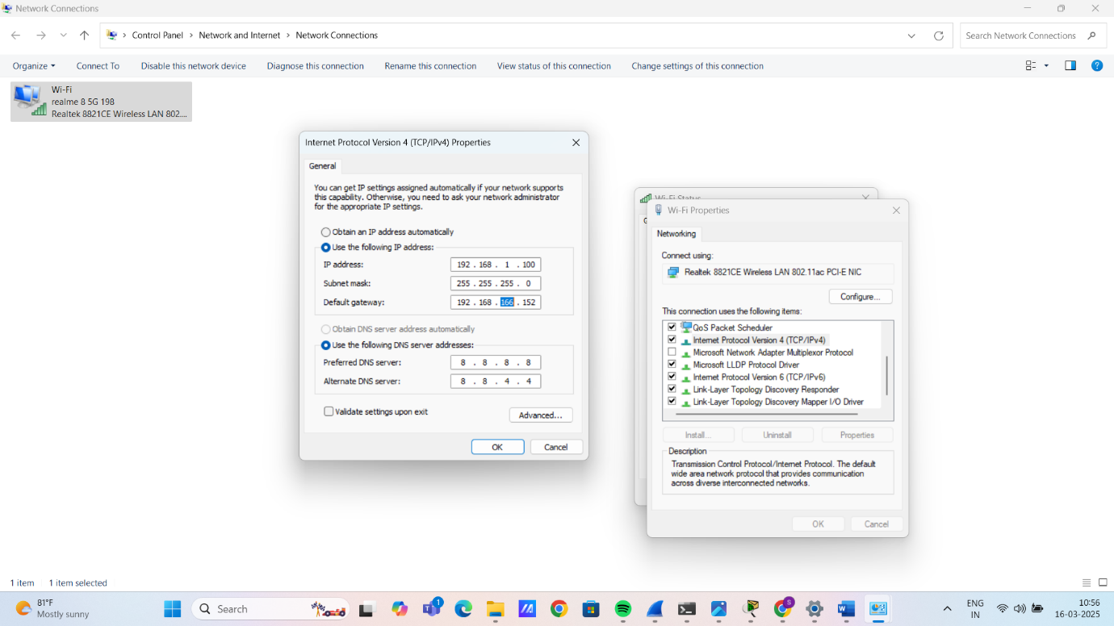

The IP that I have set has been configured:

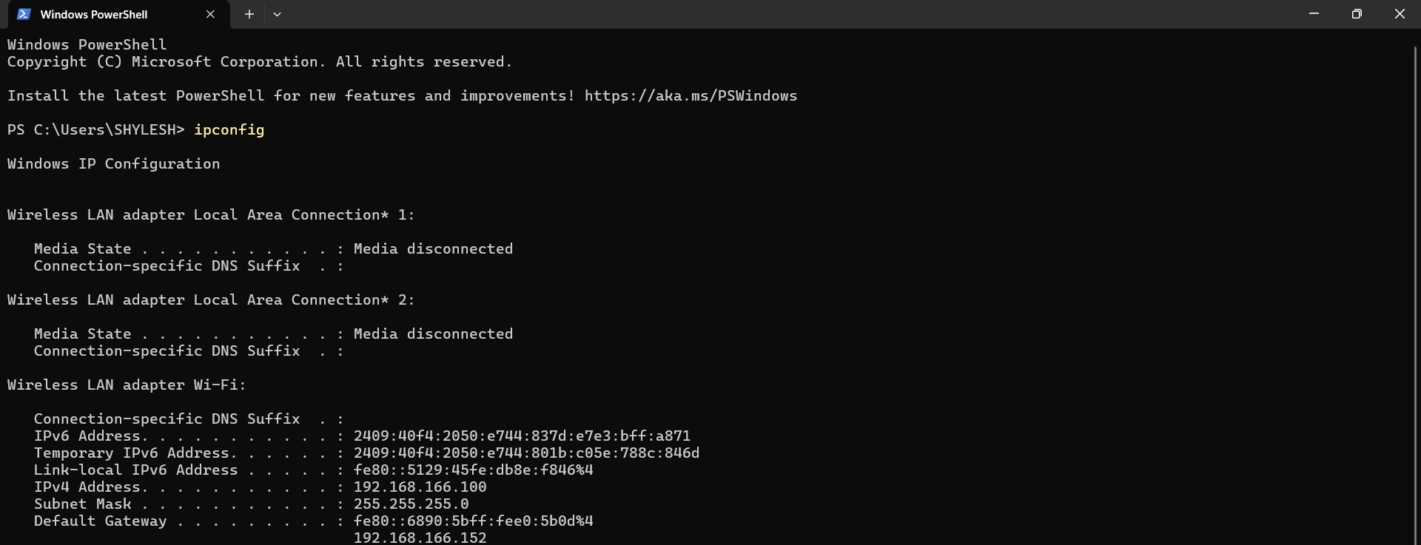

Using ping command for verification:

