4.Use Wireshark to capture DHCP Discover, Offer, Request, and Acknowledge messages and explain the process.

Ipconfig/release(To release the current IP)



Ipconfig/renew(It gets new IP)

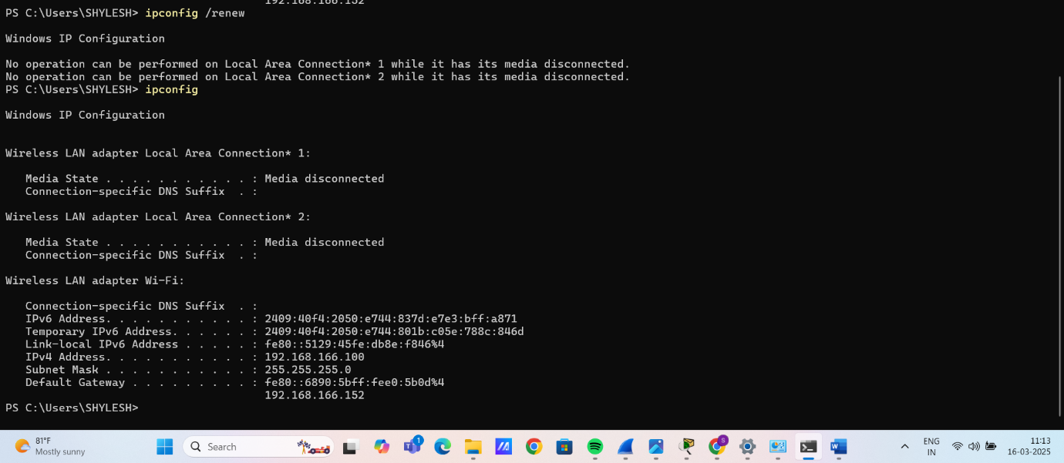

In wireshark, DHCP shows the discover, request, offer and acknowledge processes:

