**Given an IP address range of 192.168.1.0/24, divide the network into 4 subnets.**

**Task: Manually calculate the new subnet mask and the range of valid IP addresses for each subnet.**

**Assign IP addresses from these subnets to devices in Cisco Packet Tracer and verify connectivity using ping between them.**

We need 4 subnets, since 2 squared is 4, I'll borrow 2 bits from the host portion of the original /24 network.

The original /24 means 24 bits were for the network. By adding the 2 borrowed bits, I get a new /26 network. The new subnet mask is 255.255.255.192.

I subtract the last octet of the new subnet mask (192) from 256.

256 – 192 = 64

| **Subnet** | **Network Address** | **Valid IP Range** | **Broadcast Address** |
| --- | --- | --- | --- |
| **Subnet 1** | 192.168.1.0/26 | 192.168.1.1 - 192.168.1.62 | 192.168.1.63 |
| **Subnet 2** | 192.168.1.64/26 | 192.168.1.65 - 192.168.1.126 | 192.168.1.127 |
| **Subnet 3** | 192.168.1.128/26 | 192.168.1.129 - 192.168.1.190 | 192.168.1.191 |
| **Subnet 4** | 192.168.1.192/26 | 192.168.1.193 - 192.168.1.254 | 192.168.1.255 |
|  |  |  |  |

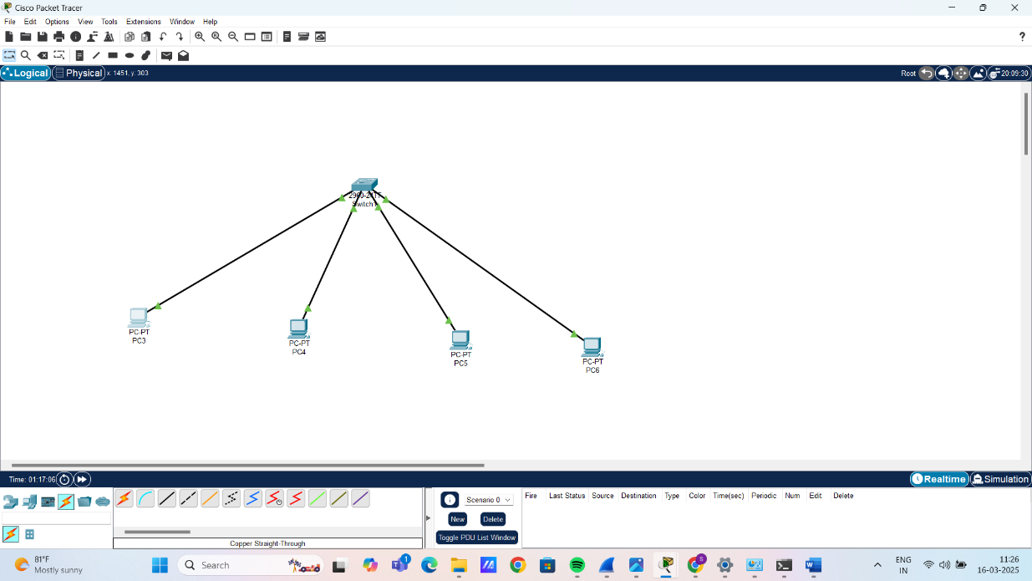

From PC 1 tracing other PC’S:

