7.In Cisco Packet Tracer, create a small network with multiple devices (e.g., 2 PCs and a router). Use private IP addresses (e.g., 192.168.1.x) on the PCs and configure the router to perform NAT to allow the PCs to access the internet.

Task: Test the NAT configuration by pinging an external IP address from the PCs and capture the traffic using Wireshark.

What is the source IP address before and after NAT?

Setting up the Packet tracer:

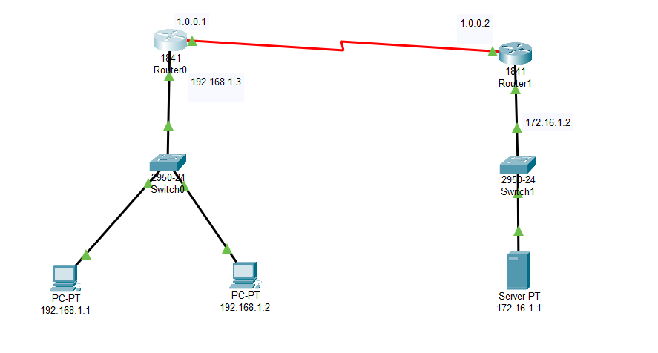

NAT Configuration:

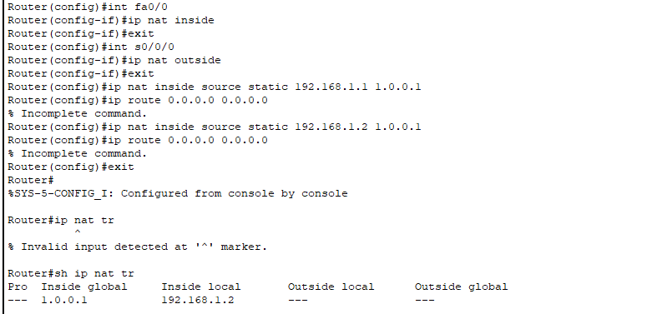

Pinging 172.16.1.1 (external network):

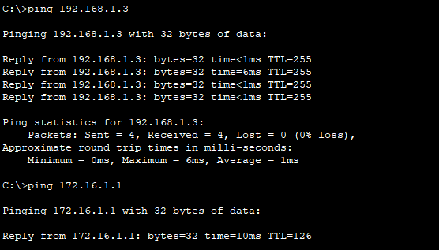

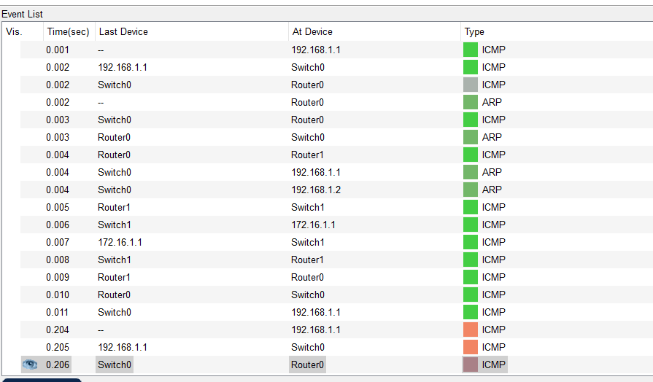



The source IP address before and after NAT:

Router is translating 192.168.1.1 → 1.0.0.1 before forwarding packets to 172.16.1.1.

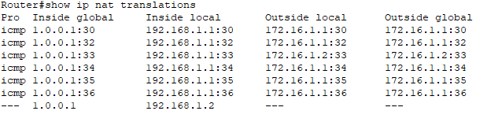

* Ping from PC to 172.16.1.1 was successful, confirming NAT is working.
* The source IP changed from 192.168.1.1 (Inside Local) → 1.0.0.1 (Inside Global) before reaching the external network.