1. Capture and analyse ARP packets using Wireshark. Inspect the ARP request and reply frames when your device attempts to find the router's MAC address. Discuss the importance of ARP in packet forwarding.

Using ipconfig to see the device IP address:

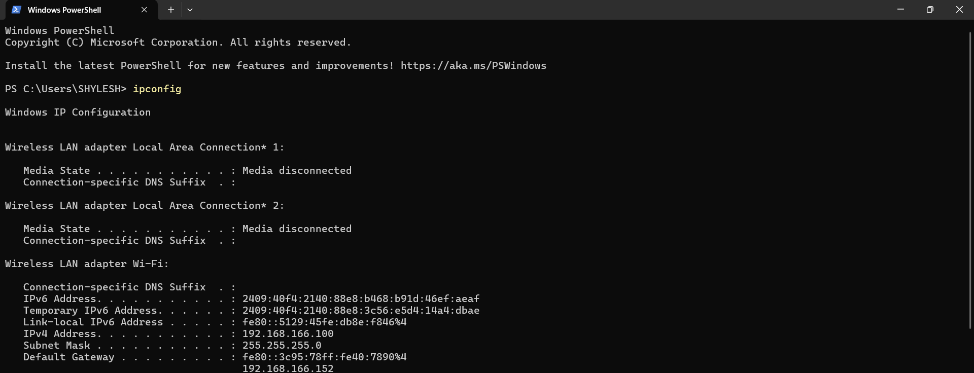

Using ping command and arp to see actions:

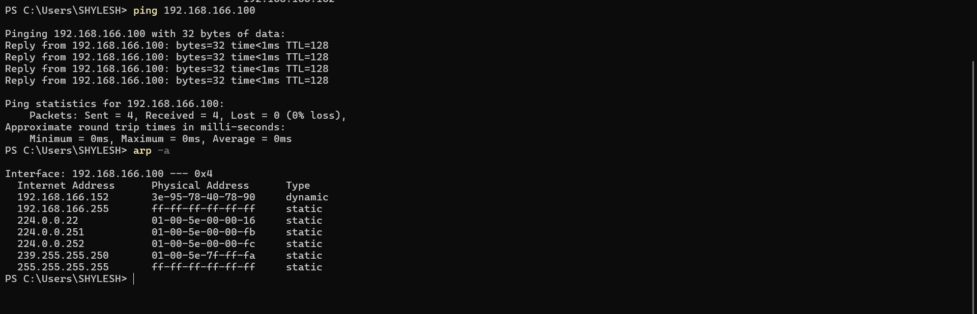

Wireshark arp request and reply:

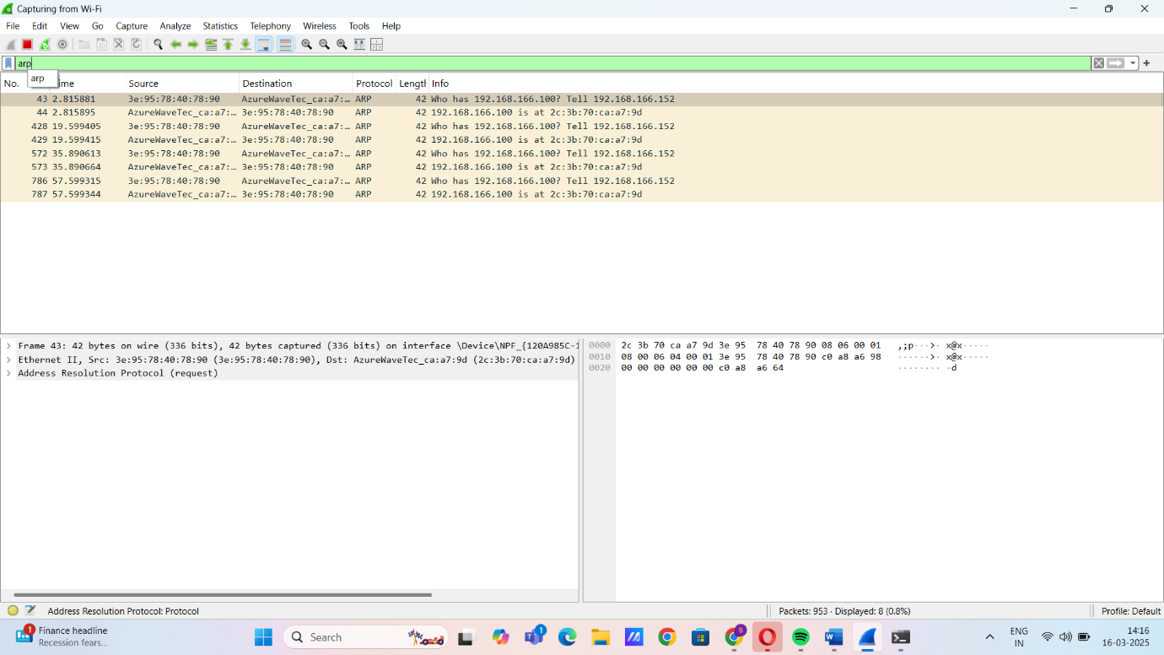

**ARP Request:**

* Message: Who has 192.168.166.100? Tell 192.168.166.152

**ARP Reply:**

* Message: 192.168.166.100 is at 2c:3b:70:ca:a7:9d

**Importance of ARP in Packet Forwarding:**

* Translates IP addresses to MAC addresses for local network communication.
* Essential for forwarding packets at the Data Link Layer (Layer 2).
* Helps devices find the router’s MAC address for forwarding packets outside the local network.
* Uses ARP requests and replies to update MAC addresses dynamically.
* Without ARP, devices wouldn’t know where to send packets, leading to communication failure.
* Maintains an ARP cache to reduce unnecessary broadcasts and improve efficiency.