2. Manually configure static routes on a router to direct packets to different subnets.

Use the ip route command and verify connectivity using ping and traceroute.

Setup in Cisco packet tracer:

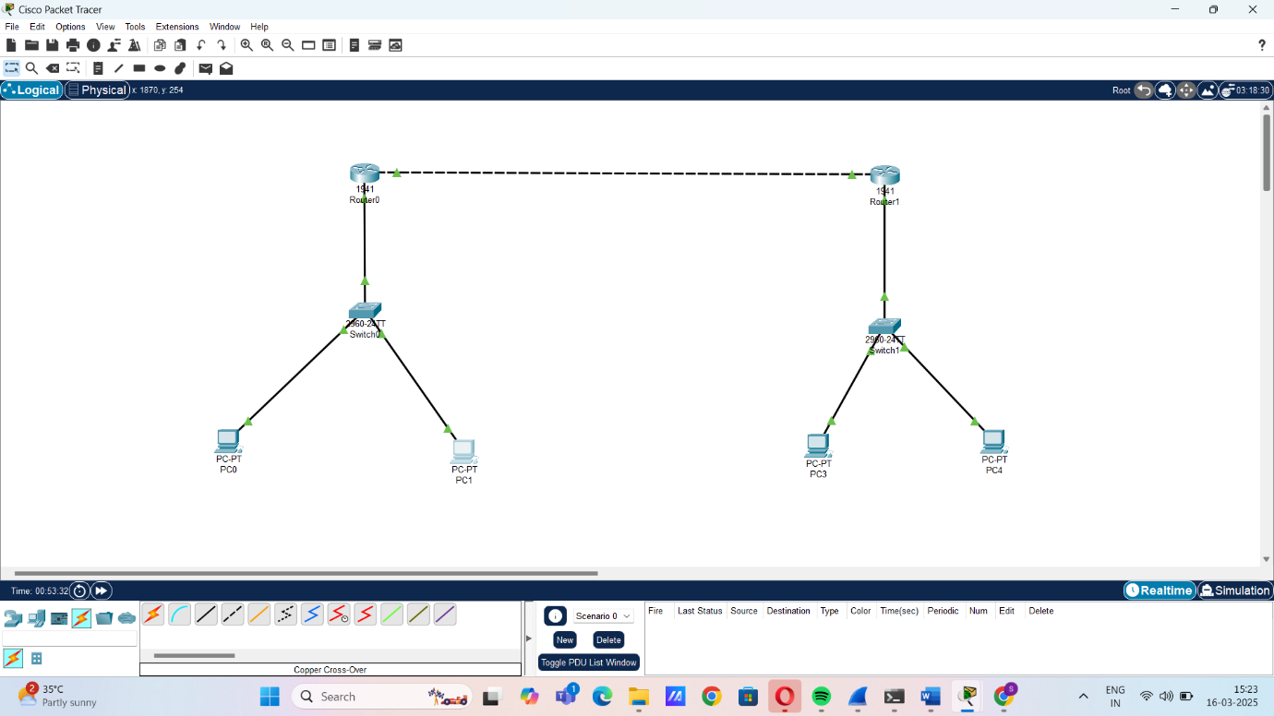

Using Tracert command in router0:

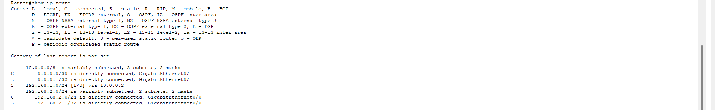

Using Tracert command in router1:

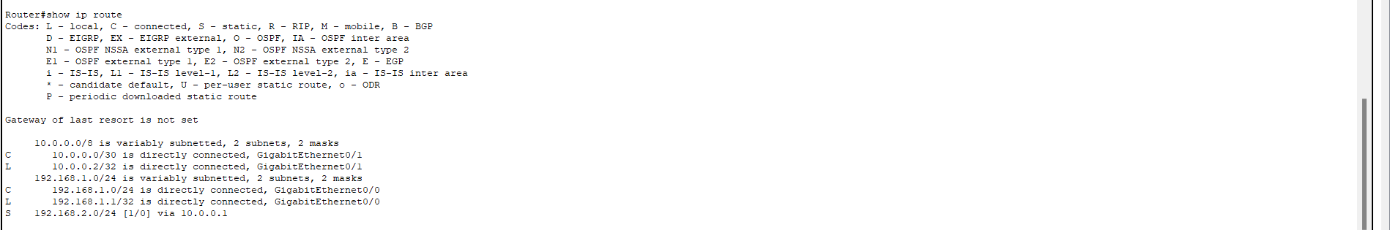

Pinging PC of router 0 from PC of router1:

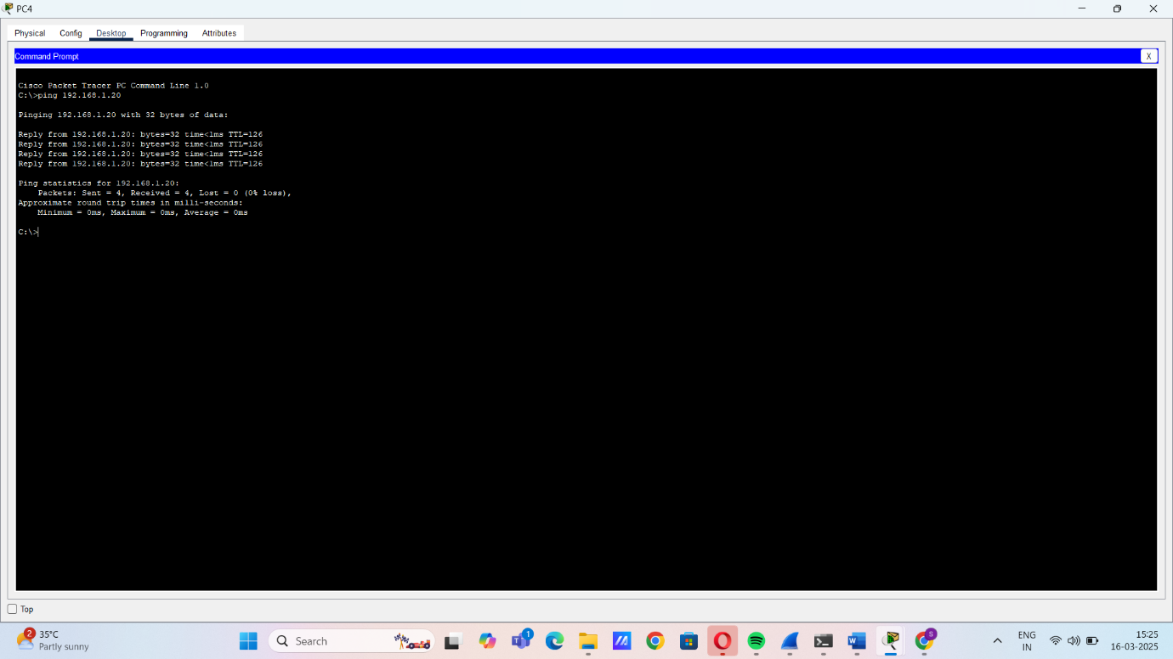

Pinging PC of router 1 from PC of router0:

