3. Given a network address of 10.0.0.0/24, divide it into 4 equal subnets.

Calculate the new subnet mask.

Determine the valid host range for each subnet.

Assign IP addresses to devices in Packet Tracer and verify connectivity.

**Given Network Information**

* **Network Address:** 10.0.0.0/24
* **Default Subnet Mask:** 255.255.255.0
* **Total Hosts in /24:** 2(32−24)=28=2562^{(32-24)} = 2^8 = 2562(32−24)=28=256 (Includes network and broadcast addresses)

**Determine the New Subnet Mask**

We need **4 subnets**, so we borrow bits from the host portion.

* **To calculate required subnet bits:**

Number of required subnets 22=42^2 = 422=4

Thus, we borrow **2 bits** from the host portion.

* **New subnet mask:**

24+2=26

**Calculate Subnet Ranges**

total addresses = 2^(32−26)=2^6=64 total addresses

* **Usable hosts per subnet:** 64−2=62 (excluding network and broadcast addresses).

**Subnet Breakdown:**

| **Subnet** | **Network Address** | **First Usable Host** | **Last Usable Host** | **Broadcast Address** |
| --- | --- | --- | --- | --- |
| 1 | **10.0.0.0/26** | 10.0.0.1 | 10.0.0.62 | 10.0.0.63 |
| 2 | **10.0.0.64/26** | 10.0.0.65 | 10.0.0.126 | 10.0.0.127 |
| 3 | **10.0.0.128/26** | 10.0.0.129 | 10.0.0.190 | 10.0.0.191 |
| 4 | **10.0.0.192/26** | 10.0.0.193 | 10.0.0.254 | 10.0.0.255 |

Setup:

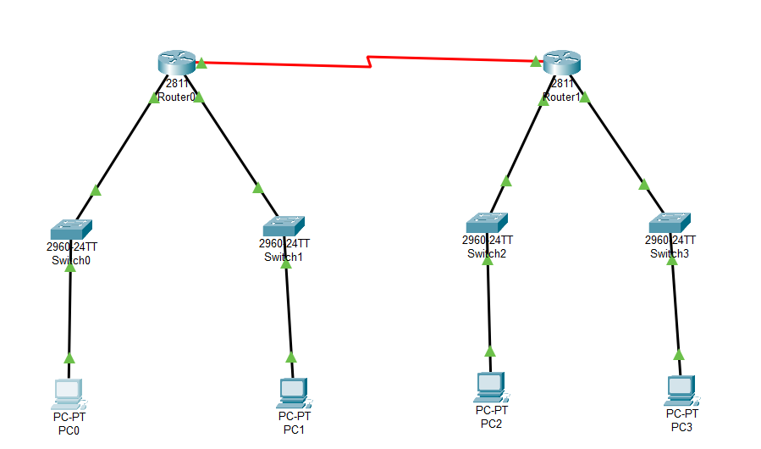

Ping from PC0 (10.0.0.2) to PC3 (10.0.0.194):

