5. In Cisco Packet Tracer, configure NAT on a router to allow internal devices (192.168.1.x) to access the internet.

Test connectivity by pinging an external public IP.

Capture the traffic in Wireshark and analyse the source IP before and after NAT translation.

Setup:

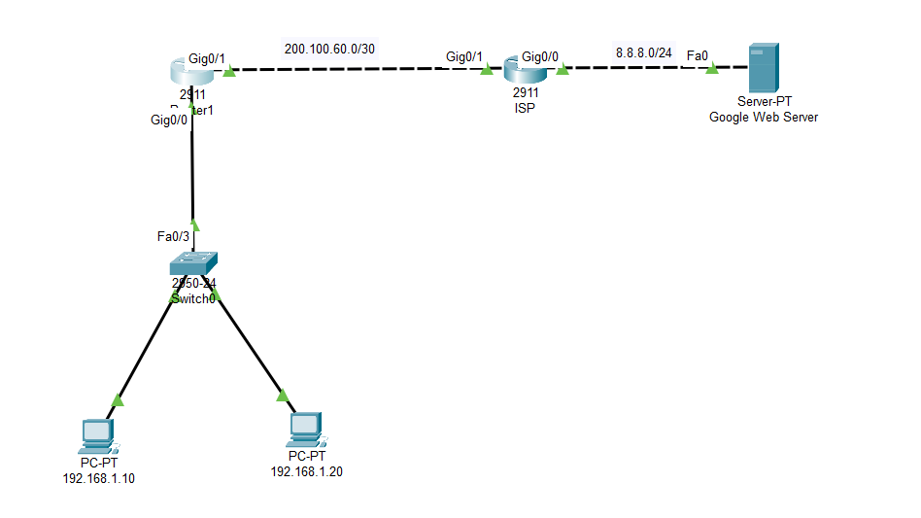

NAT Configuration:

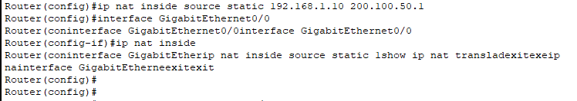

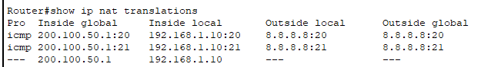

Pinging 8.8.8.8 from 192.168.1.10:

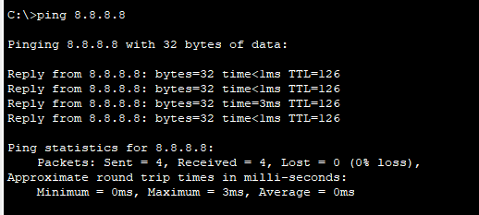

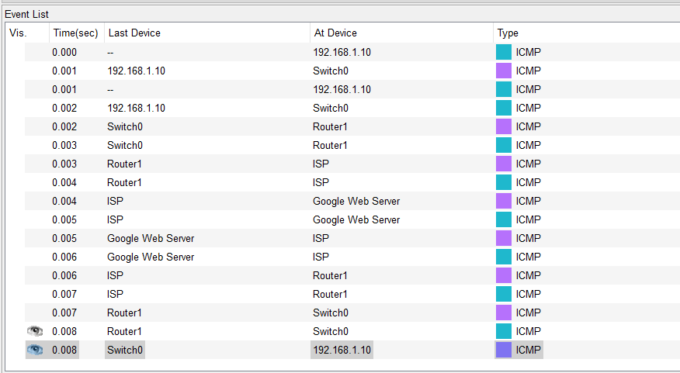

Source IP before and after NAT translation:

Before the NAT translation, the Source IP is 192.168.1.10

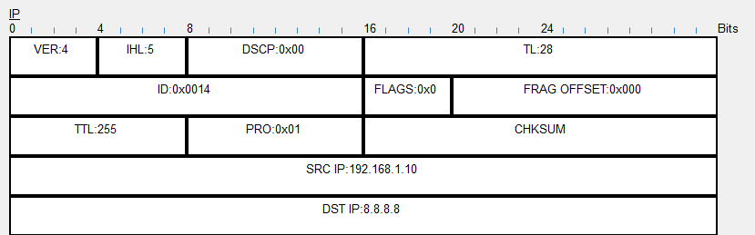

After the NAT translation, the Source IP has become 200.100.50.1

