3.Using various Trace route commands:

Basic Tracert command:

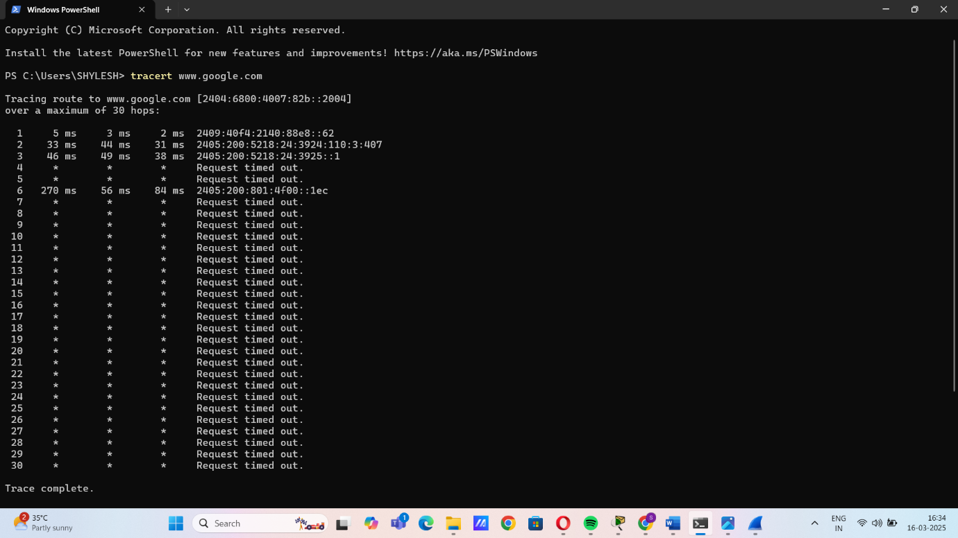

Disable DNS Name Resolution:

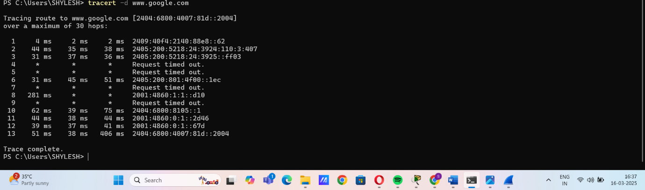

Set Maximum Hops:

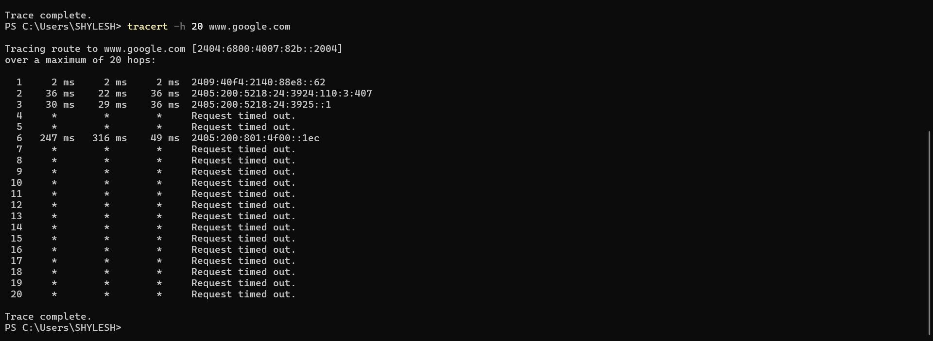

Set Timeout for Each Reply:

