Question 4,5,6,8,9,10:

* Set up trunk ports between switches and try ping between different VLANs.

### Change the native VLAN on a trunk port. Test for VLAN mismatches and troubleshoot.

### You have a Cisco switch and a VoIP phone that needs to be placed in a voice VLAN (VLAN 20). The data for the PC should remain in a separate VLAN (VLAN 10). Configure the switch port to support both voice and data traffic.

### You configured VLANs 10 and 20 on your switch and assigned ports to each VLAN. However, devices in VLAN 10 cannot communicate with devices in VLAN 20. Troubleshoot the issue.

### Try Inter VLAN routing with Router.

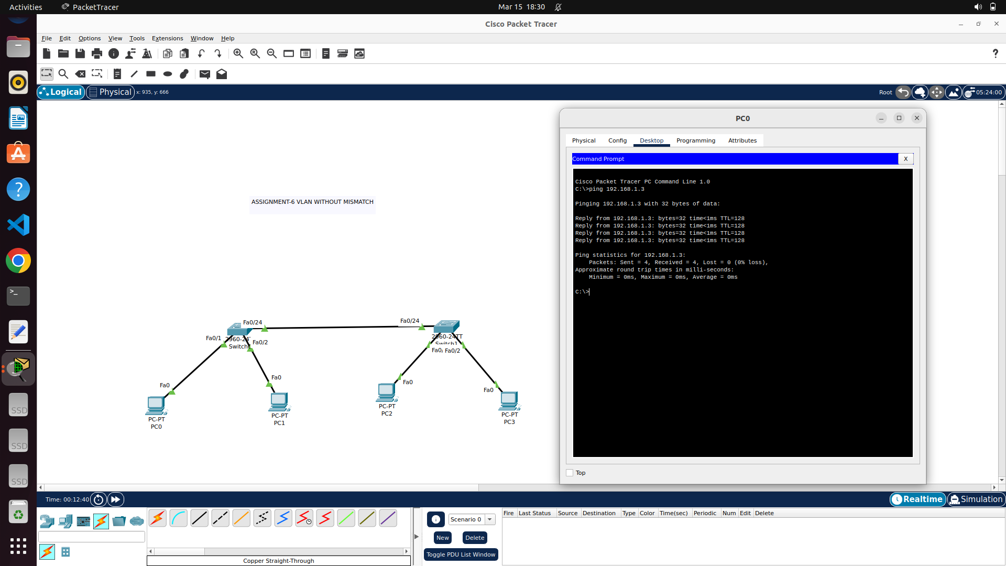

Here, to prove that vlan considers logical segmentation of network regardless of physical location,

PC0 – 192.168.1.2/24

PC1 – 192.168.2.2/24

PC2 – 192.168.1.3/24

PC3 – 192.168.2.3/24 are assigned. Now, naturally it is possible to ping from pc0 to pc2 and from pc1 to pc3 alone. Since, vlan shrinks broadcast domain. Both the interfaces of switches contributing trunk port should have same native vlan to avoid mismatches.

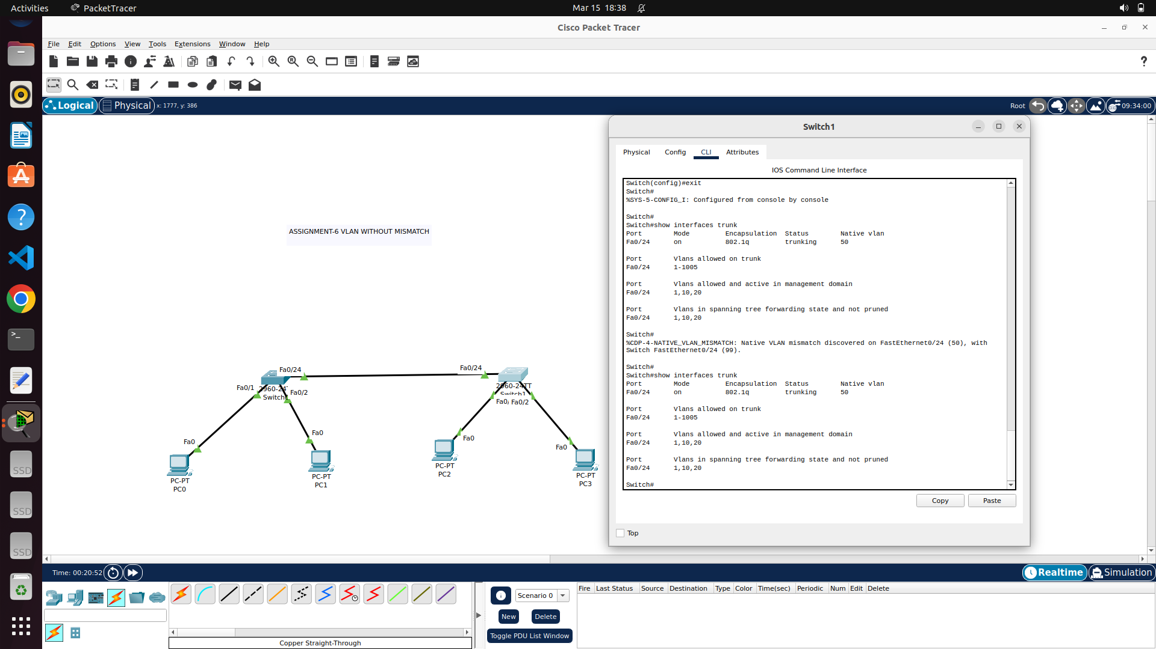

VLAN BASED NETWORK CONSTRUCTION FOR IMPLEMENTING ALL THE CREATED SUBNETS USING SINGLE SWITCH AND ROUTER

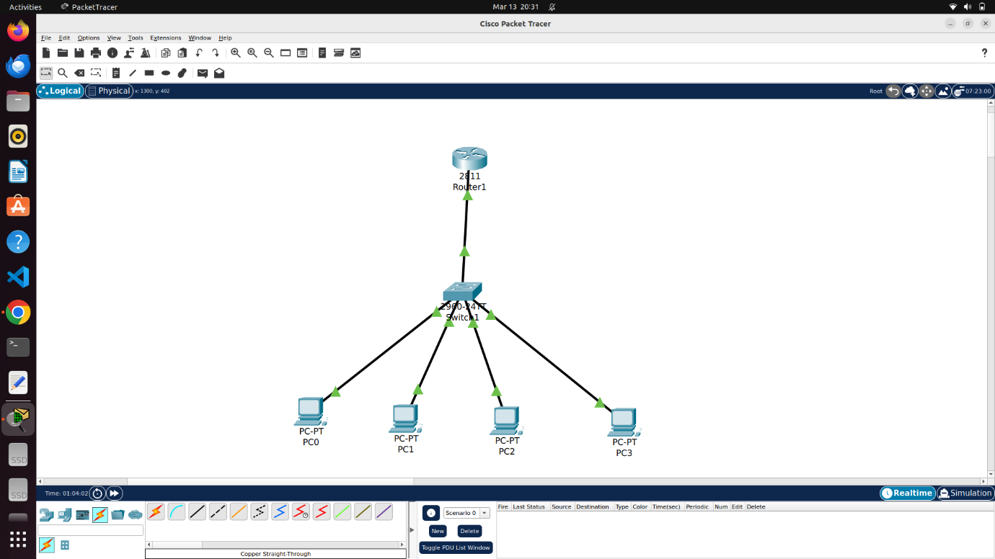

PC0 – 10.0.0.2

PC1 – 10.0.0.66

PC2 – 10.0.0.130

PC3 – 10.0.0.194

For switch, individual VLAN to be declared with its tag and each switch port to be either marked as access or trunk port.

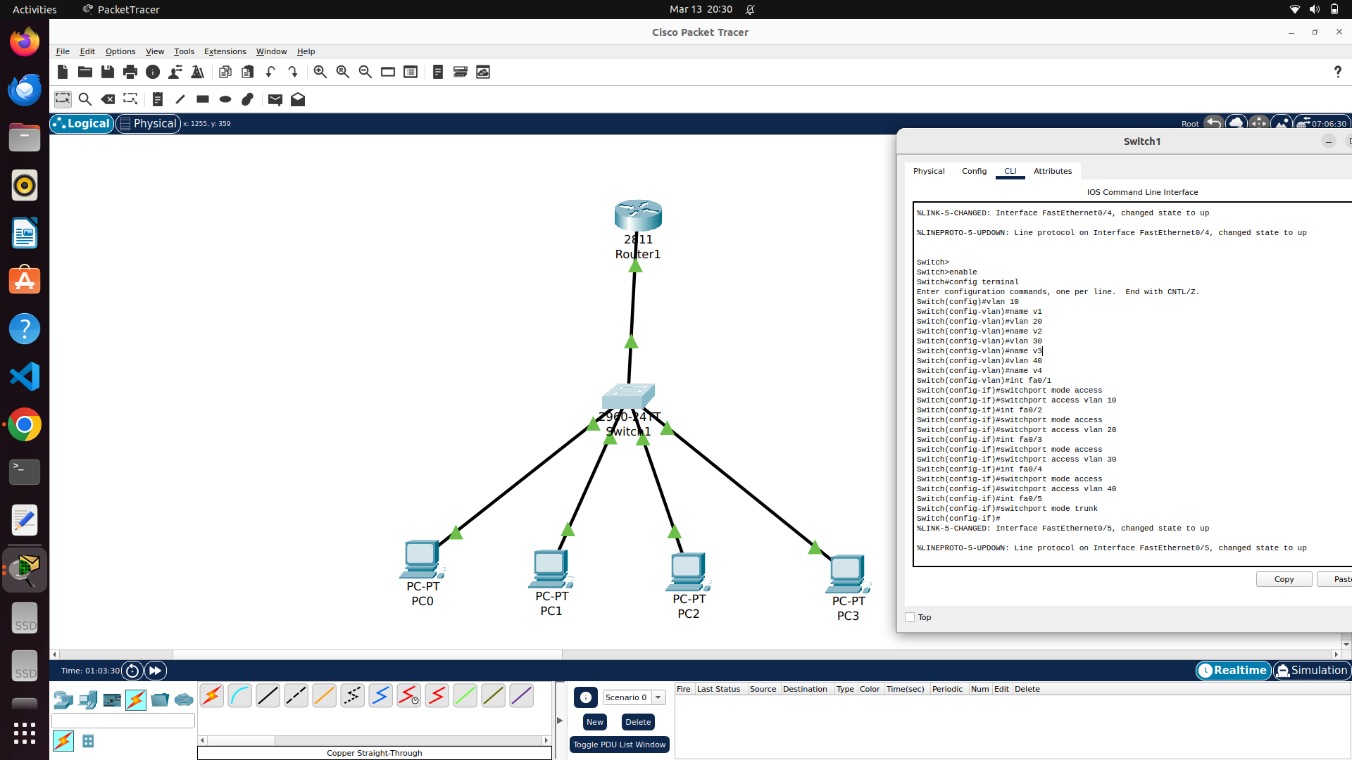

For router, each interface to be defined and should made up , followed by creating sub interfaces as per IEEE 802.1Q and assigning with available vlan and provide IP and subnet mask.

