7.Configure a management VLAN and assign IP address for remote access. Test SSH or Telnet access to the switch.

Switch configurations (in cli commands) with the network made:

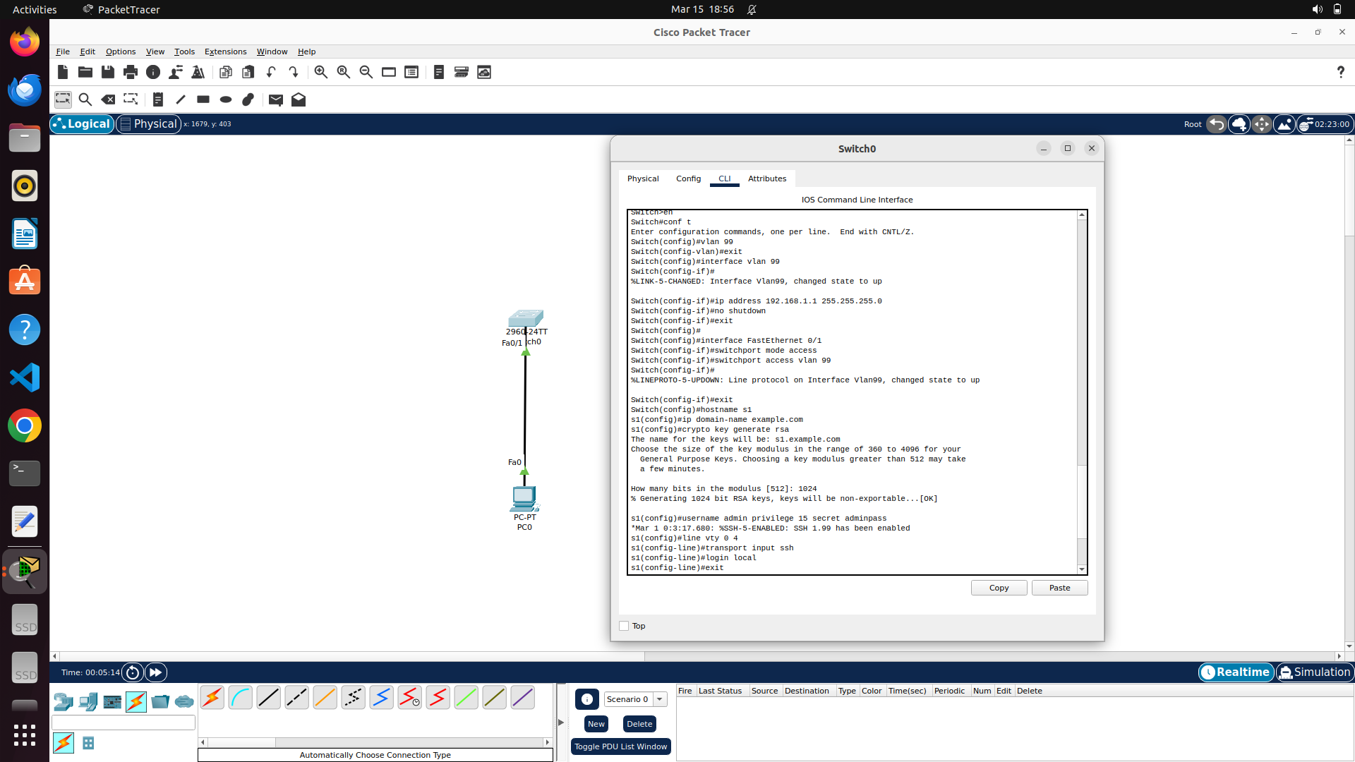

PC IP configuration as stated above:

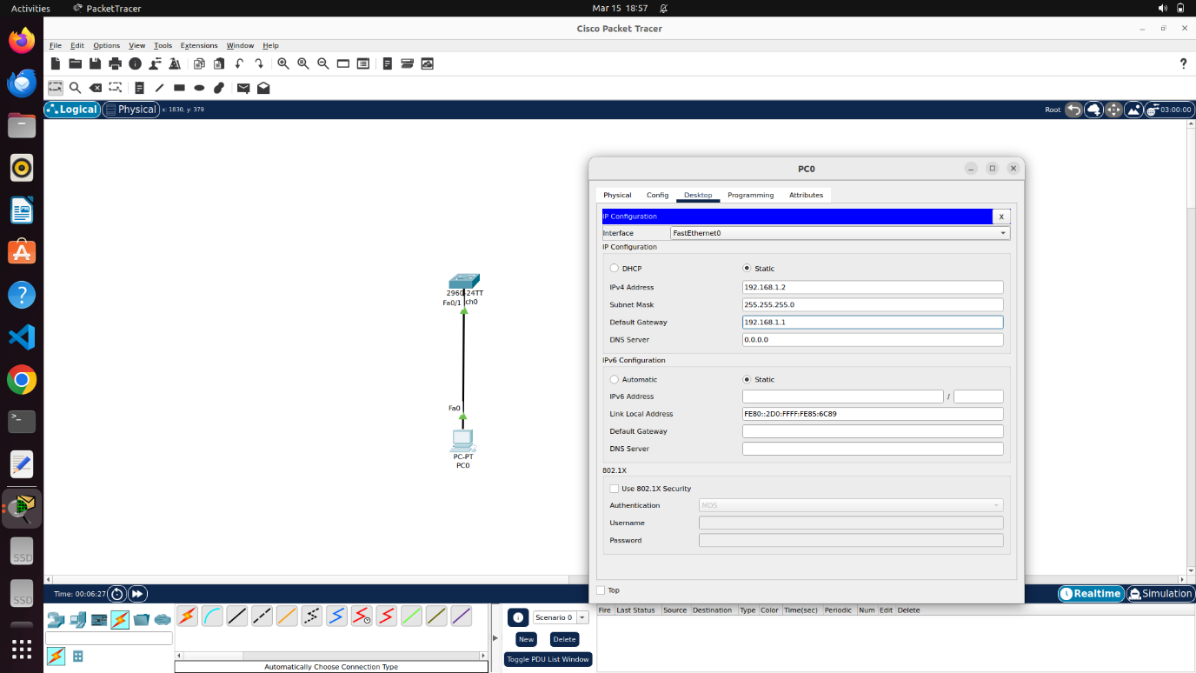

Both ping and ssh results from PC to switch (management vlan interface):

