1. **Which of layer the Wi-Fi standard/protocol fits?**

Wi-Fi operates primarily at the **Physical Layer (Layer 1)** and **Data Link Layer (Layer 2)** of the OSI model. At the Physical Layer, it defines how radio signals are transmitted, including modulation, frequencies, and channel bandwidth. The Data Link Layer handles MAC addressing, frame formatting, encryption, and collision avoidance using CSMA/CA. These layers work together to enable wireless communication between devices over IEEE 802.11 standards like Wi-Fi 6 and Wi-Fi 7. While Wi-Fi itself functions at these lower layers, it supports higher-level protocols like TCP/IP for

internet connectivity.

1. **Can you share the Wi-Fi devices that you are using day to day life, share that device's wireless capability/properties after connecting to network. Match your device to corresponding Wi-Fi Generations based on properties**

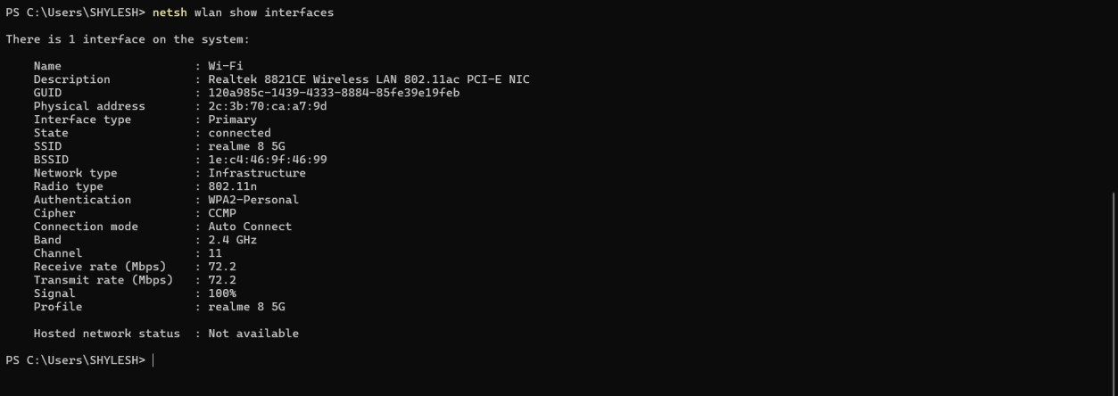

1. **what is BSS and ESS?**

**Basic Service Set (BSS)**

* + A **BSS** is the fundamental building block of a Wi-Fi network, consisting of one **Access Point (AP)** and the wireless devices (stations) connected to it.
  + It operates within a single coverage area, meaning all devices communicate through the same AP.
  + Each BSS is identified by a **Basic Service Set Identifier (BSSID)**, which is typically the MAC address of the AP.

**Extended Service Set (ESS)**

* + An **ESS** is a collection of multiple BSSs connected through a common wired network (distribution system), allowing seamless roaming.
  + Devices can move between BSSs within an ESS without losing connectivity, thanks to the same **SSID (Service Set Identifier)**.
  + ESS networks are used in large areas like offices, campuses, and public hotspots to provide broader Wi-Fi coverage.

1. **what are the basic functionalities of Wi-Fi Access point?**

**Wireless Connectivity** – Provides a wireless network interface for devices to connect to a wired network using Wi-Fi technology.

**Signal Transmission & Reception** – Transmits and receives radio signals between devices and converts them into data packets for network communication.

**Network Bridging** – Acts as a bridge between the wired Ethernet network and wireless devices, enabling seamless data transfer.

**Traffic Management** – Manages multiple connections, preventing congestion, optimizing bandwidth, and ensuring smooth data flow.

**Security & Authentication** – Implements encryption protocols like WPA2/WPA3, MAC filtering, and authentication methods to ensure secure communication.

1. **Difference between Bridge mode and Repeater mode**

**Bridge Mode**

* + Connects two separate networks (wired or wireless) to enable communication between them.
  + Assigns its own IP address and operates as a separate network entity.
  + Maintains full bandwidth and does not degrade network speed.
  + Commonly used in enterprise setups to link distant buildings or network segments.

**Repeater Mode**

* + Extends the range of an existing Wi-Fi network by amplifying the signal.
  + Does not create a new network; instead, it extends the same SSID and IP range.
  + May reduce bandwidth due to retransmission of Wi-Fi signals.
  + Used in homes and offices to eliminate Wi-Fi dead zones and improve coverage.

1. **what are the differences between 802.11a and 802.11b.**

**802.11a**

1. Operates on the **5 GHz** frequency band, reducing interference from common household devices.
2. Supports a maximum speed of **54 Mbps**, providing faster data transfer.
3. Has a **shorter range** due to higher frequency, making it ideal for indoor enterprise environments.
4. Higher cost compared to 802.11b, mainly used in business and professional setups.

**802.11b**

1. Operates on the **2.4 GHz** frequency band, allowing better penetration through walls.
2. Supports a maximum speed of **11 Mbps**, which is slower than 802.11a.
3. Has a **longer range** but is prone to interference from devices like microwaves and Bluetooth.
4. Lower cost, making it widely adopted for home and public Wi-Fi networks.
5. **Configure your modem/hotspot to operate only in 2.4Ghz and connect your laptop/Wi-Fi device and capture the capability/properties in your Wi-Fi devices. Repeat the same in 5Ghz**

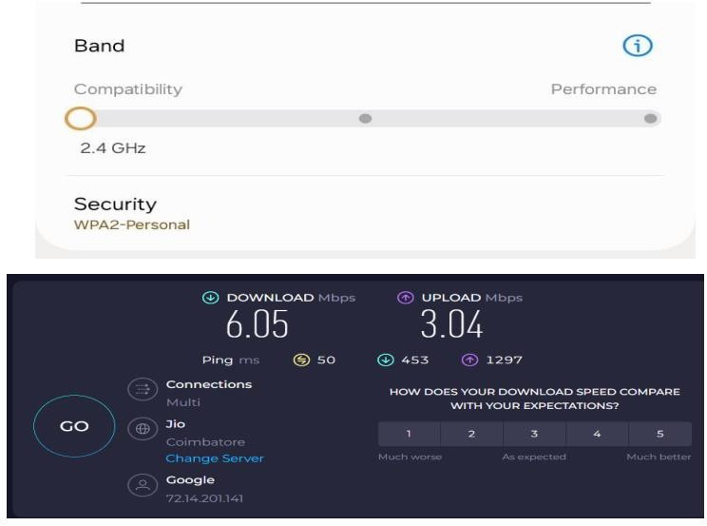

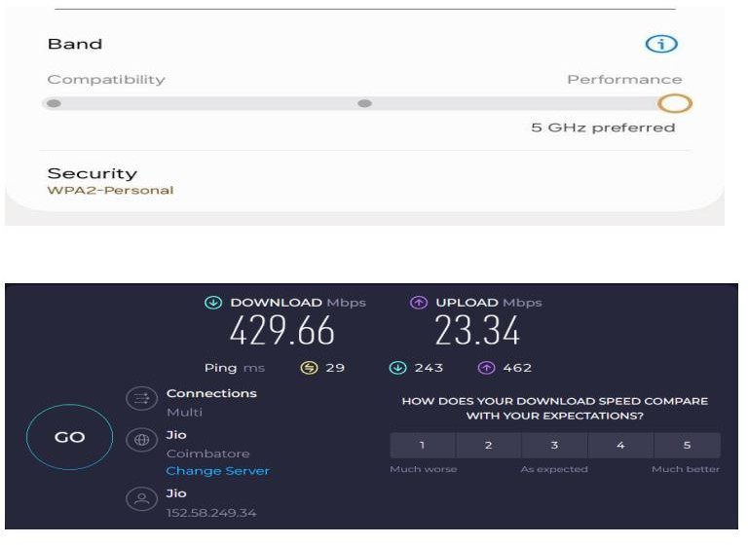

1. **What is the difference between IEEE and WFA?**

**IEEE (Institute of Electrical and Electronics Engineers)**

* + A global **professional organization** that develops technical standards across various fields, including networking, power, and electronics.
  + Responsible for defining Wi-Fi standards such as **IEEE 802.11** (e.g., 802.11a, 802.11b, 802.11ac, etc.).
  + Focuses on **technical specifications** and protocols for wireless communication.
  + Does **not certify** devices but sets the foundation for industry-wide wireless networking standards.

**WFA (Wi-Fi Alliance)**

* + A trade organization that promotes and certifies Wi-Fi products for interoperability and compliance with IEEE standards.
  + Ensures that Wi-Fi devices from different manufacturers work seamlessly together through the Wi-Fi CERTIFIED™ program.
  + Focuses on branding, marketing, and improving Wi-Fi usability for consumers and businesses.
  + Works closely with IEEE but does not create technical standards—it enforces compliance and enhances user experience.

1. **List down the type of Wi-Fi internet connectivity backhaul, share your home/college's wireless internet connectivity backhaul name and its properties**

Backhaul refers to the connection between an access point (AP) and the core network (ISP or data centre). Here are the main types:

* + **Fiber Optic Backhaul** – High-speed and high-capacity backhaul using fiber-optic cables. It provides ultra-low latency and is ideal for enterprise and urban networks.
  + **Microwave Backhaul** – Uses point-to-point microwave radio links to connect networks wirelessly, often used in remote areas or where fiber deployment is costly.
  + **Satellite Backhaul** – Provides internet access via satellite links, useful for remote or rural locations but has higher latency.
  + **Cellular Backhaul (4G/5G LTE)** – Uses mobile networks to provide wireless backhaul, often used as a backup or in temporary setups.
  + **DSL or Cable Backhaul** – Uses telephone lines (DSL) or coaxial cables to provide a broadband internet connection, common in home and small business networks.
  + **Mesh Backhaul (Wireless/Wired)** – Uses multiple Wi-Fi nodes connected wirelessly (wireless backhaul) or via Ethernet (wired backhaul) to extend coverage.

1. **List down the Wi-Fi topologies and use cases of each one.**

**Infrastructure Mode (Star Topology)**

In Infrastructure Mode, devices connect to a central Access Point (AP), which acts as the hub for communication, providing network access and internet connectivity. This mode is widely used in home, office, and public hotspot environments due to its simplicity, centralized security, and ease of management. The AP ensures efficient routing, authentication, and encryption for all connected devices, making it an ideal choice for networks where stable and reliable connectivity is essential. Its structured nature also makes it scalable and suitable for environments with a large number of devices.

**Ad-Hoc Mode (Peer-to-Peer Topology)**

Ad-Hoc Mode allows devices to communicate directly with each other without the need for a central Access Point, creating a decentralized peer-to-peer network. This mode is best suited for short-term or temporary setups like file sharing, gaming, or small local networks where setting up an AP is unnecessary. While Ad-Hoc Mode is quick to deploy and offers flexibility, it lacks centralized management, security, and network-wide control, which can lead to potential instability and performance issues in larger, more complex networks.

**Mesh Network Topology**

Mesh Network Topology involves multiple Access Points working together to extend Wi-Fi coverage and provide seamless connectivity across large areas. Each AP in the mesh

communicates with other APs, allowing devices to move freely across the network without losing connection. This topology is ideal for large homes, campuses, or outdoor spaces where consistent and reliable coverage is required. Mesh networks are self-healing, meaning that if one AP fails, the others can still maintain network connectivity, making them highly reliable and resilient.

**Point-to-Point (PtP) Topology**

Point-to-Point (PtP) Topology is designed for establishing a high-speed, long-range wireless connection between two locations using directional antennas. This topology is commonly used in business and ISP networks to link buildings or remote areas where running cables is impractical or expensive. PtP provides a reliable and efficient means of extending network access over long distances, with minimal latency and high bandwidth. It's an essential solution for backhaul networks and situations requiring fast and stable connections between distant sites.