**Module – 1**

**1. Write a C program to determine the given number is odd or even using Bitwise operators.**

#include <stdio.h>

int main()

{

int n;

scanf("%d",&n);

if(n&1){

printf("The number is a odd number");

}

else{

printf("The number is a even number");

}

return 0;

}

**2. Write a C program to count the number of bits set in a number.**

#include <stdio.h>

int main()

{

int n,set=0;

scanf("%d",&n);

while(n!=0){

n=n&n-1;

set++;

}

printf("%d",set);

return 0;

}

**3. Write a C program to swap two numbers. Use a function pointer to do this operation.**

#include <stdio.h>

void swap(int* a, int* b){

int temp;

temp=*a;

*a=*b;

*b=temp;

}

int main()

{

int x,y,set=0,c,d;

scanf("%d %d",&x,&y);

void (*fun_ptr)(int*,int*) = swap;

fun_ptr(&x,&y);

printf("%d",x);

return 0;

}

**4. Write an equivalent pointer expression for fetching the value of array element a[i][j][k][2]**

*(*(*(*(a+i)+j)+k)+2)

**5. Write a C program to Multiply two matrix (n*n) using pointers**

#include <stdio.h>

int main()

{

int n,k=1;

scanf("%d",&n);

int mat1[n][n];

int mat2[n][n];

int mat3[n][n];

for(int i=0;i<3;i++){

for(int j=0;j<3;j++){

scanf("%d",*(mat1+i)+j);

//*(*(mat3+i)+j)=0;

}

}

for(int i=0;i<3;i++){

for(int j=0;j<3;j++){

scanf("%d", *(mat2+i)+j);

}

}

for(int i=0;i<3;i++){

for(int j=0;j<3;j++){

*(*(mat3+i)+j)=0;

for(int k=0;k<3;k++){

*(*(mat3+i)+j) += (*(*(mat1+i)+k) * *(*(mat2+k)+j));

}

}

}

for(int i=0;i<3;i++){

for(int j=0;j<3;j++){

printf("%d ",*(*(mat3+i)+j));

}

printf("\n");

}

return 0;

}

**6. Find the output of the following // Consider the compiler is 32-bit machine**

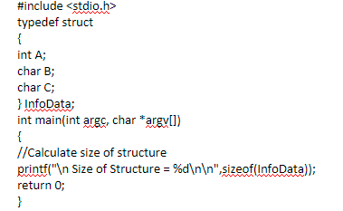

Int A – 4

Char B- 1

Char C-1

Total – 6

Size of structure – 8 bytes (2 padding)

**7. Find the output of the following // Consider the compiler is 32-bit machine**

Char A – 1

Double B – 8

Char C – 1

Total – 1+(7 padding) +8 + 1+(7padding)

Size – 24 bytes ( 14 padding)

**8.** 800000000