**Week -3 Assignments**

1.user press ctrl+C  - SIGINIT

kill() system call is invoked   - SIGTERM

CPU tried to execute an illegal instruction - SIGILL

When the program access the unassigned memory - SIGSEGV

2. List the gdb command for the following operations

* 1. To run the current executable file - r
  2. To create breakpoints at - b N (N specifics the line number)
  3. To resume execution once after breakpoint -continue
  4. To clear break point created for a function - clear function
  5. Print the parameters of the function in the backtrace - info args

3. Guess the output for the following program.

Answer: 7-2’s

4. Guess the output for the following program.

Answer: 3 4 2 4 1 4 1 4

5. Create two thread functions to print hello and world separately and create threads for each and execute them one after other in C

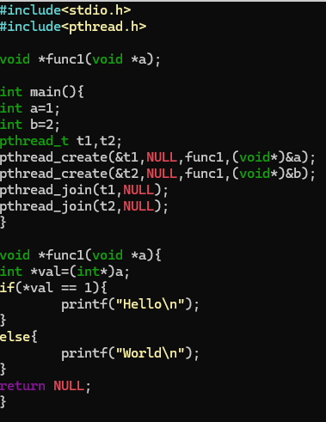

6.How to avoid Race conditions and deadlocks?

By using Mutex for synchronization process in the multi-threading process, we can lock the commonly available memory space for multiple threads to a particular thread until it finishes execution and can be used by the next thread.

7. What is the difference between exec and fork ?

By using exec function a new process is created replacing the old process whereas while using fork() we create a duplicate process the available parent process performing the same function as parent or specified process.

8. What is the difference between process and threads

Process are the program that are to be executed, process may contain multiple segmented which are to be executed whereas Threads are a segments of process which are executed either parallelly or concurrently. A process can contain multiple thread that are executed.

9. Write a C program to demonstrate the use of Mutexes in threads synchronization

