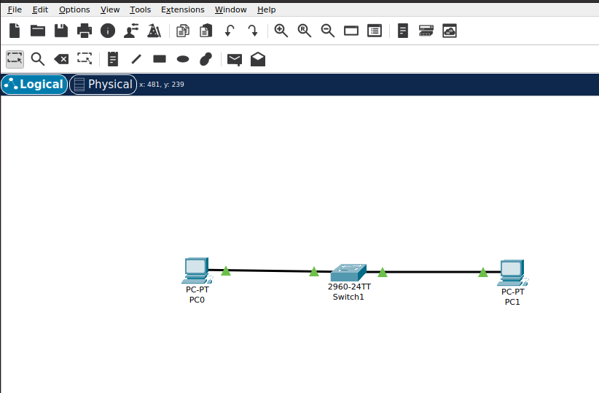
VISHAL G
Simulate a small network with switches and multiple devies. Use ping to generate traffic and observe the MAC address table of the switch. Capture packets using wireshark to analyse Ethernet frames and MAC addressing
PC 0:
Cisco Packet Tracer PC Command Line 1.0
C:\>ping 192.168.1.2

Pinging 192.168.1.2 with 32 bytes of data:

Reply from 192.168.1.2: bytes=32 time<1ms TTL=128
Reply from 192.168.1.2: bytes=32 time<1ms TTL=128
Reply from 192.168.1.2: bytes=32 time<1ms TTL=128
Reply from 192.168.1.2: bytes=32 time<1ms TTL=128

Ping statistics for 192.168.1.2:
Packets: Sent = 4, Received = 4, Lost = 0 (0% loss),
Approximate round trip times in milli-seconds:
Minimum = 0ms, Maximum = 0ms, Average = 0ms
MAC TABLE:
Switch>show mac address-table
Mac Address Table
-------------------------------------------

Vlan Mac Address Type Ports
---- ----------- -------- -----

1 00e0.b0ac.ac12 DYNAMIC Fa0/1
1 00e0.b0c3.ae45 DYNAMIC Fa0/2

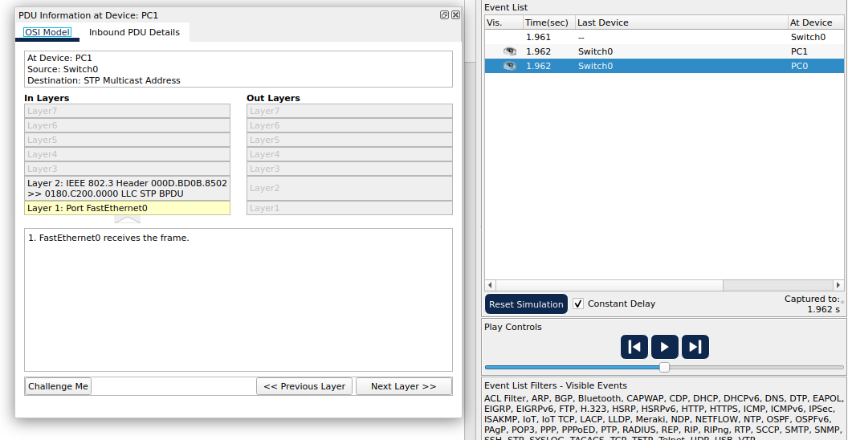
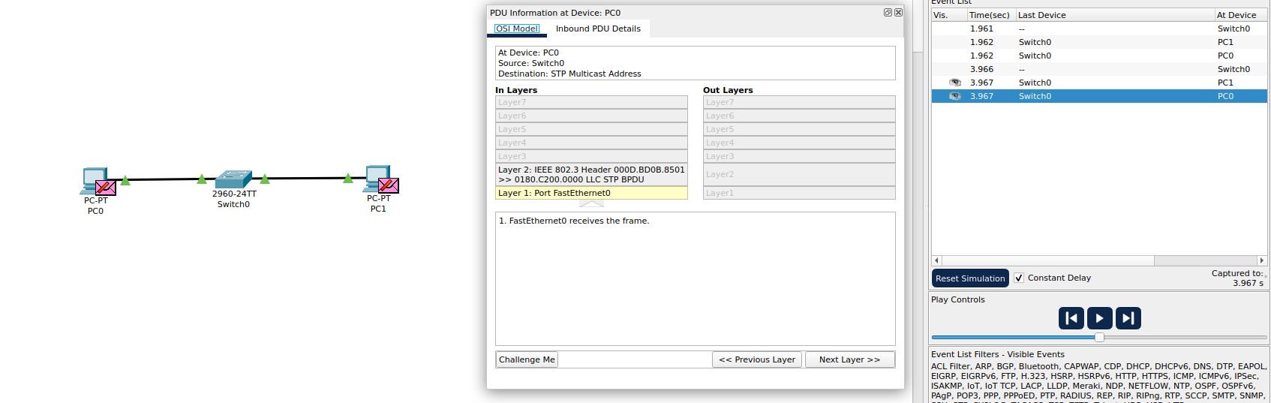

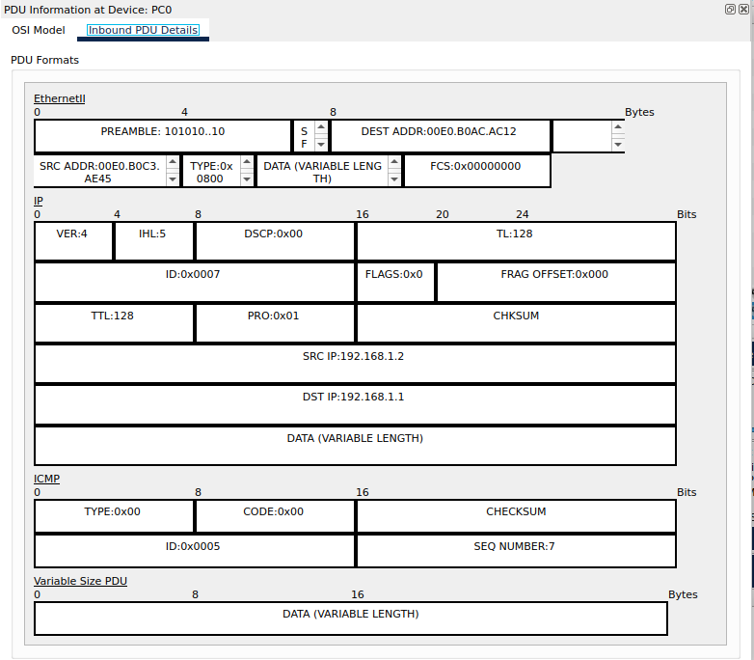
Capture and analyse Ethernet frames using wireshark. Inspect the structre of the frame, including destination and source MAC addresses, Ethertupe, payload, and FCS
Configure static IP adresss, modify MAC and verify network connectivity using ping and ifconfig command
Troubleshoot Ethernet communication using ping and traceroute
C:\>ipconfig /all

FastEthernet0 Connection:(default port)

Connection-specific DNS Suffix..:
Physical Address................: 00E0.B0AC.AC12
Link-local IPv6 Address.........: FE80::2E0:B0FF:FEAC:AC12
IPv6 Address....................: ::
IPv4 Address....................: 192.168.1.1
Subnet Mask.....................: 255.255.255.0
Default Gateway.................: ::
0.0.0.0
DHCP Servers....................: 0.0.0.0
DHCPv6 IAID.....................:
DHCPv6 Client DUID..............: 00-01-00-01-23-23-7E-21-00-E0-B0-AC-AC-12
DNS Servers.....................: ::
0.0.0.0

Bluetooth Connection:

Connection-specific DNS Suffix..:
Physical Address................: 0060.5C72.79B7
Link-local IPv6 Address.........: ::
IPv6 Address....................: ::
IPv4 Address....................: 0.0.0.0
Subnet Mask.....................: 0.0.0.0
Default Gateway.................: ::
0.0.0.0
DHCP Servers....................: 0.0.0.0
DHCPv6 IAID.....................:
DHCPv6 Client DUID..............: 00-01-00-01-23-23-7E-21-00-E0-B0-AC-AC-12
DNS Servers.....................: ::
0.0.0.0

Create a Simple LAN Network with two Linux machines connected via a switch

Ping from One machine to another:
PC 0:
C:\>ping 192.168.1.2

Pinging 192.168.1.2 with 32 bytes of data:

Reply from 192.168.1.2: bytes=32 time<1ms TTL=128
Reply from 192.168.1.2: bytes=32 time<1ms TTL=128
Reply from 192.168.1.2: bytes=32 time<1ms TTL=128
Reply from 192.168.1.2: bytes=32 time<1ms TTL=128

Ping statistics for 192.168.1.2:
Packets: Sent = 4, Received = 4, Lost = 0 (0% loss),
Approximate round trip times in milli-seconds:
Minimum = 0ms, Maximum = 0ms, Average = 0ms

PC 1:
Cisco Packet Tracer PC Command Line 1.0
C:\>ping 192.168.1.1

Pinging 192.168.1.1 with 32 bytes of data:

Reply from 192.168.1.1: bytes=32 time<1ms TTL=128
Reply from 192.168.1.1: bytes=32 time<1ms TTL=128
Reply from 192.168.1.1: bytes=32 time<1ms TTL=128
Reply from 192.168.1.1: bytes=32 time<1ms TTL=128

Ping statistics for 192.168.1.1:
Packets: Sent = 4, Received = 4, Lost = 0 (0% loss),
Approximate round trip times in milli-seconds:
Minimum = 0ms, Maximum = 0ms, Average = 0ms
Use Traceroute to identify where the packets are being dropped
PC0:
C:\>tracert 192.168.1.2

Tracing route to 192.168.1.2 over a maximum of 30 hops:

1 0 ms 0 ms 0 ms 192.168.1.2

Trace complete.
PC1:
C:\>tracert 192.168.1.1

Tracing route to 192.168.1.1 over a maximum of 30 hops:

1 0 ms 0 ms 0 ms 192.168.1.1

Trace complete.

Research the linux ketnel’s handling of Ethernet devices adn network interfaces
The Linux kernel manages Ethernet devices and network interfaces through its network stack, which enables communication between software and hardware. Each network interface (such as `eth0` for wired Ethernet) is treated as a device file in `/sys/class/net/`, and the kernel interacts with them using network drivers. These drivers act as a bridge between the hardware (Ethernet cards) and the kernel’s networking subsystems.

When data is sent, the kernel processes it through different layers. At the Network Interface Layer, drivers communicate with the physical hardware, handling packet transmission and reception. The Internet Layer (IP) determines routing, and the Transport Layer(TCP/UDP) ensures data is delivered reliably or quickly, depending on the protocol used.

The kernel also supports virtual network interfaces such as VLANs, bridges, and tunnels, allowing advanced networking setups. Users can configure interfaces using commands like `ip link`, `ifconfig`, or `ethtool` to assign IP addresses, modify MAC addresses, and enable/disable interfaces. Additionally, features like packet filtering (iptables), traffic shaping and firewall rules are handled by the kernel for security and performance optimization.

Overall, the Linux kernel provides a flexible, scalable, and efficient networking framework, making it ideal for everything from personal computers to enterprise and cloud environments.
How would you configure a basic LAN intenface using the IP command in Linux
vishal@Ubuntu20:~/Downloads$ ip a
1: lo: <LOOPBACK,UP,LOWER_UP> mtu 65536 qdisc noqueue state UNKNOWN group default qlen 1000
link/loopback 00:00:00:00:00:00 brd 00:00:00:00:00:00
inet 127.0.0.1/8 scope host lo
valid_lft forever preferred_lft forever
inet6 ::1/128 scope host
valid_lft forever preferred_lft forever
2: enp0s3: <BROADCAST,MULTICAST,UP,LOWER_UP> mtu 1500 qdisc fq_codel state UP group default qlen 1000
link/ether 08:00:27:97:67:0c brd ff:ff:ff:ff:ff:ff
inet 10.0.2.15/24 brd 10.0.2.255 scope global dynamic noprefixroute enp0s3
valid_lft 78999sec preferred_lft 78999sec
inet6 fe80::6268:bf4:66ca:67d6/64 scope link noprefixroute
valid_lft forever preferred_lft forever
vishal@Ubuntu20:~/Downloads$ sudo ip addr add 192.168.1.1/24 dev enp0s3
vishal@Ubuntu20:~/Downloads$ sudo ip link set enp0s3 up
vishal@Ubuntu20:~/Downloads$ ip addr show enp0s3
2: enp0s3: <BROADCAST,MULTICAST,UP,LOWER_UP> mtu 1500 qdisc fq_codel state UP group default qlen 1000
link/ether 08:00:27:97:67:0c brd ff:ff:ff:ff:ff:ff
inet 10.0.2.15/24 brd 10.0.2.255 scope global dynamic noprefixroute enp0s3
valid_lft 78946sec preferred_lft 78946sec
inet 192.168.1.1/24 scope global enp0s3
valid_lft forever preferred_lft forever
inet6 fe80::6268:bf4:66ca:67d6/64 scope link noprefixroute
valid_lft forever preferred_lft forever
Use Linux to view MAC address table of a switch
Switch#show mac address-table
Mac Address Table
-------------------------------------------

Vlan Mac Address Type Ports
---- ----------- -------- -----

1 00d0.5867.1e1d DYNAMIC Fa0/2
1 00d0.ba36.ec16 DYNAMIC Fa0/1
Use a bridge or ip link command to inspect MAC table
Cisco packet tracer doesnt use Linux based machine as it doesnt allow execution of any Linux command. This ip link command is not used in cisco packet tracer, while MAC table can be analysed by
show mac address-table
This command allows

